..Section 6. Sorting and Packing
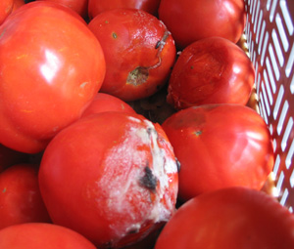
The above photo was taken only 24 hours after harvest. One cracked tomato caused the loss of five others and created an environment for illness-causing pathogens to thrive. If a crack is “healed-over” it may be acceptable for a 2nd. It will likely have a shorter shelf life. The below tomato has juice coming from the crack and should not be put into a harvest tote with good tomatoes.
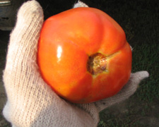

Pre-Sorting During Harvest
The first step of an efficient packing operation is training harvest crews on what to bring in and what to leave out in the field. The amount of scrutiny demanded of the person packing the box for shipping is directly affected by the skill and carefulness of the harvest crew. If pickers send in produce that will need to be rejected at the packing stage it slows the packing task, and is frustrating for the packer.

Damaged, Rotten, or Diseased Produce
Cut, bruised, nicked, diseased, rotten, or otherwise “distressed” produce will decay faster and be more susceptible to disease, causing good produce in the same box to spoil also and increasing the potential of food safety issues. It should be pre-sorted during harvest and left in the field.

For some contagious crop diseases, such as late blight in tomatoes, it is recommended to remove the diseased fruit from the field. Contact your extension agent or a disease identification lab for specific disease management information if you suspect your crop may have a contagious disease.

What Is A “2nd”?
“2nds” are produce items that are cosmetically imperfect—shape, size, or uniformity—or are too ripe to meet the shelf life needs of your market. 2nds are also called #2 grade or commercial grade. Produce that is rotten or unsafe or dehydrated or near the end of its shelf life is not a 2nd and it should not be sold.

If you have a market or other outlet developed for 2nds they can be sorted into separate containers during harvest or in the pack shed. If there is not a market or use for them, it is generally recommended to pre-sort them out at harvest similar to damaged produce. Bringing un-useable produce into the pack shed adds the labor of sorting it out during packing.

When Is Produce Sorted And Packed For Shipping?
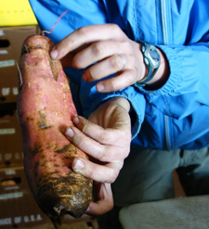Edible yes, but this sweet potato is not a #1.

Most fresh market produce is sorted and packed for shipping after cleaning and before storage. Cooling occurs before or after sorting/packing, depending on the crop.

Some produce will be cooled and stored (washed or unwashed) immediately after harvest, and resorted and carton-packed later shortly before shipping. It is extra-important that produce stored for long periods be properly pre-sorted to prevent spoilage of good produce and/or food safety issues.

Who Is The Customer? What Are Their Needs?
Wrong and right way to pack peppers.
Visual appearance makes a big difference. The top image creates the impression that the producer doesn’t care. The lower image, with orderly rows, demonstrates commitment to quality and professionalism.

Wrong and right way to pack peppers image here from the present manual.
Photo: Dennis Fiser

Meeting your customers’ needs is a key component of business success.

Purchasing produce is a sensory experience. The “organoleptic properties” of produce—including taste, sight, smell, and touch—have a huge influence on customers’ purchasing decisions. Farms that market only well-displayed, #1 quality produce are generally in highest demand in every market.

If you are direct marketing through roadside stands, farmers markets, restaurants, or CSAs, flavor is a major consideration. Direct market growers have a face-to-face opportunity to communicate with and educate customers. These customers may be willing to purchase produce that is not uniform in shape or size, may be cosmetically imperfect, or may be packed in different containers or weights than the industry standard. However, even well educated customers are affected by their senses, and “eye-appeal” is still important. Growers may find their sales are negatively affected if they stray too far from #1 quality and cosmetic perfection, or if their alternative packaging is unappealing.

Retail stores and wholesalers generally have more stringent requirements, in particular to visual appearance, and require consistent and uniform quantity, quality, size, weights, and packaging. Some buyers and markets have their own preferences, but most expect produce to be packed to USDA industry standards.

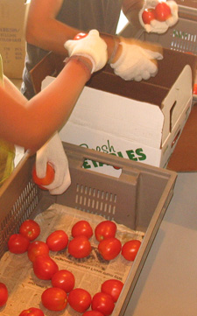
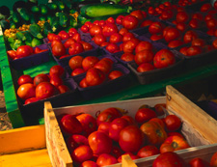
Atina Diffley packed tomatoes to three grades. #1s were sold direct to retail stores and wholesalers, They were close to cosmetically perfect, at a turner or pink stage, and she expected them to reach maximum shelf life. #2s went to her roadside stand—above photo. They had minor cosmetic flaws or were riper. #3s or “canners” were often pre-sold for a specific canning date. They were generally ripe, and could be cosmetically unattractive and mixed sizes. No fruit with a rotten spot was allowed in any grade.

USDA Grade Standards
The Agricultural Marketing Service branch of the USDA maintains a complete list of US Grade Standards for fruits and vegetables. Most common produce items have both No. 1/Fancy and No. 2/Commercial grades based on characteristics such as shape, size, color, damage, and freshness. The primary difference between the two groups is visual appearance and the specified tolerance for damage or decay.

No. 1/Fancy grades are generally sold to buyers who will display it directly to consumers – primarily grocery stores and food retail outlets. No. 2 Commercial grade produce is usually processed and sold to foodservice buyers, including restaurants, institutions, and processed foods producers. The crop profiles in this manual include summaries of the USDA Quality Standards. Full-text versions are available for free online at: www.ams.usda.gov/standards/ stanfrfv.htm.

Consistent Quantity
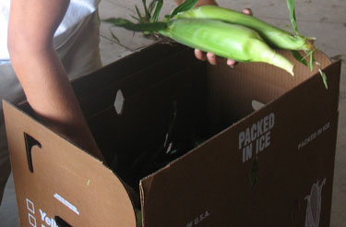
Many crops, including sweet corn and cucumbers, can be sequentially planted to create a consistent supply throughout the growing season.
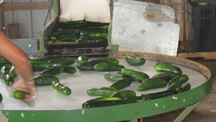
Packing cucumbers off of a rotating pack table makes selection and grading easier.
Another aspect of uniformity that is important to wholesalers and retailers is that produce be consistently available for an extended period of time. It can be hard to get into a wholesaler or retailers’ supply chain if produce availability is erratic, coming in and out of the market. Buyers will have to purchase from other sources and can be already loaded up when your product is ready for market. Make it easy for them to buy your produce by planning sequential plantings and consistent volume. An effective strategy for keeping wholesalers satisfied is to have ready produce for your market as early as possible by using season extension tools, maintaining a steady and reliable volume through the entire growing season and extending as late into fall as possible, again with the help of season extension.

Sorting
Produce is generally sorted during the packing process. For many crops, each piece of produce needs to be examined individually and a decision made. For other crops, such as salad mix or green beans, the produce is sorted through in bulk and bad pieces are removed. To maximize the efficiency of the sorting/packing process, rotating pack tables and conveyor belts are very useful.

Packing the carton is a last chance for quality control and is a “skilled” level task. Developing an “eye” for quality and standards takes training and practice.

Packers should be trained to recognize the proper sizes and shapes. Some types of produce are traditionally sorted by weight, others by length or size. Sizing rings or examples of different shapes and sizes can be referred to as needed. For most crops, sizing is done visually and by hand. A sizing belt can be added to a pack line or a sizing table can be used to sort round produce, such as potatoes or apples.
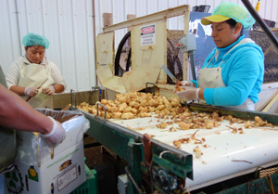
Jerusalem artichokes, also called “sunchokes,” being sorted and packed on a conveyer belt after being cleaned in a brush washer at Harmony Valley farm. Photo Atina Diffley

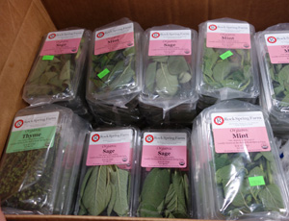alley farm.

Nicks and other visible damage to the produce are relatively easy to see and should be sorted out. Food shelves are often thrilled to receive this produce if it is not rotting and can let you know the best times and places to drop it off. Some communities have a food shelf pick-up service and can send a truck out to your farm.

Sometimes subtle color differences are an indication that decay is developing or that bruising has occurred, but is not yet highly visible. It can take a day or two before bruises fully develop after the damage has been done.
Sometimes rot and bruise spots are not easily visible to the eye and to be detected they need to be felt. Fingers should be busy gently feeling for soft spots as they turn produce over to look for visible damage.

Produce can also be bruised, rotten, or diseased internally, and it may not be observable through an external examination. It is important to cut and taste a few pieces of a lot of produce to check for internal quality.

When in doubt keep some of the questionable produce in your own storage facility for a few days to see if a problem develops. As packers gain experience they will learn when a color variation is a problem and when it isn’t. Good lighting is important over the pack area to see these subtle differences.

Cosmetic requirements can be challenging to teach. To some degree the task is based on one’s sense of visual beauty, which isn’t the same for each person. Produce doesn’t necessarily need to be “perfect.” It does need to be attractive. For example, if a produce item has a small scar that is well healed it won’t likely cause decay, and if the scar is small and isn’t visually unattractive it may be considered a #1. Multiple small scars combined, or a long jagged scar may be too much.

Decide first if spoilage is a concern. If it is, do not ship it. If it is not a spoilage issue, look at the produce item as a whole and ask if the cosmetic issue detracts substantially from its visual appearance. This is a subjective question, and as packers learn the expectations of the market they will gain a sense for what level of perfection is required.
Images from present manual
DO NOT USE on page 52 Atina Diffley packing peppers at
DO NOT USE on page 51 and 52 The Lady moon tomato pictures- they have been washed, which we are discouraging in this manual, and they are very green.

Ultimately the most important thing is to understand and meet the needs and expectations of your market. Good communication with your buyer is crucial. Invite feedback. Ask your buyer if they are satisfied, if you are packing to their specifications, and if your product is holding well for them. If you don’t understand what they need, visit the warehouse or store and ask to be shown boxes that are packed the way that they want.

Trimming
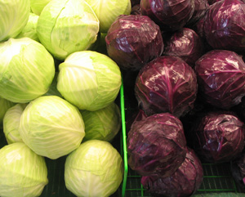
If the farmer leaves a few outer leaves on the cabbage for shipping, the retailer can remove them to “freshen” the heads up for display.
Crops such as onions and leeks have the roots and leaves trimmed for packing. Yellow or discolored leaves should be trimmed off of bunched roots. Broccoli stems should be cut to the correct length in the field, usually around 6 inches. If its not it will need to be trimmed at packing—if they are too long customers often break them off in the stores. Cabbage should be packed with a few outer leaves to protect the head. When the retailer receives it they will usually trim the outer leaves to “freshen” the cabbage for display.
Anything with a head: lettuce, bok choy, cabbage, cauliflower, etc, should have a nicely trimmed and clean “butt” end that won’t catch and tear adjoining produce. Squash stems should be cut level, not angled and pointy sharp. If bulk roots have long tails they may be trimmed down to a few inches, but they shouldn’t be trimmed all the way to the bulb or freshness and flavor will be lost. A few outer leaves can be left on cauliflower and carefully wrapped around the head to protect it for a “leaf wrap” pack. Cauliflower can also be trimmed down to the head, and then wrapped with plastic to protect it. Check with your buyer for their preference. Much of this trimming occurs at harvest. It is the packer’s task to clean up anything missed and to communicate if the harvest crew needs more training.

Packing the Box
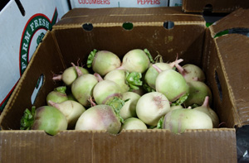
Bulk roots above do not have to be arranged individually. They are heavy though, so it’s important that the box, especially the bottom, is strong. Below round cabbage is packed in the “nesting” style. This holds them secure and keeps them from shifting in transit.
Atina - TRY TO GET A PHOTO HERE OF A NEST PACK
If you are packing produce for your own direct market sales, such as going to a farmers market, the most important consideration will be ensuring that the produce is protected from damage. You can use standard produce cartons, or pack in plastic field totes, whatever works best for you and your produce.

Wholesalers and retailers expect a standard pack. Carton weight, size of produce, produce count, and type of carton are important considerations. Standardized weights and packaging are especially important when selling to a wholesaler because the retailer buying your produce will see it first as a line item on the wholesaler’s product list. If you have deviated from the standard pack they will not know what to expect and may not buy it.

Proper ventilation is essential for packaging to maintain cooling in storage or during shipping. Most containers will have vents for this purpose, and even perforated plastic liners generally provide enough ventilation. When containers are stacked together, care should be taken to line the vents up so that they create a “tunnel” effect, and air can move between them.
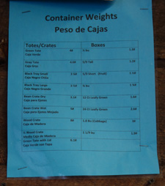
Posting container weights in the packing area provides workers with useful information. When packing boxes, the scale needs to be set for the desired produce weight plus the weight of the packing material.

Produce cartons come in different weights and strengths and are priced accordingly. If the carton isn’t strong enough to protect the produce, damage can occur. Buying a lighter weight carton can seem like a financial savings but it can result in produce being damaged and lost sales. Collaborating with other farmers to order boxes together can be a way to reduce the cost through a volume purchase. For crops that are packed wet it is important to use containers that do not break down when exposed to water. Waxed cardboard is standard for hydro-cooled and iced produce.

Produce should not be packed too tightly or too loosely in containers. Either extreme can cause bruising or injury – whether from over-compression or from loose produce bouncing around.

Smaller crops like baby greens, bulk brussel sprouts, beans, b-sized potatoes, or bulk roots do not have to be individually arranged. Larger produce should be placed into the packing container in an orderly fashion and in a way that protects the produce from compression damage.

First impressions can have a strong impact. When buyers open a carton, the visual appearance and presentation of the packed box make an impression and can affect their future purchasing decisions.
When packing acorn squash for example, similar size fruit lined up in orderly rows, stems facing the same direction, with the dark green side up and the yellow ground spot down, is visually appealing. It sends a message of professionalism and quality. It creates trust and earns respect.
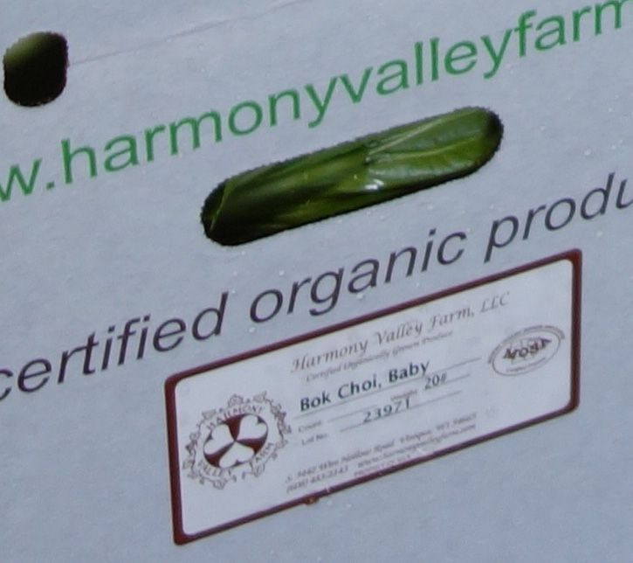
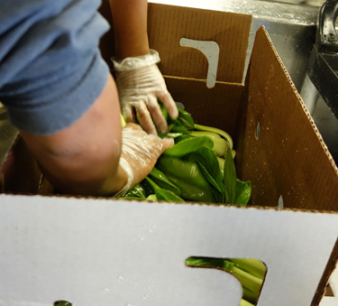
Baby bok choy is gently packed at 20# into leafy greens waxed cartons at Harmony Valley farm and then covered with a waxed paper liner before the cartons are closed. Photos Atina Diffley
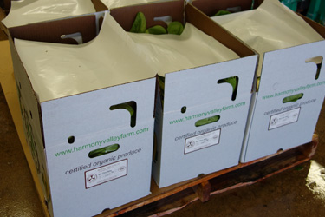

Box Liners
Perforated polyethylene liners in boxes are often used for produce susceptible to dehydration. The perforations allow excess water to drain from the produce, while protecting the produce from dehydration by keeping a humid environment.

Waxed paper liners are used under and over many crops to protect them from damage. Some crops, such as broccoli, can be package-iced without any barrier between the ice and the broccoli. For others, such as some leafy greens, a sheet of paper should be placed between the ice and the produce.

For crop-specific container sizes and types, and additional packaging needs, refer to Section 8: Crop Profiles or ask your buyer to educate you on their expectations.

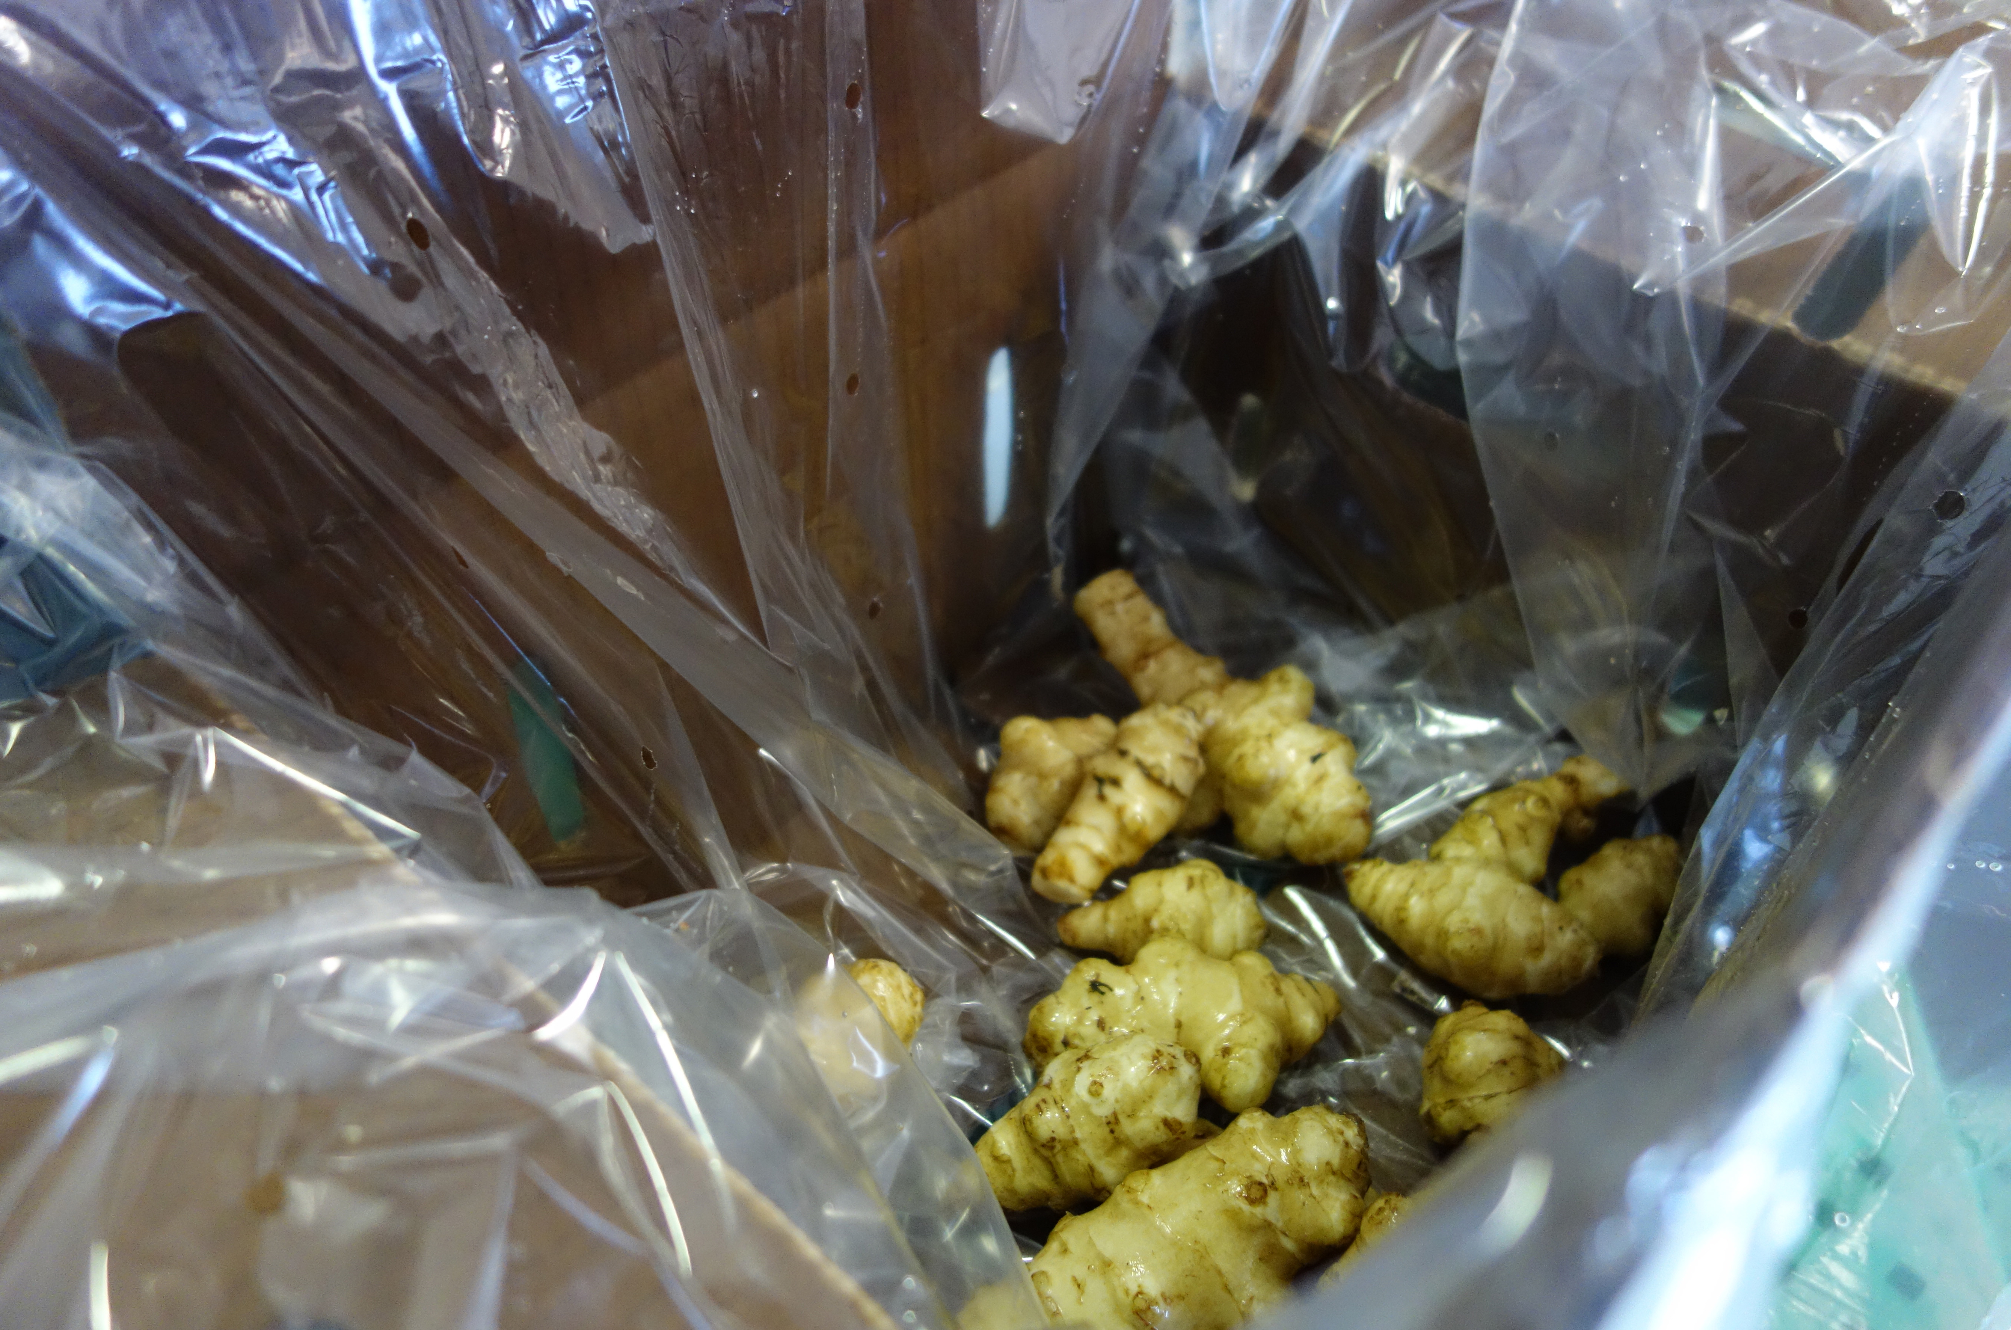
Clean sunchokes are packed in perforated polyethylene liners inside of waxed cartons at Harmony Valley farm. Photo Atina Diffley

Unit Packaging and Bunching and Product Labeling
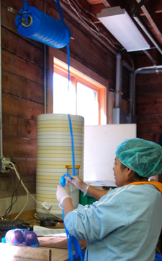
At Harmony Valley farm, netting to pack 3# onions is purchased in a roll, cut to size, and then tied into a knot to close the bottom. Onions are weighed on an electronic scale in a standard container and poured into the net bag. A label is then stapled on.
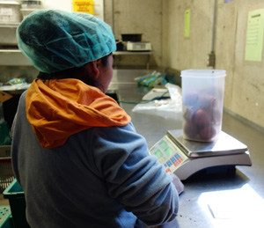
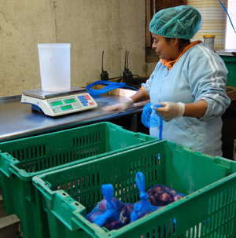
Packing in clamshells, or net, paper, or plastic bags can protect produce from compression damage and dehydration, and increase sales. Unit packaging can be easily labeled and is a great opportunity to brand produce with your farm name and logo, provide PLU codes or traceability information, and recipes, marketing information, or other incentives to customers. Customers often purchase more when the produce is packaged and labeled than when it is sold in bulk.

Baby greens, apples, or root crops can be packed in plastic bags. Potatoes are sometimes packed in a heavy paper bag. Bags can be labeled with a pre-printed or attached label. The hard plastic of clamshell containers protects berries, mini-peppers, herbs, cherry tomatoes and other produce, and are perfect for applying a sticky-backed label. Net bags are commonly used for potatoes, onions and apples; a heavy paper label can be stapled to the top.

While plastic and paper bags can be preprinted, for small or diverse farms with multiple different packaged crops, it can be more economical to purchase a label printer to custom-print labels on the farm. There is more information on label printing machines later in this section.

There are many supplies of produce packaging and finding someone in your community is often the most economical option. Monte Packaging http://www.montepkg.com/ and Hubert http://www.hubert.com/ are two options for produce packaging that ship nationally.
There are many label and tag and packaging products that can be preprinted to identify, brand, market, and trace your produce. Twist ties and rubber bands can be printed with farm information, and used to bunch greens, herbs, and asparagus, or to hold a loose head closed so it will not dehydrate as quickly. Bunch tags can be slipped over rubber bands. Many small and mid-sized growers work with http://www.bedfordind.com/ or Agri Label & Tag, http://www.agrilabeltag.com/smalllargeplulabels.html for custom printed ties, bands, and bunch tags.
Small stickers can be put on each produce item and might include your farm logo, a PLU number or other traceability code, or the USDA organic seal. If labels are applied directly to produce, the adhesive needs to be a food-grade label adhesive. For pre-printed adhesive labels there are thousands of companies that can supply your needs.

Some states supply free twist-ties, sticky labels, and tags to its members and offer cost-sharing for development of farm-specific labeling that incorporates the state’s buy local program. Check with your state department of agriculture to learn what is available to you.

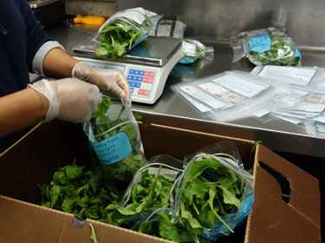
At Harmony Valley farm, labels are custom printed on the farm and attached to bags before hand filling and weighing.

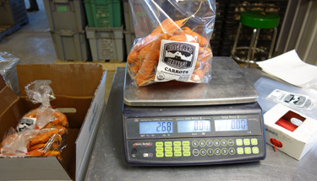
Carrots are protected from dehydration with this 2# pack in a plastic bag at Ridgeland Harvest farm.

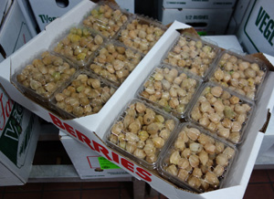
These clamshell-packed ground cherries are the perfect container to place a brand name label on.
Rock Spring farm culinary herbs are packed into clamshell containers and labeled with farm and product information. Six clamshells of one herb type are packed together in a plastic bag, and the shipping carton is packed with a mix of herbs.

Carton Labels
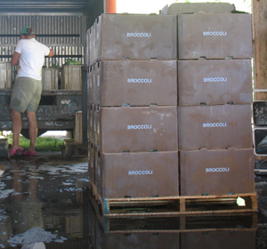
Food Safety In The Pack Shed: Boxes of produce should never be set on the ground or floor. Use clean pallets or carts to keep produce from touching the floor.
Produce cartons need to be labeled with your farm name and address; the name of the produce item with the weight or volume; and the lot number. The lot number is very important for linking a crop back to the field where it was grown and associated records. This system of traceability is crucial food safety information in the event of a recall or food safety issue. Lot numbers will also help you and your buyer rotate inventory for freshness.

Lot numbers should be used on produce cartons, bill of ladings, invoices, or any other document that accompanies the sale and shipment of fresh produce from the farm. It does not need to be included on item labeling or packaging used directly on single units of produce, such as fruit stickers or twist ties.

Producers can develop their own lot numbering system specific to their operation. Essential information includes the date the box was packed and the field where it was grown. Lot numbers might also include the date it was shipped, the storage facility where it was stored, or who packed it, or any other information that is important to track its history. At Diffley’s Gardens of Eagan lot numbers started with the field number that the produce was grown in, then the date it was packed, and then the initials of the person who packed it. Example: E37 | 9-13-12 | AD. Some farmers like to use a day of the year system; in that case October 22, 2012 could be written as 296-12.

It doesn’t matter what system you use as long as you and your buyer know how to interpret your code, the crucial information is included, and it traces back to your farm records.

Small and mid-sized farms often use a generic label pre-printed with their farm name and address information. The information that changes for each crop—produce name, weight, and lot number—can be hand written on the pre-printed labels with a permanent marker or printed for each individual crop with a label printer. A printer can also be useful to print labels with recipes or other information for unit packed products.

There is no solid rule of thumb for when a farm is large enough to buy a printer. Basic black and white label printers start at $500. You may also want a label dispenser or label gun. These range from a simple wall mount dispenser for $20 to an electrical dispenser for $500. Advantage Label & Packaging http://www.advantagelabel.com/ recommends the Tharo V label printer for small and mid-sized farmers. Advantage also provides software and hardware to help farmers create databases to record and track lot number information.

Waxed cartons and humid room coolers need adhesives that will stay on in wet conditions. When ordering labels work with a reputable printer and be sure the label materials are appropriate for your needs.

Sort and Pack In The Field
Sometimes produce can be packed right in the field. Advantages include minimizing handling which can cause bruising and other damage, quicker processing time, and reduced labor hours. Field packing requires a system to handle cleaning and cooling in the field at harvest, or in the pack shed after harvest and extra care must be taken to keep shipping cartons clean. Challenges can include quality control, and lack of shade.
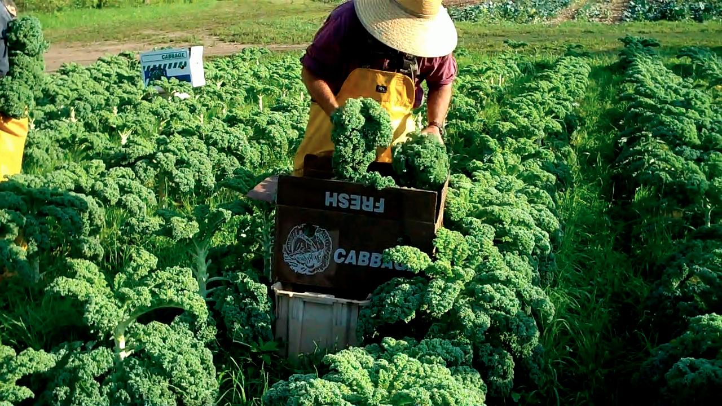
On cool days at Diffley’s Gardens of Eagan harvest crews field-packed kale direct into the shipping carton, and placed it into a refrigerated truck until it was brought into the pack shed. Notice the shipping carton is set on a plastic field tote to keep it off the ground. On hot days the kale was picked into plastic totes and brought to the pack shed where it was placed in to water tanks to hydro cool, then packed.

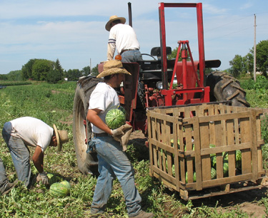
Watermelons were dry brushed clean, and packed in wooden bins at Diffley’s Gardens of Eagan. Retail stores rolled the bins directly onto the sales floor for display. 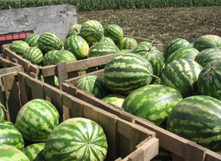

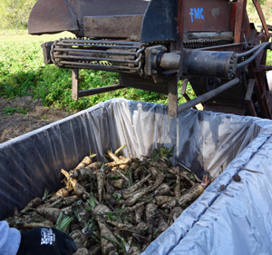
At Harmony Valley farm parsnips are being picked with a FMC mechanical harvester and packed directly into plastic-lined wooden bins, where they will be stored through the winter until washing at shipping time. Some farms wash root crops before storage.

