Section 3. Harvesting
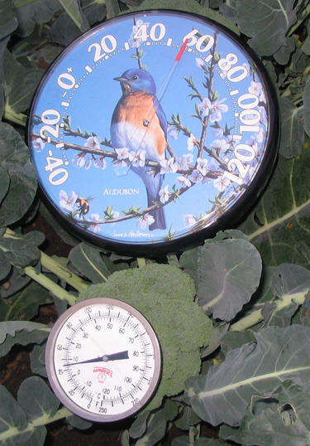
The above photo, taken at 7 am on September 18 shows the air temperature was 58° F. The broccoli, at 45° F, was still cool from the evening air. This broccoli can be harvested, iced and go right into storage in a room cooler.
The photo below was taken at 4 pm of the same day. The air temperature was then 88° F and the core temperature of the broccoli had risen to 82°. If harvested now, this broccoli must be pre-cooled, costing time, money, quality, and shelf life.
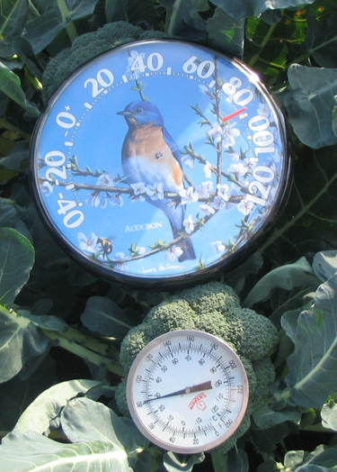

The best possible quality of any fruit or vegetable exists at the moment of harvest. From that point on, quality cannot be improved, only maintained. Shelf life begins at harvest.

First Step Of The Cold Chain

Harvest: Good Cooling Begins in the Field
Postharvest cooling costs time, energy, and money. Before discussing the various methods of cooling, there are harvest practices that can greatly reduce the energy and labor costs of cooling and shorten the time needed to reduce produce to storage temperature. These practices will increase the efficiency of standard cooling methods and can help smaller-scale farmers with limited cooling infrastructure to still be able to provide a saleable product.

- Harvest and ship crops frequently, every several days.
- Harvest early in the day, when field heat is at a low point.
- Avoid exposing harvested produce to direct sun; immediately move into the shade. Temporarily store produce under a tree, use box trucks, build roofs onto wagons, or place harvested produce in a refrigerated truck until it is transported to the pack shed. The core temperature of produce exposed to direct sunlight can quickly reach temperatures several degrees warmer than the ambient air.
- Move crops into cooling facilities frequently during harvest.
- Night temperatures are typically 15 to 20° F cooler than daytime highs. Harvest at night under lights can take advantage of this.

Move the Image on page 39 in the present manual from the Cooling Section to here—Harvest, presently subtitled “Harvesting Flowering Kale onto a shaded harvest cart with a hydraulic belt harvest aid.
Change the subtitle:
At Harmony Valley farm roofs have been built onto hay wagons to shade produce from the sun; here flowering kale is being harvested with the aid of a hydraulic harvest belt.
Photo Harmony Valley Farm

Atina and Martin Diffley used aluminum U-haul boxes to keep sun and wind and dust off of produce during harvest. Broccoli was picked first thing in the morning while cool, and immediately placed in the truck. Doors could be closed during transport to keep out field road dust. The low height of the truck box was perfect for packing. Pack shed staff rolled over a scale and packed right off the back into shipping containers, then iced the full cartons, and moved them into a room cooler. This system eliminated the step of unloading, and saved time and labor. Broccoli could be harvested, packed, cooled, and moved into storage quickly.
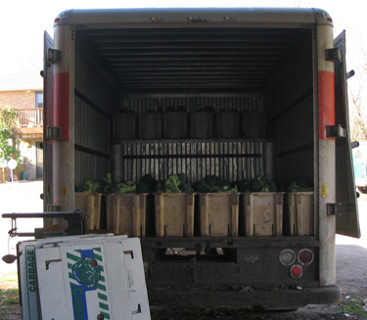

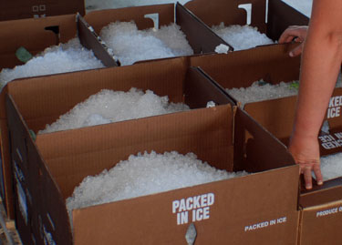
Iced broccoli packed in waxed cartons, ready for the room cooler.
On a rainy, overcast, and muddy day, a four-wheel drive truck and trailer did the job of hauling this broccoli out of the field and keeping it clean at Diffley’s Gardens of Eagan, but if the sun had come out, shade would have been needed.
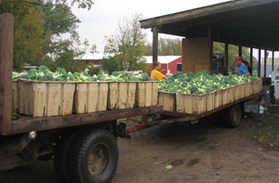

When To Harvest
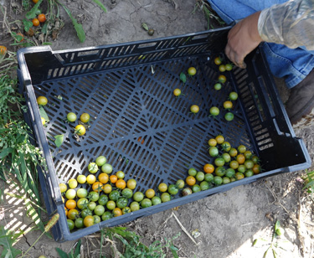
Tender skinned cherry tomatoes have a tendency to crack as they mature—especially after rain—causing the loss of fruit, and extra work sorting at harvest. At Rigdgeland Harvest farm, tomatoes are harvested as “turners.” They are physiologically mature and will finish ripening—turning red, sweet, and juicy sweet—in the protection of the pack shed. Quality will be higher, and fruit will hold up better in shipping then if they had been vine ripened to full maturity—referred to as “red ripe.” Notice how well vented the field tote is. Tomatoes need air as they ripen in storage.
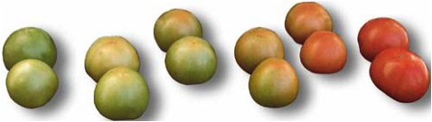
1 2 3 4 5 6
Wholesalers generally want to receive tomatoes as “turners,” similar in appearance to #3, or #4. Retailers expect a little more color, #4 or #5, but they usually do not want a “red ripe” (#6). At farmers markets, customers generally want to purchase close to ripe, or red ripe. (#5 or #6) Tomatoes picked at the maturity of #3 and #4 are physiologically mature and will ripen in a few days., while tomatoes picked at red ripe (#6) are difficult to bring in from the field or ship without bruising.

Ripeness and Maturation Indicators
Ensuring that crops are harvested at the appropriate maturity and ripeness is important for buyer acceptance, eating quality, and post harvest shelf life.

Two different definitions of ripeness and maturation should be considered when judging when to harvest. The first and most straightforward definition is how maximum ripeness and maturity are defined for a particular crop. Crop-specific definitions can be found in the USDA grade standards—and include descriptive tables with size, shape, and color charts, and sizing rings. Other important characteristics include texture, and sugar content.

An additional definition should be considered: the ripeness or maturity level appropriate to the market that is being targeted. This can vary for cultural, regional, seasonal, or culinary preferences. Where and how the product will be sold can affect when it is harvested.

Know your market—examples:
- If kale is sold as a baby green it should be very young and tender and packed in a plastic bag or otherwise protected from dehydration. If bunched, those same baby leaves will not hold up in a retail display; more mature, less tender leaves are needed.
- Some markets demand “premium” cucumbers, with very young, tender seeds, sweet flesh, and thin skins. Other markets expect cucumbers to be slightly more mature; they need a thicker skin to prevent dehydration of the fruit in the open display coolers. Still other markets use very mature cucumbers with large seeds and skin that is yellowing.

Some crops increase ethylene production as they ripen; the produce will continue to ripen after being removed from the plant, getting sweeter and softer after harvest. These crops are purposefully harvested before they are fully ripe, so that by the time they reach market they will have fully ripened. A crop that is harvested in this manner must be physiologically mature; or mature enough that it is capable of ripening fully after harvest. Only certain crops have this capacity. They include: apples, avocados, bananas, blueberries, cantaloupes, cherimoya, figs, guavas, kiwifruit, mangoes, papayas, pears, peaches, persimmons, quinces, stone fruits, and tomatoes.

All other crops will not ripen after harvest; they will soften and rot, due to moisture loss, decay, and tissue deterioration. They must be harvested at the stage of maturity at which they will be eaten.

- Quality Tip: Harvest and ship crops frequently, based on the crops’ maturation and ripening rate. During hot weather this may need to be daily or every other day. During the cool fall season, three to four days may be more appropriate.

Harvest Wet or Dry
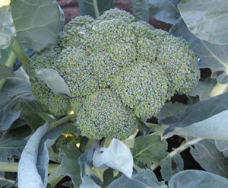
Broccoli is best harvested early in the morning, when cool and dewy. The beads should be tightly closed, and heads should not be loose. Photo Atina Diffley
“Learn all the rules in farming—then learn when to break them,” Atina Diffley says. Harvesting wet or dry can make a big difference for many crops, but sometimes times the weather doesn’t cooperate and farmers have to break the rules to get the crop in. Understanding the consequences of breaking the rules helps in the decision-making process.

Generally wet harvested crops are also heat sensitive and it works well to harvest them in the morning when they are cool and wet from dew.

Plants are usually dry by the afternoon and that can be a good time to harvest crops that prefer to be harvested dry. Fortunately, dry-harvested crops are not as sensitive to harvesting in the heat of the day. Growing a diverse crop mix can be helpful in managing harvest workflow while also meeting the harvest needs of the individual crops.

Best Harvested Dry:
- Crops in the solanaceous family: potatoes, eggplant, peppers, tomatoes; and most cucurbits: cucumbers, melons, summer squash. Harvesting when wet increases the risk of fungal diseases.
  - If these crops must be harvested wet, be sure to practice good disease prevention strategies to limit the human transfer of disease from plant to plant during the harvest process. Do not harvest from plants already diseased and keep harvest knives and hands clean. If a crop is near the end of its harvest period, it will be less of a problem if harvesting wet spreads a disease.
  - For tomatoes, eggplant, and summer squash, which are best dry-brushed rather than washed, harvesting wet may result in fruit needing to be washed.
- Green beans can develop rust if harvested wet.
- Storage onions, garlic, and winter squash need to be dry for storage and generally keep better if harvested dry.
  - During long rainy periods, or when frost threatens, waiting to harvest until the plants are dry may not be an option. In that case, use fans to dry produce with moving air.

Best Harvested Wet (and cool):
- Fresh greens, broccoli, cabbage, cauliflower, green top onions, leeks, sweet corn, and green top roots benefit from being harvested while wet; it helps them stay cool and hydrated.
  - Time and weather conditions may not allow you to harvest all these crops when they are wet. Prioritize harvest of the most sensitive crops (greens, broccoli, sweet corn, and green top roots) during the dewy cool morning. If harvest in dry or warm conditions is necessary, be sure to have a quick cooling process ready. Hydro cooling can be an excellent way to keep these crops hydrated through the process of cooling and cleaning. Cauliflower, and leeks are not as sensitive and can be harvested after the others. Cabbage holds so well, it does not make a significant difference if harvest is wet or dry. Washing of cabbage should be avoided.

Hand or Machine Harvest
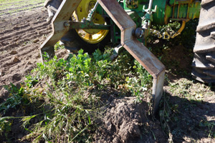
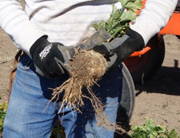
Have the right tools and process ready for each crop. At Harmony Valley, celeriac is dug with a “lifter”—a root-digging tool that Richard de Wilde had made from a hardened-steel, beveled grader blade. Field staff trim the roots with field knives, pack them into field totes, and immediately place the boxes in the shade of a roofed hay wagon. Photos Atina Diffley
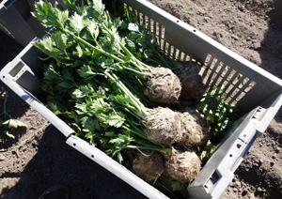

Crops can be harvested by hand or by machine.
Hand harvesting can be advantageous because it allows workers more opportunity to select for quality and maturity, damage to produce can be minimized, and hand harvest allows for multiple harvests of the same planting. Having enough labor to harvest the crop in the time frame needed can be a challenge for some farmers, and sometimes hand harvest is not economically viable.

Machine harvest can save money and allow a large amount of harvest to be accomplished during short windows of opportunity. Speed of harvest can help product move quickly into cooling. For crops that could be harvested more than once, such as green beans, machine harvest can result in lower yields, and the cost and size of equipment needs to match the scale of production. In general, machine harvest causes some bruising and nicking of produce.
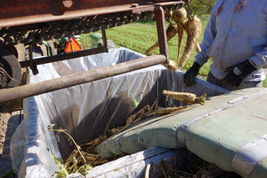
Some of the best crops to harvest by machine are bulk root crops. At Harmony Valley farm, a foam pad cushions parsnips as they fill a bin from a FMC mechanical harvestor. Even hard root crops are vulnerable to bruising, nicks, and cuts. The field worker is pre-sorting, throwing out parsnips that will not keep. Photo Atina Diffley.
Photo by Atina Diffley

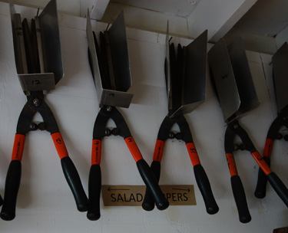
There are times when the crop or field conditions do not allow for mechanical harvest of baby greens at Harmony Valley—then harvest crews reach for these clean, sharpened, and easy-to-find salad nippers to harvest by hand. Photo Atina Diffley

REMOVE Figure 2 on page 37. Ramsey Highlander

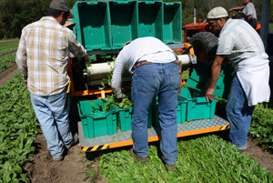Harmony Valley in Viroqua Wisconsin uses a mechanical harvester for spring mix and baby greens. Atina Diffley was amazed when taking these photos, “I counted in seconds—from the moment the leaf was cut, as it moved up the conveyor and filled the field tote, which was immediately set on the roofed harvest wagon, out of the sun, where it was weighed, recorded and ready for transport back to the pack shed—33 seconds from cut to shade! For small growers, it can be difficult to compete economically with this level of efficiency on a national wholesale market.” Photos Atina Diffley
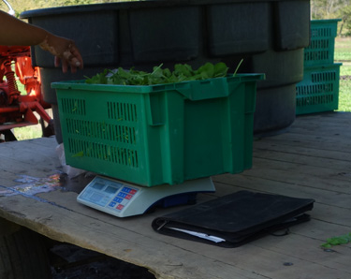

Use the side bar on page 37
Build a Simple Hand Cart
Stooping or kneeling and crawling to harvest salad greens requires a lot of time and energy. Lifting and moving your harvest container many times as you fill it adds to the workload. One alternative is to use a salad cutter. Another alternative is to build a simple cart, which allows you to sit and roll while you harvest. This is less tiring for the knees, back, hamstrings, and torso. The cart also holds your harvest container, so it rolls along with you.
For complete instructions on building this cart, go to:
http://bse.wisc.edu/hfhp/tipsheets_ html/cart.htm

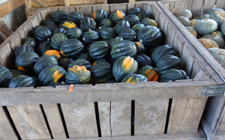

By harvesting into 1,000 bins, heavy squash can be safely moved with a forklift or pallet jack, instead of by hand, 50# at a time. Photos Atina Diffley

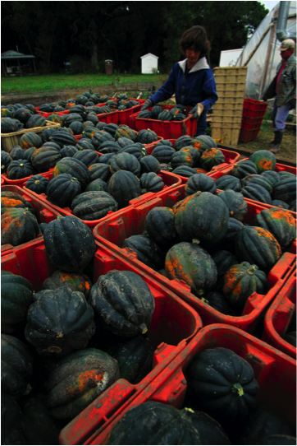

Minimize Hauling of Harvested Produce.
Hauling heavy field totes of produce is exhausting for workers and can consume valuable time. Look for ways to minimize the distance and amount of produce that needs to be hand-carried. Some possible strategies include:

- Watermelons, cabbage, sweet corn, roots, and squash can be harvested into bins, and then moved with a fork lift or pallet jack.
- Handcarts can be used in the field to carry produce out.
- Harvest conveyor belts can save time and physical strain on pickers.
- Build loading docks onto pack sheds.
- Use roller tables to unload into sheds and storage.
- Having multiple harvest vehicles and wagons can minimize the need to unload produce. Field crews can back up to pack sheds and take a different vehicle back out to the field. Pack shed crews can pack right of the truck or wagon.

Field-Sort At Harvest
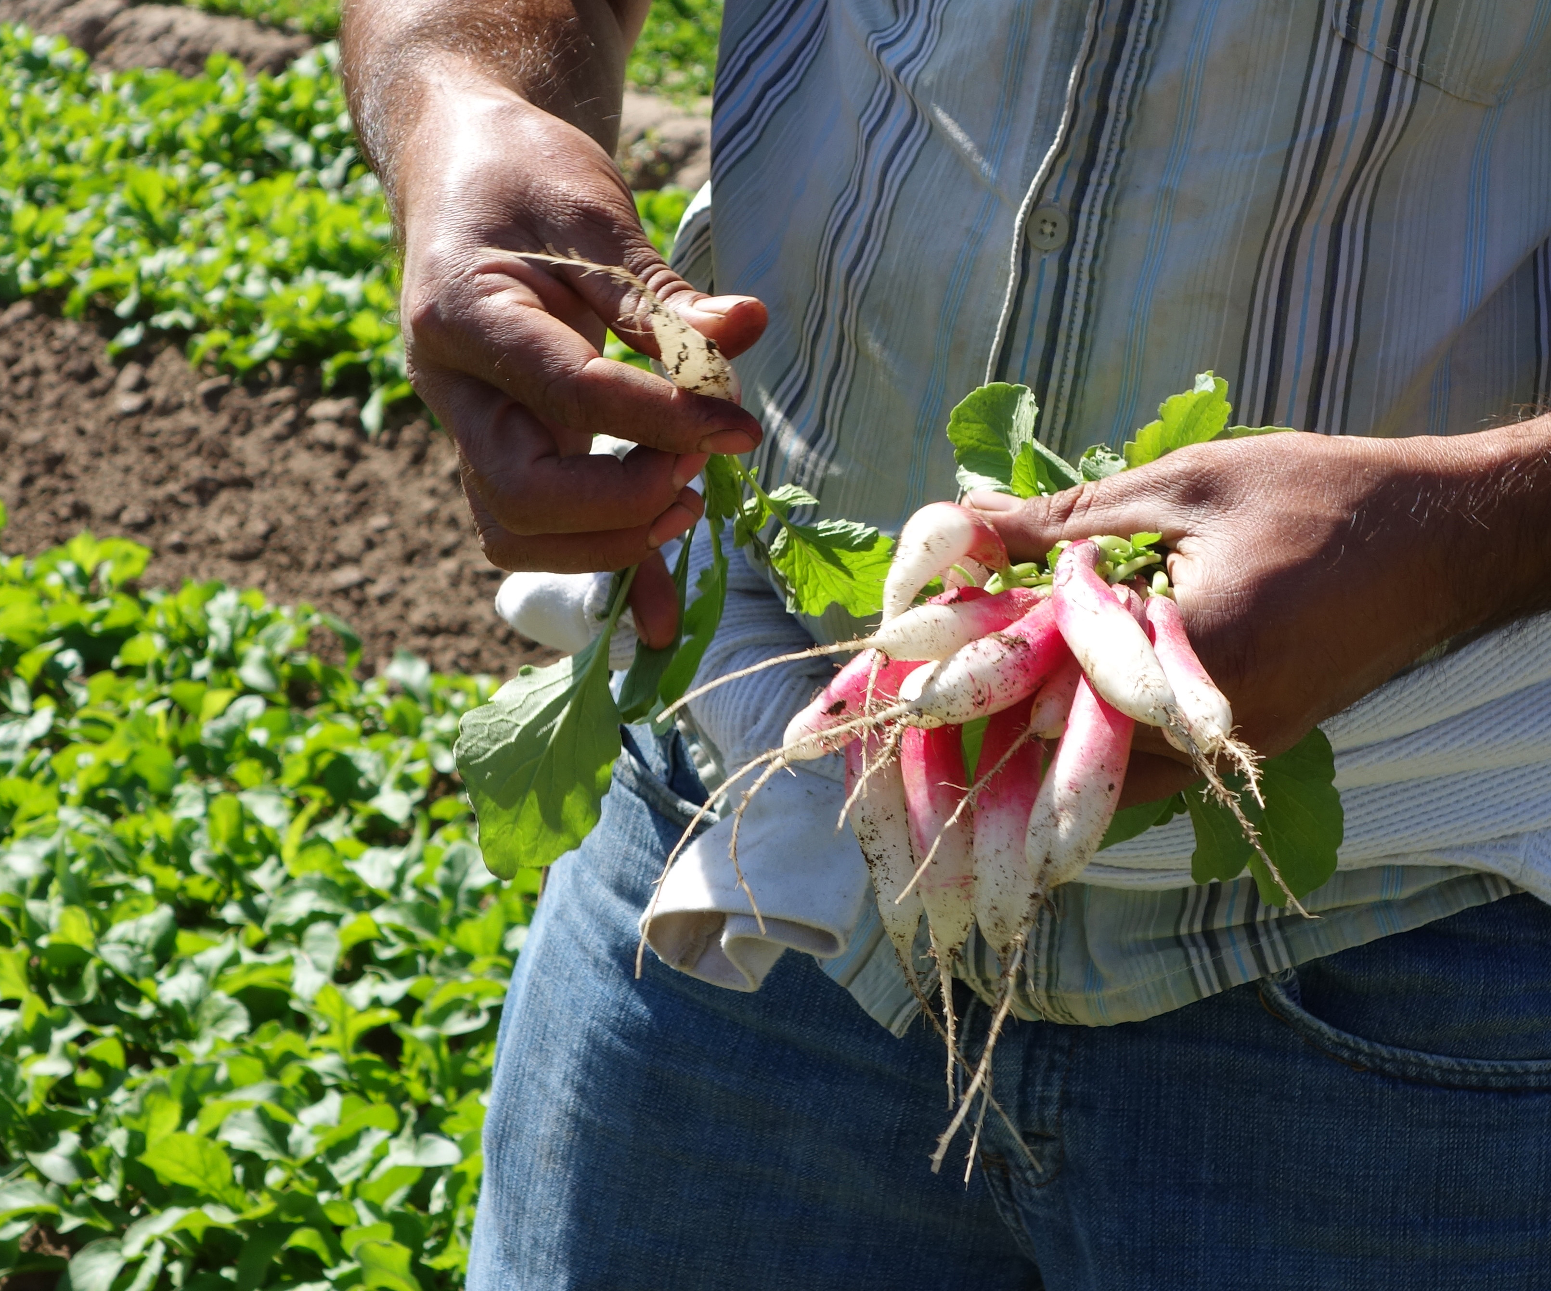
Crops such as bunched roots and greens are bunched in the field at harvest with rubber bands or twist ties. When bunching greens, place the twist-tie high enough on the leaf. If the tie is too close to the bottom, the bunches can fall apart when customers handles them. When selling wholesale, stems are not generally trimmed on the farm; retailers will trim and hydro-crisp before displaying. Photos Atina Diffley
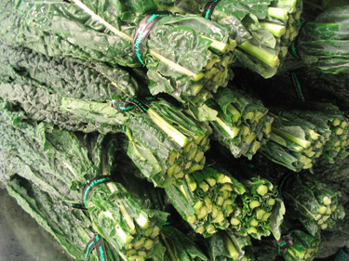
Produce that is damaged, cut, bruised, nicked, or rotten will decay faster and be more susceptible to disease. It should be pre-sorted during harvest. Unless there is an outlet for it, it is best to not bring it into the pack shed.
Some farmers like to field sort size or grade in the field into different harvest containers.

Tools and Harvest Containers and Methods
Have the right tool and method for the crop based on your farm’s scale.

Harvest containers need to meet each individual crops needs. If you have a diverse mix of crops you will likely need more than one size and depth. A shallow field tote will be needed for easily bruised crops, such as tomatoes, which can be damaged if stacked too deep. Bushel and leafy green size field totes are commonly used for the majority of crops. Many farms use five-gallon plastic buckets for sturdy root crops.

Harvest containers should be smooth, vented, and clean to reduce injury to the produce. Plastic bins are generally preferred due to their durability and smoothness, but they are more expensive than wood. Harvest containers should also be rigid, such as plastic crates and buckets, or wooden boxes. Flexible containers do not provide sufficient protection.
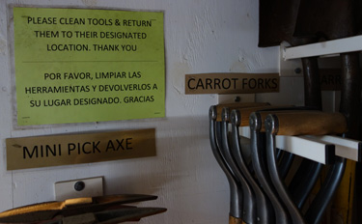
At Harmony Valley farm, tools are cleaned after use and hung in their designated location, easy to find and ready for the next task. Photos Atina Diffley.
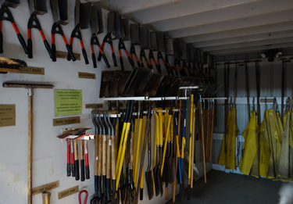

Consider weight. Filling a leafy greens field tote with potatoes won’t damage the roots but would weigh around eighty pounds. How will it be carried?

Clippers or knives used for harvesting should be sharpened and cleaned daily. Storing twist ties, rubber bands, and other field supplies in plastic containers with lids keeps them clean, dry, and easier to carry.

Preventing Handling Damage to Produce During Harvest and Transit

At harvest produce is handled and is therefore at risk of being injured. Damaged produce tends to have a shorter shelf life, be more prone to disease and decay, and appeal less to customers. Bruises take time to become visible and may not show on the fruit until some days later. Taking the proper care in handling can minimize many injuries that occur during harvest.

- Workers should remove jewelry, wear cotton gloves, and trim nails prior to harvesting.
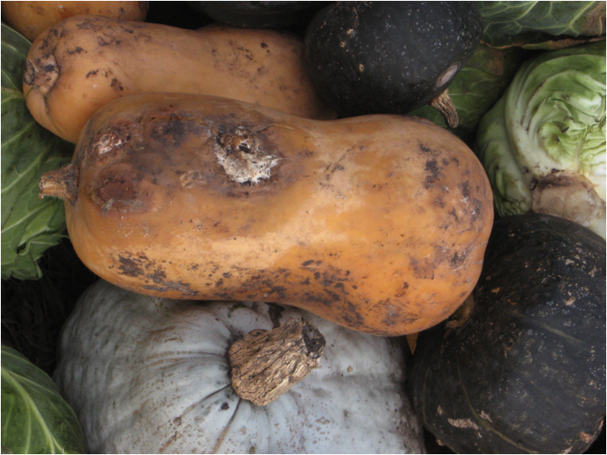
Care should be taken to set squash stems side out during harvesting to prevent scratching of neighboring fruit and later spoilage in storage. Photo Atina Diffley

- Produce should be set gently into containers, not be dropped or thrown, or “manhandled.” Produce should be seen not heard! If you can hear it hitting the container, the picker was too rough.
- Overfilling of harvest containers causes compression damage.
- Produce is prone to damage during transport from the fields to the packing facilities. Drive slowly—especially on rough roads. Take corners carefully—produce can shift in cartons. Grade field roads to eliminate major bumps. Vehicles should have adequate suspension systems, and tire pressure can be reduced to provide an extra cushioning effect.
- For crops such as tomatoes and winter squash, take care that the stem of one fruit doesn’t cut its neighbor.
- Tomatoes stems are often removed and fruit set shoulder side down in the box.

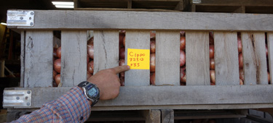
Record and Label Harvest
Recording date, yield, field number, and quality provides valuable information for later decision making. All produce that will be stored before packing should be labeled. Photo Atina Diffley

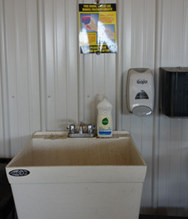
Food Safety and Harvest: People and tools can transfer pathogens. Harvest crews need access to hand washing facilities and toilets. Port-a-potties and sanitizer can be utilized in remote locations. In the photo below, Harmony Valley farm posts clear instructions and a dip tank of sanitizing water for field knives. Clean gloves and waterproof bibs hang ready for use. Photos Atina Diffley.
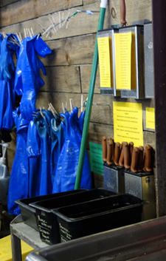
Add photo:
Food Safety and Equipment: Martin Diffley checks a harvest tractor for possible fluid leaks.

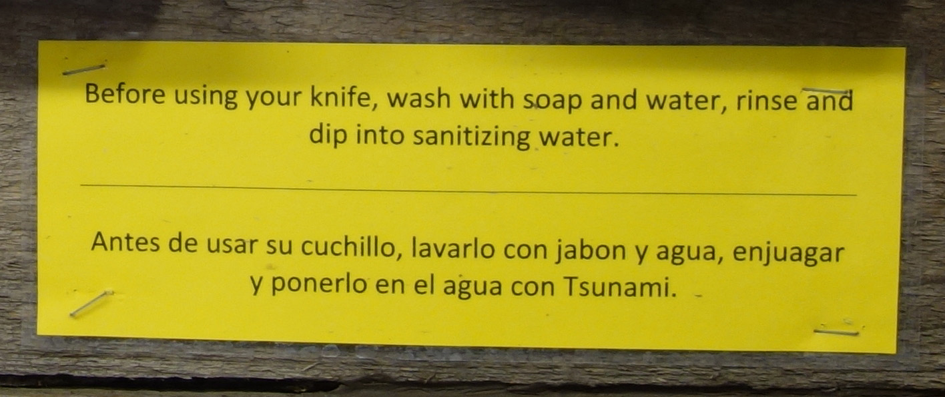

Section 3 Harvest Authors: Atina Diffley, Amanda Korane

Postharvest Handling and Cooling of Fresh Fruits, Vegetables, and Flowers for Small Farms, L. G. Wilson, Extension Postharvest Horticulturist, M. D. Boyette, Extension Biological & Agricultural Engineer, E. A. Estes, Extension Agricultural & Resource Economist, Department of Horticultural Science, North Carolina Cooperative Extension Service, July 1999
Local and Fresh Foods in the U.S. 2007. Packaged Facts. May 1, 2007.
Sustain. 2007. Organic Harvest, An Action Plan for Local, Organic, and Family Farmed Foods.
Roosevelt, M. 2005. What’s Cooking On Campus. Time: Nov. 1, 2007.
Birkerts, E. 2002. The local market opportunity for organic produce: An objective business analysis. The Prairie Partners Group, LLC.
Iowa State University. 2005. Produce Profitability Calculator. http://www.extension.iastate.edu/hrim/localfoods/calculator/index.cfm?fa=c.formLogin
IFOAM. 2007. The Principles of Organic Agriculture. http://www.ifoam.org/about_ifoam/principles/index. html

