Welcome to Market Share, a bounty of goodness from a group of local farmers!
This weeks box includes:
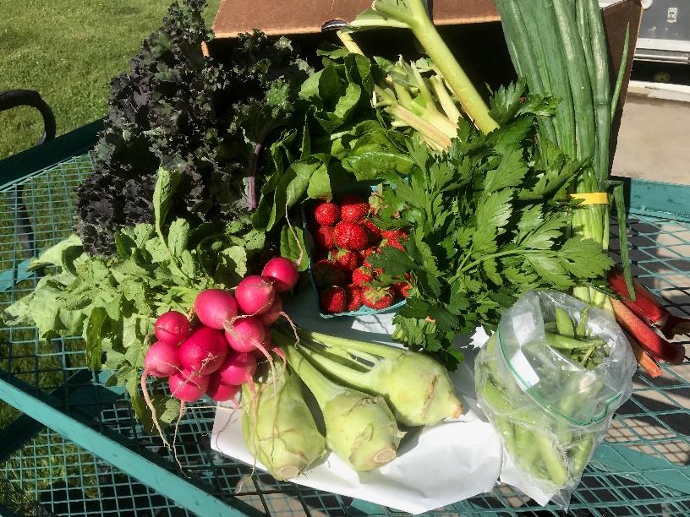
Snap Peas
Kohlrabi
Strawberries
Romaine
Spring Onions
Rhubarb
Kale
Radishes
Parsley

Did you know?
Wabasha Farmers Market has a weekly newsletter that is sent out to announce what is in season, what to expect at the market and if there are any activities happening during our normal market day? You can sign up simply by clicking on SIGN UP on our Facebook Page. Don’t forget to “DIG US” on Facebook too!
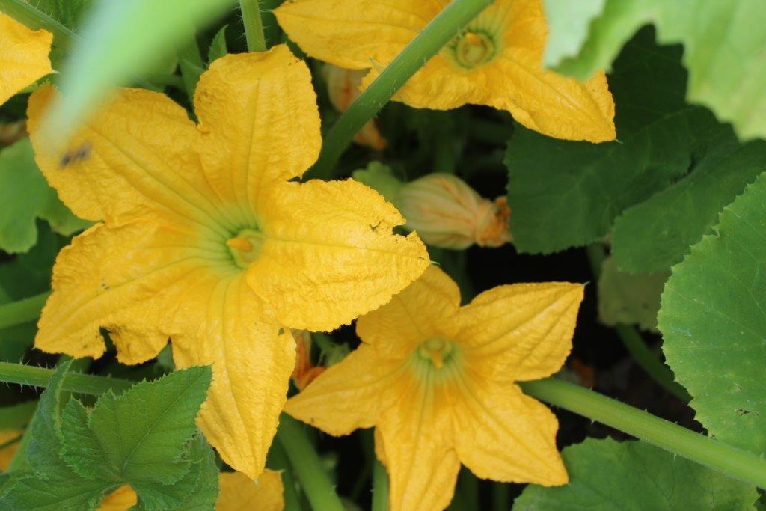
Field Report
Thanks to all the warm and wet weather, crops are moving along nicely! There is a big heat wave coming through this weekend and we anticipate the crops will really grow and love things!

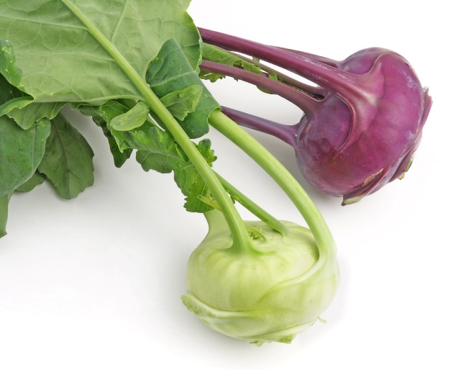
Fun Fact
What are KOHLRABI?
Kohlrabi has been created by artificial selection for lateral meristem growth (a swollen, nearly spherical shape); its origin in nature is the same as that of cabbage, broccoli, cauliflower, kale, collard greens, and Brussels sprouts: they are all bred from, and are the same species as, the wild cabbage plant (Brassica oleracea).
The taste and texture of kohlrabi are like those of a broccoli stem or cabbage heart, but milder and sweeter, with a higher ratio of flesh to skin. The young stem in particular can be as crisp and juicy as an apple, although much less sweet.
Kohlrabi stems (the enlarged vegetal part) are surrounded by two distinct fibrous layers that do not soften appreciably when cooked. These layers are generally peeled away prior to cooking or serving raw, with the result that the stems often provide a smaller amount of food than one might assume from their intact appearance.

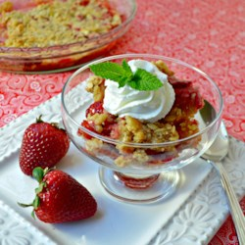
Recipes: Strawberry Rhubarb Crisp

Ingredients
- 1 cup white sugar
- 3 tablespoons all-purpose flour
- 3 cups sliced fresh strawberries
- 3 cups diced rhubarb
- 1 1/2 cups all-purpose flour
- 1 cup packed brown sugar
- 1 cup butter
- 1 cup rolled oats

Directions
- Preheat oven to 375 degrees F (190 degrees C).
- In a large bowl, mix white sugar, 3 tablespoons flour, strawberries, and rhubarb. Place the mixture in a 9x13 inch baking dish.
- Mix 1 1/2 cups flour, brown sugar, butter, and oats until crumbly. You may want to use a pastry blender for this. Crumble on top of the rhubarb and strawberry mixture.
- Bake 45 minutes in the preheated oven, or until crisp and lightly browned.
—Recipes printed From Allrecipes.com 6/28/2018

Thank you for joining us for a summer of delicious vegetables!!

