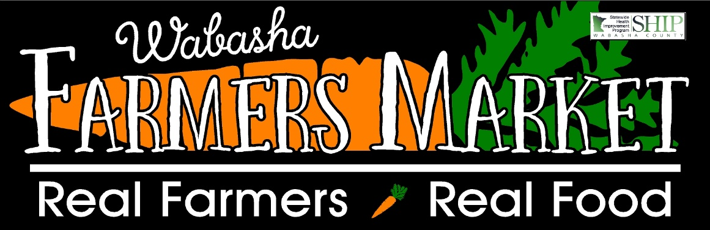

Welcome to Market Share, a bounty of goodness from a group of local farmers!
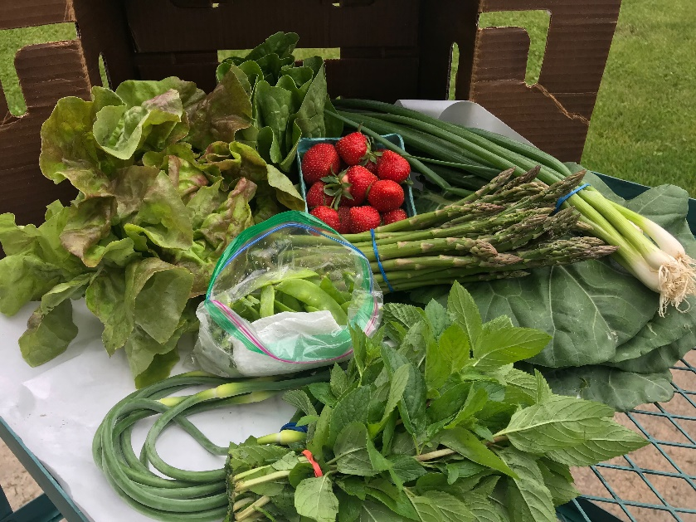
This weeks box includes:

Lettuce – two varieties red and green
Collard Greens
Peas
Spring Onions
Asparagus
Strawberries
Garlic Scapes
Mint

Please note that the first boxes are normally filled with lovely greens to enjoy. Many vegetables that you are eager to eat take longer to grow. As the weeks wear on, the boxes will get more abundant and diverse then will slowly decrease as the season comes to an end.
What is Market Share?
Market Share is a CSA model where fresh, locally grown produce will be available at drop sites weekly to be enjoyed all season long. What makes Market Share different is that we aggregate our produce. Aggregate means that we are combining the produce from local farmers to supply the boxes with a larger variety than 1 farmer would be able to do.
Deliveries will be in ½ bushel wax boxes. These boxes will be lined with wax freezer paper on the bottom as we hope to preserve them to reuse. Please remember to bring your box back to the drop site when you pick up your next market share. Consider bringing bag to transfer the produce on site if you would rather not worry about the box weekly.
Field Report
The rain this week! Wow have we had rain. Our crops love the rain, but the fields sure are muddy. With our mud boots on, we are entering the fields to do what we can. I think these babies need some nice hot sun now.
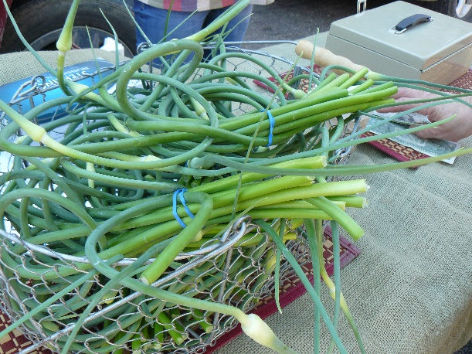
Fun Fact: Garlic Scapes

Garlic scapes are the flower bud of the garlic plant. The bud is removed in mid- to late June to encourage the bulbs to thicken up. Scapes make a fabulous addition to a flower bouquet, and they are delicious to eat! Scapes taste just like garlic.

Recipes: Collard Greens – Ingredients:
- 1/2 pound smoked meat (ham hocks, smoked turkey wings, or smoked neck bones)
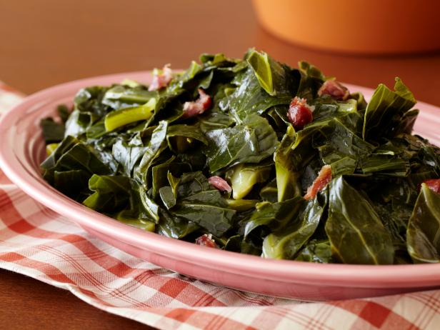
- 1 tablespoon House seasoning, recipe follows
- 1 tablespoon seasoned salt
- 1 tablespoon hot red pepper sauce
- 1 large bunch collard greens
- 1 tablespoon butter

House Seasoning:
- 1 cup salt
- 1/4 cup black pepper
1/4 cup garlic powder *recipe compliments of Paula Deen
Directions
In a large pot, bring 3 quarts of water to a boil and add smoked meat, house seasoning, seasoned salt and hot sauce. Reduce heat to medium and cook for 1 hour.
Wash the collard greens thoroughly. Remove the stems that run down the center by holding the leaf in your left hand and stripping the leaf down with your right hand. The tender young leaves in the heart of the collards don't need to be stripped. Stack 6 to 8 leaves on top of one another, roll up, and slice into 1/2 to 1-ince thick slices. Place greens in pot with meat and add butter. Cook for 45 to 60 minutes, stirring occasionally. When done taste and adjust seasoning. Serve with favorite dish as a side.
Feedback
Feedback is strongly encouraged and a very important part of any program. If you have ideas, suggestions, concerns or just want to talk, please reach out to Sara George our market manager and Market Share coordinator. I can be reached at wabashafm@gmail.com by email, home 715-442-2488 and cell 715-651-5046. Please note that I am challenging to reach as when not at the market or making deliveries I am spending time in the field so don’t give up!
Thank you for joining us for a summer of delicious vegetables!!

