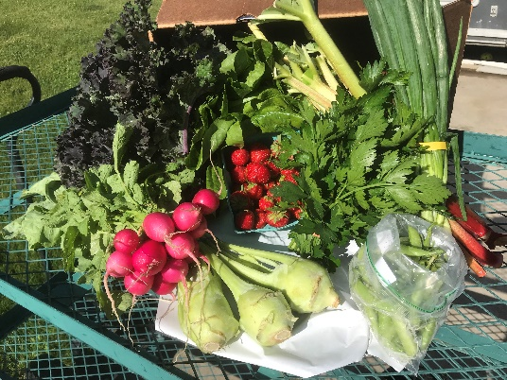
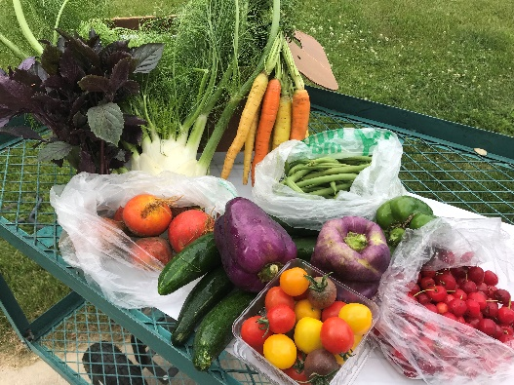
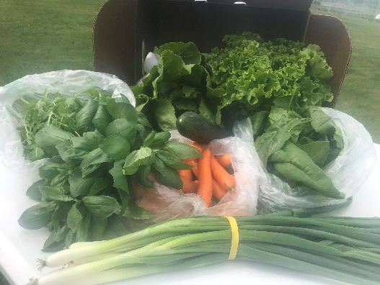
Welcome to Market Share, a bounty of goodness from a group of local farmers!
Do you enjoy the goodness of the garden, but don’t have a green thumb and never seem to make it to the farmers’ market? We are here to help — connecting you to the source of your food through one box that will save you some of the time and effort it takes to menu plan and shop each week. We all know that food that is grown closer to you is more nutritious, and less time between field to fork means longer lasting and fresher food for you. If you want a robust local food system, you have to support it, and you can do just that when you join our Market Share.

If you are looking for a consistent and convenient way to enjoy seasonal fruits and vegetables grown by local farmers, Wabasha Farmers’ Market has the program for you! The 2019 Market Share boxes.

What is Market Share?
Market Share is a CSA model where ½ bushel boxes of fresh, locally grown produce will be delivered to drop sites weekly every Thursday to be enjoyed all season long. What makes Market Share different? We aggregate our produce. Aggregate means that we are combining the produce from multiple local farmers to mix the boxes with a diverse variety of farm fresh fruits and vegetables.
A limited number of subscriptions are available for the 2019 growing season (June—October). Sign up by May 1st and you will receive a weekly delivery of fresh‐from‐the‐farm produce for you and your family!

What does it cost?
Your weekly boxes are $25. Making a full subscription of 16 boxes $400. There are two payment options, pay in full $400 at sign up, or pay $200 at sign up and the remaining $200 on August 1.
We now offer a bi-weekly option, where you receive 1 full box of produce every-other week. This would cost $25 per box and you would receive 8 boxes for $200. Again, there are two payment options, pay in full $200 at sign up, or pay $100 at sign up and the remaining $100 on August 1.

Where are the drop-sites?
You are able to choose any of the following drop sites for your Market Share Box option:
Wabasha:
- Saint Elizabeth’s Medical Center
Wellness Center
1200 5th Grant Blvd W
Wabasha, MN 55981

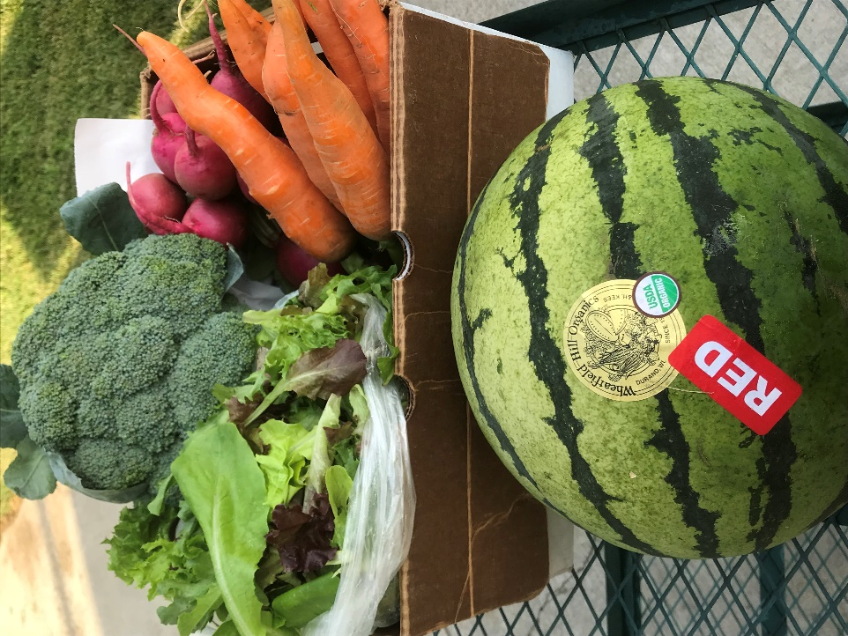
- Wabasha County Social Services Building
County Employees ONLY
411 Hiawatha Dr E
Wabasha, MN 55981

- Eagle’s Nest Coffee House
330 2nd St W
Wabasha, MN 55981
Stockholm:
- Stockholm Pie Company
N2030 Spring St
Stockholm, WI 54769
Pepin:
- D&S Gardens
In the walk-in cooler
N2074 County Road N
Pepin, WI 54759

Please make checks payable to the Wabasha Farmers’ Market. Payments can be made at the local Farmers market or you can mail them to:
Wabasha Farmers Market
c/o Sara George
N2074 County Road N
Pepin WI 54759

Feedback is strongly encouraged and a very important part of any program. If you have ideas, suggestions or just want to talk, please reach out to Sara George our market manager and Market Share coordinator at wabashafm@gmail.com, home 715-442-2488 and cell 715-651-5046.
Thank you for joining us for a summer of delicious-ness!!

