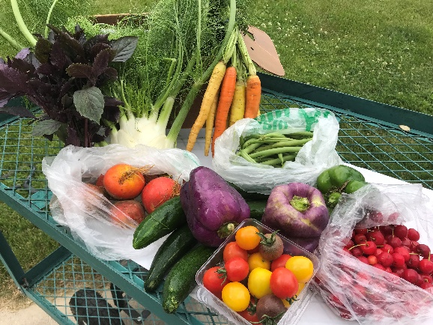
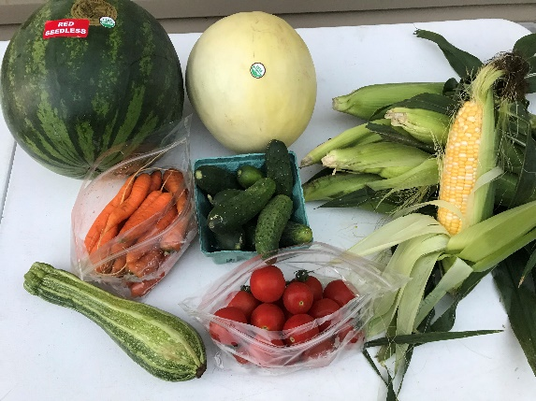
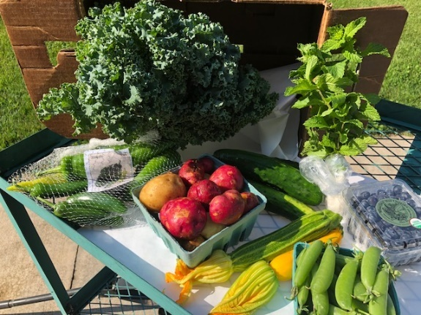
Market Share FAQ’s
Things to think about when setting up your Market Share Boxes:
- Think about convenient drop locations, good locations include:
  - Best is a large employer in town that will promote the boxes
    - Think hospitals, clinics, yoga studios, city hall
  - An institution that will intends on making purchases anyhow, makes a great drop site
  - A coffee shop
  - Something on your normal route

- Think about box frequency
  - It is common for people to “share boxes”. My challenge was how do you split a watermelon? Cantaloupe? Cabbage? Lettuce? (I tried, even to the point where I was putting 2 in each)
  - An idea is to offer a weekly box for the faithful veg eaters and a bi-weekly option for those that prefer smaller portions.
- Think about pricing
  - Do not make Sara’s mistake! If your box is $25 do not put $25 worth of produce in said box! Your market needs to make money on this.
  - The more money it is, the more hesitant the buyer seems to be.
    - Wabasha current prices are $25/box. 16 weekly boxes is $400, 8 bi-weekly boxes $200. Should there be an upcharge for the smaller box purchase?
- Think about marketing
  - Facebook and Local Line are no brainers! They are both free, and very effective.
    - A paid facebook ad brought me a lot of sales in 2019
  - Contact your local businesses and see if they can share it with their staff
  - A sign at your drop site
  - Your farmers can each share the information (Facebook, word of mouth and events that they attend are great places!)
  - Press release in local newspaper
  - Newspaper ad
  - Talk about it on the radio
  - Your town’s for Facebook for sale sites
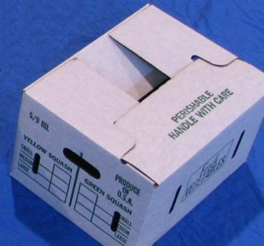
- Think about what boxes you plan to use
  - If you sell 20 Market Share CSA’s; you will need approx. 50 boxes.
    - You will drop one off and they return it the next pick-up so you need 2 per customer with about 25% of people forgetting to bring their boxes back.
  - If you intend to re-use boxes, you should use a plastic liner so that you keep the box in good condition. (for food safety reasons as well).
  - Boxes can be purchased from Jordan Seeds

- Think about your farmers.
  - Who has product available in quantities?
  - You will want to have farmers that are good at communicating.
    - Ideally a text or phone call a couple days prior to market **you set the day/time
    - Ask those farmers to bunch it up. Say you have 20 bunches of kale and they only give you a box of kale. You then have to bunch it. NO! You are selling it for them, they can pre-bunch it.
  - Farmers that are not reliable are difficult to have participate
  - Think outside the market, which local farmers are around that you can lean on?
    - Maybe charge a membership fee or something to participate
    - Make sure that they have food safety plans and water tests and use them!

- Think about traceability
  - You are required to be able to say who provided the kale that is in the box. Who provided the spinach etc. What Sara did was only allow farmers that had enough for every box. i.e. 20 bunches of kale
Check # once paid
  - An example of traceability is seen below. What date, what farm, what product.
 |  |  | Market Share 2 (20) |  |  |  | $3,306.00
#1355 | June 20, 2018 | Many Hands Farm | Strawberries | $ 2.50 | $50.00 |  | $3,256.00
#1355 | June 20, 2018 | Many Hands Farm | Asparagus | $ 2.50 | $50.00 |  | $3,206.00
#1355 | June 20, 2018 | Many Hands Farm | Lettuce | $ 2.00 | $80.00 |  | $3,126.00
#1355 | June 20, 2018 | Many Hands Farm | Scallions | $ 2.00 | $40.00 |  | $3,086.00
#1355 | June 20, 2018 | Many Hands Farm | Garlic Scapes | $ 2.00 | $40.00 |  | $3,046.00
#1353 | June 20, 2018 | Good Turn Farm | Collard Greens | $ 1.75 | $35.00 |  | $3,006.00
#1353 | June 20, 2018 | Good Turn Farm | Mint | $ 2.00 | $40.00 |  | $2,971.00
#1351 | June 20, 2018 | Barefoot Gardens | Snow Peas | $ 2.00 | $40.00 |  | $2,935.00

# of boxes
Amount per box
Total amount due
Running balance

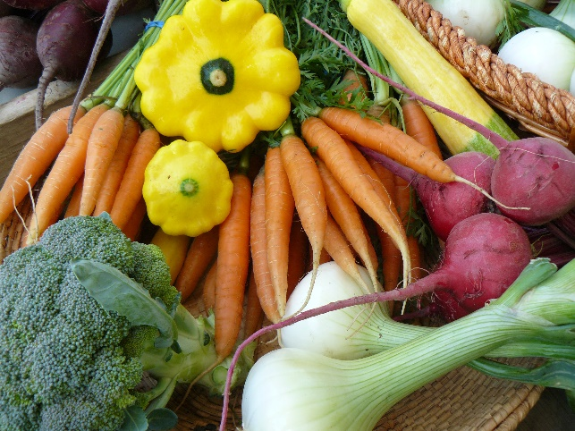
- Think about variety and color.
  - There are some “common” things that people come to expect in CSA boxes. That includes carrots, tomatoes, beans, peas, lettuce, cucumbers, peppers. These can go in often.
  - People like to try something new but not too often. Once per box you can try a kohlrabi or okra or celeriac. But don’t fill it with new and unusual things or they will not know what to do with any of it.
  - Pair herbs with appropriate items. For example: tomatoes, peppers and cilantro; cucumbers and dill; basil and tomatoes

- Recipes
  - So it is helpful to have a flyer go with each box.
    - Identify each item in the box
    - Have a recipe for any unusual item
    - Do fun facts on items
    - Take photos, customers love photos
    - Talk about what’s coming, what’s almost gone, what there could be canning deals on
    - Have some information about the market on there. Maybe some special events you have coming up, kid’s programs, volunteers needed
  - In order to have a flyer in each box, you either need to aggregate off site, have a printer at the market OR email the flyer. So, be sure to capture their email addresses!!

- First Boxes – add this note!!
  - Please note that the first boxes are normally filled with lovely greens to enjoy. Many vegetables that you are eager to eat take longer to grow. As the weeks wear on, the boxes will get more abundant and diverse then will slowly decrease as the season comes to an end.

- Encourage communication

- Have fun!
