TRANSITIONING TO ORGANIC?

Scholarships Available to Minnesota Dairy and Crop Producers

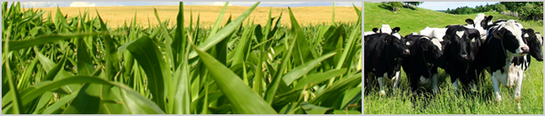

The transition from conventional to certified organic practices is a three-year process for crop and pasture production. Effective financial management during this time is important for short and long-term farm prosperity. However, very little “real world” information is available about the financial performance and profitability of farms during transition.
If you are a transitioning or recently certified organic dairy and/or row crop farmer in Minnesota, you are invited to participate in the “Tools for Transition” project. As a participant, you will:
- Enroll in the Farm Business Management (FBM) education program.
- Receive a scholarship worth up to 90% of FBM tuition fees.
- Meet in small groups and one-on-one with farm business management instructors to develop accurate business records, financial statements for your farm (eg. cash flows, projected profitability statements, balance sheets, and risk analysis), and annual farm business analyses.
- Use your new statements to monitor your financial performance during transition, map progress toward personal goals, and, most importantly, make informed business decisions for your own operation.
Financial data from your farm business will be privacy protected and combined with data from other farms to ensure confidentiality. This information will then be compared with financial data from certified organic and conventionally managed farms to identify financial challenges and farm business opportunities for transitioning farmers.

AM I ELIGIBLE TO RECEIVE A SCHOLARSHIP?

You are eligible to receive a scholarship if you are a:

- Dairy and/or crop farmer who is beginning or currently in the process of organic transition (previous participation in FBM does NOT disqualify you from this opportunity).
- Dairy and/or crop farmer who has been certified organic for less than three years.

You must enroll in the FBM education program and share your farm data to receive a scholarship.

HOW MUCH ARE THE SCHOLARSHIPS?

Scholarships equal up to 90% of the FBM tuition fee. Scholarships will be offered annually for up to three years to farmers who are in transition. For “newly certified” farmers (certified fewer than three years), scholarships will be offered on a sliding scale as follows:

- 80% of the tuition fee during the first year of participation
- 70% during the second year, and
- 60% during their third year.

Participants pay the remainder of the tuition fees. For example, if FBM tuition is $1,500/year, a farmer who is in transition will receive a scholarship equal to $1,350 and will be responsible for paying the remaining $150 annually.

HOW DOES THE FBM PROGRAM WORK?

In Minnesota, the FBM program is offered by the Minnesota State Colleges and Universities (MnSCU) system and the Southwest Farm Business Management Association. There are more than 70 instructors conveniently located throughout Minnesota. As a student in the program, you will meet in small groups and on an individual basis with a FBM instructor. The instructor will tailor an education program to meet your business management needs. At the end of the year, you will receive a whole farm analysis and enterprise analyses that detail the financial performance of your farm business. Your financial results will be privacy-protected and included in FINBIN, an online benchmarking tool which is made public through the University of Minnesota’s Center for Farm Financial Management. More than 125 certified organic farmers in Minnesota have participated in the FBM education program. To view their financial results, visit the Minnesota Department of Agriculture website and look for “Organic Farm Performance in Minnesota 2009”: http://www.mda.state.mn.us/food/organic/bizmgmt.aspx.
HOW DO I SIGN UP FOR PROGRAM?
.

Contact Meg Moynihan at the Minnesota Department of Agriculture to learn if you qualify for a tuition scholarship. This pre-screening process is simple and quick – you will be asked a couple of questions to ensure that you qualify for the “Tools for Transition” FBM Scholarship Program. Then you will be assigned to a farm business management educator who will take care of the rest! Scholarships will be awarded on a first-come, first-served basis. Meg Moynihan, Minnesota Department of Agriculture, 651-201-6616 or meg.moynihan@state.mn.us.

The Tools for Transition project is funded by the USDA National Institute of Food and Agriculture’s Organic Agriculture Research and Extension Initiative and is administered in partnership by the University of Minnesota, Minnesota Colleges and Universities, Minnesota Department of Agriculture, and Minnesota Institute for Sustainable Agriculture.
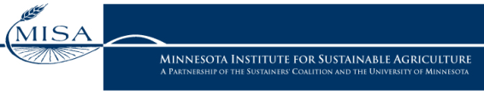
In accordance with the Americans with Disabilities Act, an alternative form of communication is available upon request. TDD: 1-800-627-3529.
An Equal Opportunity Employer and Provider.

