Team SOS (Second Opinion Strategy)

Description of business idea
This is an integrated, equitable strategy to new food business licensing that is both more effective and efficient than current practices for businesses that don’t fit traditional models. Team SOS provides a system in which integrated resources and information result in the successful licensing and launch of innovative food businesses in MN.
Rationale
The rules and regulations that govern food businesses in MN are many and complex; and open to sometimes inconsistent interpretations by regulators. The statutory basis for regulations must go through legislative processes for change and therefore is difficult to update for current conditions. The current regulatory climate creates significant barriers to innovative food business models that are challenging to fit within existing food safety and regulatory requirements. The current regulatory system is not user-friendly, is not well coordinated across regulatory agencies, and is not efficient at licensing innovative businesses within a reasonable time-frame. As a former regulator said, “The current system cannot be explained to the average person. That needs to change”.
Under the current system, entrepreneurs with innovative ideas sometimes feel that they are faced with a choice of having to modify their original plan to adapt to a more “traditional” model, or give up on their idea altogether, or end up waiting for long periods to start their business while licensing issues are resolved.
This is especially problematic in our food business environment where the pace of innovation has increased over the last 5-10 years in MN (see trend below).

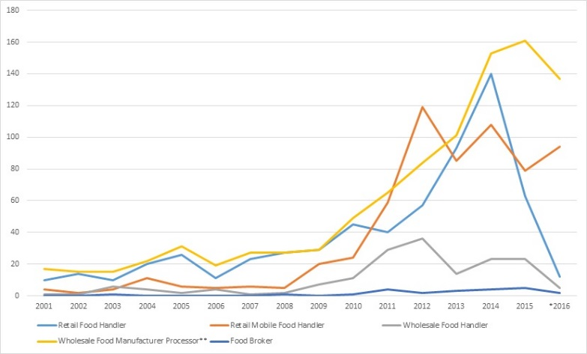

University of MN president Eric Kaler has said that “Minnesota is the Silicon Valley of the food industry”. In addition, the MN Cup created in 2013 a new division: The Food, Agriculture & Beverage Division, which is designed as a way for the region’s food community to support and foster MN’s entrepreneurs and their innovative ideas. What is less well-known even within this award-winning food business community is the extent to which food regulatory issues can pose barriers to new and innovative start-ups.
In 2015, Minnesota’s sustainable agriculture and local food community received a Bush Community Innovation Grant to examine ways to create a strategy that “promotes food safety and economic development through a user-friendly food business regulatory system which is coordinated, reliable and efficient”. I participated in these conversations and offered one strategy which I call Team SOS. Team SOS will work with entrepreneurs and regulators to license new food business models effectively and efficiently.
Inspectors, supervisors and commissioners of the regulatory agencies are aware of the need to improve the system that licenses new, innovative food businesses and are committed to facilitating a new approach. However, staff and funding shortages along with a lack of receptivity to new practices have hampered progress to consider or implement new models of licensing.
Currently, regulators meet the demand to license more complex or difficult models via informal meetings. However, these meetings are not part of an official process, are not mandated and may face elimination as new staff and commissioners come and go. The current internal culture at the MN Department of Agriculture is conducive to new approaches to solve this issue: the Team SOS idea has been favorably received; and in fact has been partially implemented by current MDA staff to assist with complex licensing issues faced by inspections field staff. The drawback of this current MDA effort is that it includes only higher-level regulatory staff. The Bush Foundation-funded project demonstrated that inclusion of the entrepreneurs themselves as well as representatives from the sustainable agriculture and local food communities led to more rapid identification and resolution of issues.
Waiting a few more years to implement this idea will have the following negative effects: Increased frustration from food entrepreneurs; potential erosion of customer service from the regulatory agencies as the flow of innovative ideas increases; the continued perception that regulators impose arbitrary roadblocks and do not facilitate innovation; increased mistrust and frustration between regulators and food entrepreneurs; the possibility of anti-innovative changes in the internal culture of the regulatory agencies (e.g. with a new commissioner might come new priorities that do not include facilitating licensing of new models.
Target Market
Team SOS helps the food entrepreneur in MN who is facing difficulties in solving licensing issues. These difficulties include a longer than expected time to resolve licensing issues, a lack of a business plan that meets regulatory standards, or a new model that requires adjustment or interpretation to fit into regulatory categories. Team SOS will meet with the entrepreneur, discuss his/her plan, , work through matching-up of proposed operations to regulatory requirements, and establish a reasonable timeline for a plan review and final inspection and licensing. Team SOS will keep track of cases it hears. It will do the following.

The numbers

There are more than 1,600 calls that MDA fields every year from people inquiring about starting a food business in MN. Only 300+ licenses are granted every year. Even a 10% increase in the number of new food businesses getting a license would translate into vibrant, innovative food businesses climate, more businesses opening in MN, and the addition of new jobs and economic benefit to the state.

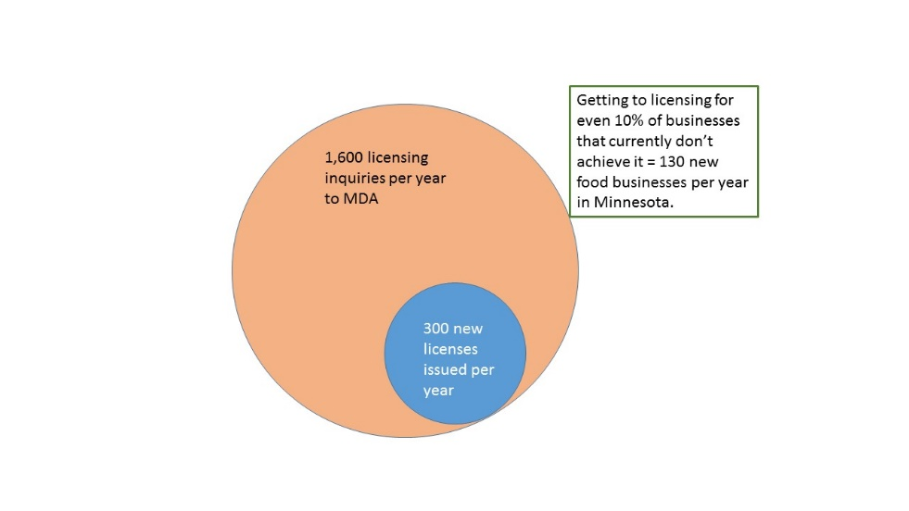

Food entrepreneurs currently operating under exemptions or exclusions from licensing are a pool of potential future licensed food entrepreneurs. Potential food entrepreneurs who could be helped by this new SOS Team number into the hundreds:
Direct marketing farmers, farmers’ markets, and value-added food processors listed in Minnesota Grown directory | 1,027
Farmers’ Markets in MN (some overlap with previous number) | 220
Farmers’ Market vendors in MN | 5,000-6,000
Cottage Food Operators – Tier I (up to $5,000 in annual sales) | 1,321
Cottage Food Operators – Tier II ($5,001 to $18,000 in annual sales) | 79
Minnesota School Districts with Farm-to-School programs | 268

Why this approach?

Trust and expertise are essential to develop effective interactions between entrepreneurs and regulators. Team SOS provides a collaborative environment where new business owners and highly trained regulators, together with business experts and local food advocates, can find an effective and efficient path to licensing.
In addition, this approach has the benefit of helping regulators and educators learn how food entrepreneurs access information and how they access initial points of contact with the agencies. The Team will collect and evaluate this information from entrepreneurs and provide recommendations for improving the websites and outreach tools of the MDA and MDH. : This is the “smart” component of the system.

Agency participation in Team SOS will be mandated at the legislative level. Regulators from MDA (and MDH when needed) will have authority and extensive experience to interpret and navigate the complex rules and regulations. Representatives of business organizations such as DEED and food systems advocates such as RTC will participate on an as-needed basis. These positions may be voluntary or mandated. Legislative funding for participation of organizations would facilitate an equitable approach to Team SOS, ensuring a cross-organization composition of the team.

The Team SOS approach was piloted through the Bush Foundation-funded project, and found to produce a successful outcome. For example, the Wabasha Farmers’ Market achieved licensing for aggregation and distribution of vendors’ excess produce. The team approach directly facilitated this result, after 18 months of delay due to difficulty in resolving licensing questions between the farmers’ market manager and the local inspector.

Competition/Similar approaches

The City of Minneapolis implemented a 311 system in 2005 in response to difficulties new business owners encountered with the licensing process. Minneapolis hires four “coaches” who take initial calls and route them to the appropriate agencies. Each call that comes in is given a case number and tracked until satisfactory resolution. The time for licensing new food businesses went from 60 days or more to less than 10 days.
The Team SOS approach is a more personal and equitable system, where the food entrepreneur, having reached a barrier to licensing via the current system, requests a hearing at a meeting of the SOS Team. Step one is the initial meeting, where the model is discussed and solutions to the barriers are found. The food entrepreneur then leaves the meeting with a case number and a list of instructions for “next steps” that must be implemented within a mutually-agreed time frame. Step Two is the plan review. Step three is the final inspection and licensing.
Market Entry Point and Business Model

New food businesses that encounter barriers to licensing will engage with Team SOS. These are the businesses for which a local inspector has decided the model, as such, may not be licensed; or the inspector lacks the experience to deal with the model. The Team must have representatives from the agencies (mostly MDA, but MDH as needed). This presence has to be mandated by legislation in order for it to be stable and not vulnerable to staffing changes at the agencies. Those regulators present must be high level inspectors/supervisors, with the authority to interpret statute and adapt models. Regulators must be free to suggest alternative plans that will allow compliance with regulations. The team must be fluid to be equitable: representatives from various organizations will be “on-call” as the need for their services arises with each new business model presented to the Team. The Team will provide information to MDA on how to improve point of entry layout (website information layout), and on how to improve messaging for communication with entrepreneurs. This is the “smart” component of the system. The Team will also identify rules and regulations that need to be changed to accommodate new business models while protecting food safety.

Economic impact
The economic impact of adopting this model will be felt across MN with the addition of innovative businesses and jobs to the local economy. Initially, the legislature will mandate the formation of this group and appropriate funding for the equivalent of one FTE position to be housed within MDA. Representatives of DEED and non-profits volunteer their time. MDA is mandated to participate. The cost to the entrepreneur will be $200. Estimated revenue first year: $200 x 30 new models: $6,000. Estimated number of new businesses helped during the first year of implementation: 15 (a 5% increase from current levels). Estimated number of new jobs created because of Team SOS: from 15 to 30 or more
Potential interest for venture capitalists
Team SOS handles all types of food entrepreneurial licenses. Participating in the meetings where these are considered, provides the venture capitalist with a first review of models worthy of investment. The bigger payoff is in the potential to invest in the most novel and current of food business models.

