PROPOSAL FOR IMPROVING FOOD LICENSING
FOR SMALL BUSINESS

Economic upheavals and the lure of the local food movement have inspired unprecedented numbers of Minnesotans to start food businesses.

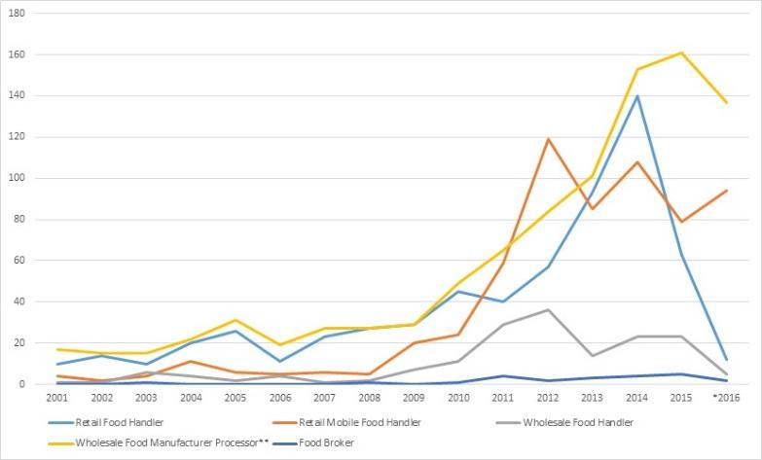
2010 to 2016: 150% in number of food business licenses issued.

Mostly:
* retail food handler
* food manufacturer
license types used by small and mid-size food entrepreneurs.

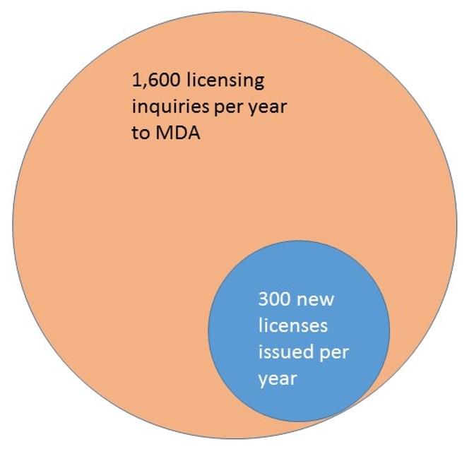
Just 10% more of these inquiries getting to licensing =
130 more food businesses per year in MN
Not all license inquiries succeed, for many reasons.

Surveys by MDA found that about 80% of food license applicants received helpful to very helpful information and a timely response to their requests, but about 20% were not satisfied with either response or timeliness.

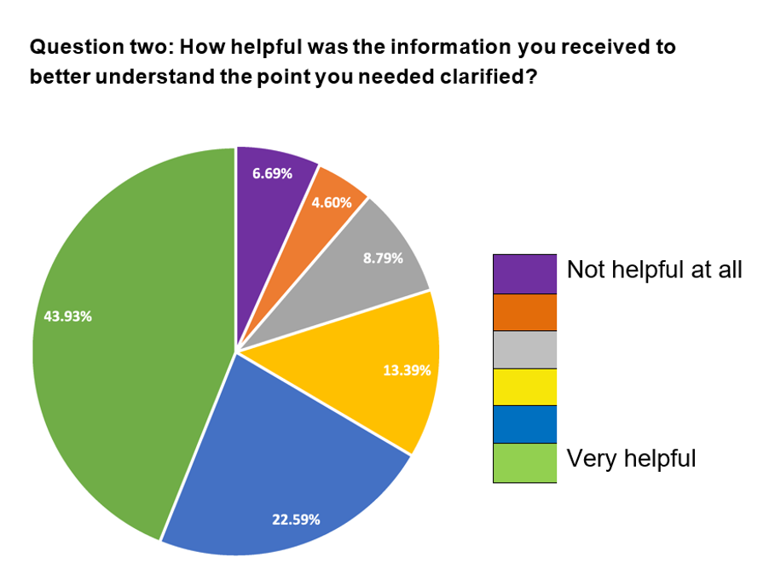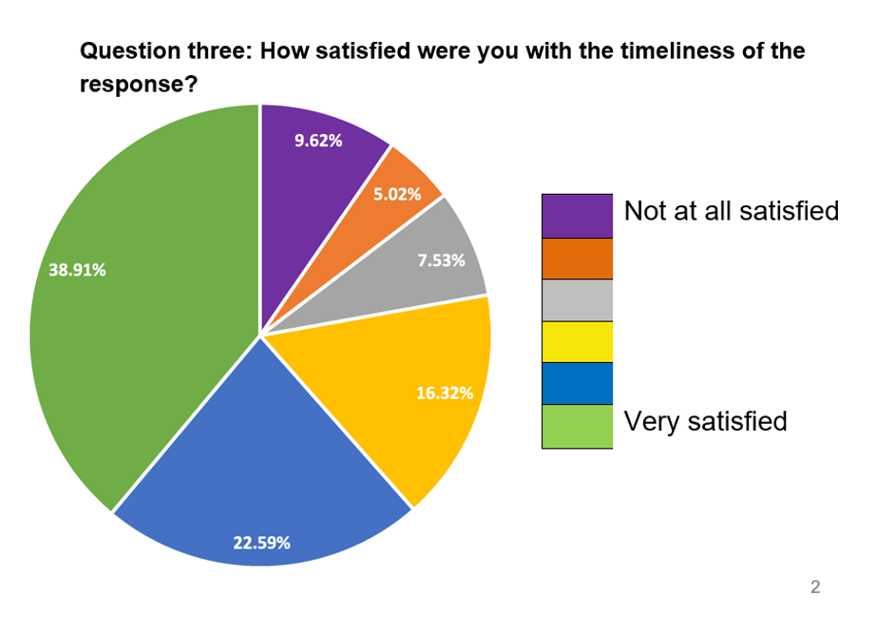

Some innovative enterprises become tangled in unclear regulatory language | Example:  Wabasha Farmers’ Market took:  18 months  +  involvement of farm groups  +  meeting with MDA staff  to achieve licensing for innovative local produce distribution enterprise. | Delays are especially costly to small business

SMOOTHER, MORE CONSISTENT REGULATORY PROCESS
A new MDA “Food Business Innovation Coordinator” position backed up by a team of experts would clear the path to licensing, providing both consistent regulatory interpretation and timely decision-making.

- One FTE Coordinator for food business innovation housed at MDA (how does this related to existing licensing liaison?)

- SALT: Solution Advisory Licensing Team
  - Regulatory specialists from MDA and MDH
  - Experienced business entrepreneurs
  - Representatives of economic development agencies/DEED
  - Food system advocates

IMPROVED CLIMATE FOR SILICON VALLEY OF FOOD
The SALT Team will serve the innovative food entrepreneur
while protecting food safety.

The coordinator and team would:

- have authority to issue definitive interpretations of statute and rule
- Convey decisions and interpretations back to MDA and MDH staff trainers and field-level staff for implementation in the field.

