PROPOSAL FOR IMPROVING FOOD LICENSING
FOR SMALL BUSINESS

Unprecedented numbers of Minnesotans are attempting to start food businesses.

From 2010 to 2016, there was a 150% increase in the number of food business licenses issued.

Most of the increase came in retail food handler and food manufacturer licenses, the license types most used by small and mid-size food entrepreneurs.

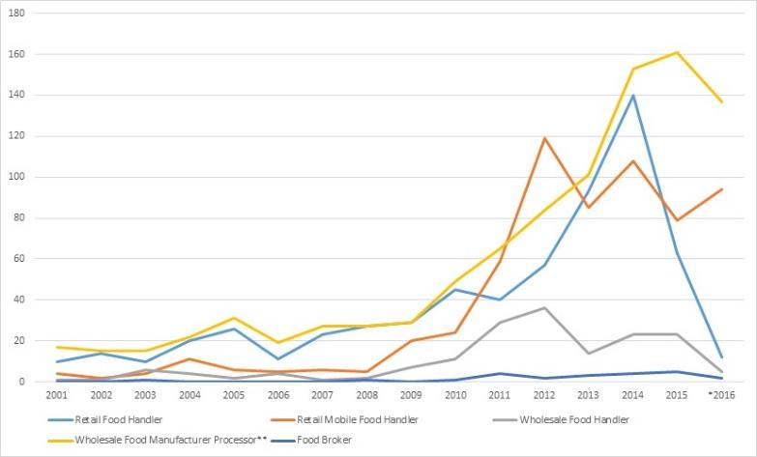

License requests more than doubled between 2010 and 2014, but not all inquiries or requests lead to successful licensing of a new food business.

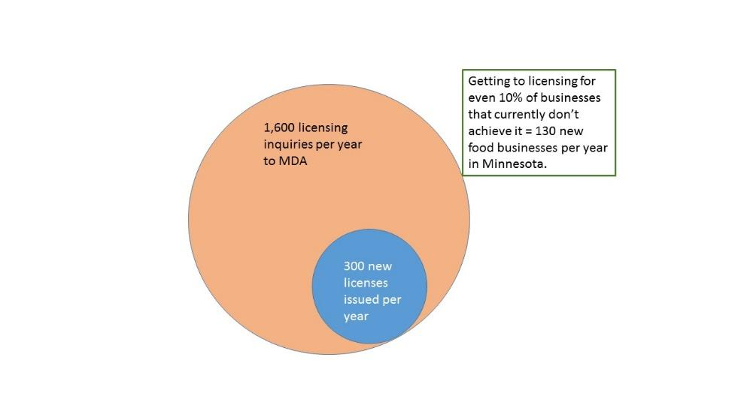

Many small- to mid-scale food businesses are innovative in nature. Their business models may not be fully reflected in statute and Rule governing food safety in Minnesota.

Surveys by MDA found that 80% of food license applicants received helpful to very helpful information in response to their requests, but 20% were not satisfied. Similarly, 78% of applicants were satisfied or very satisfied with timeliness of response, but 22% were dissatisfied. (reference Pareto principle?)

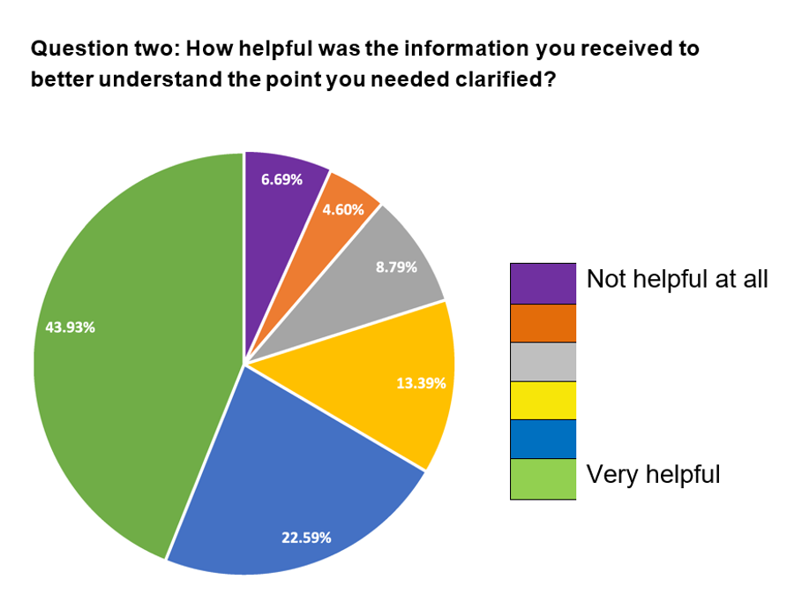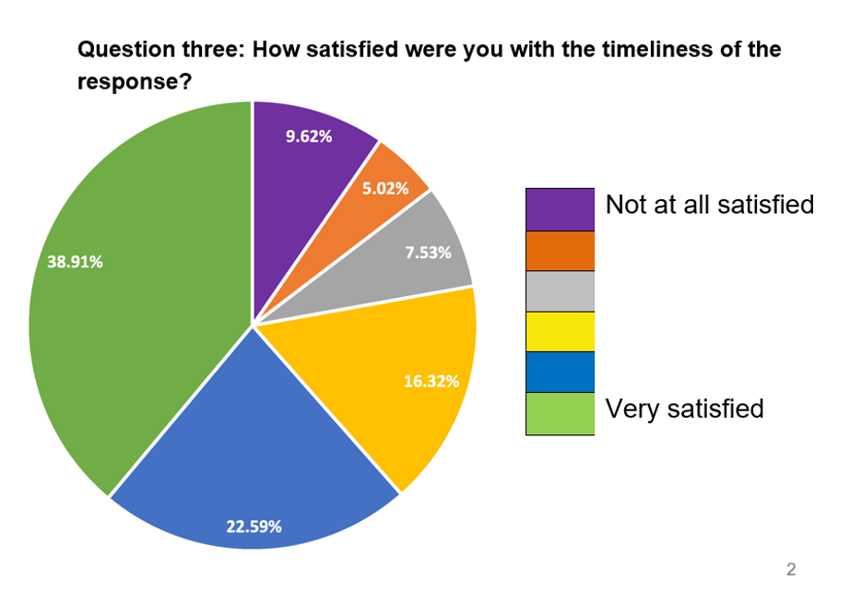

Yet, the 20% to 22% not satisfied likely includes the most innovative entrepreneurs, who could move Minnesota’s food economy forward. (reference Pareto principle?)

Some innovative food models become tangled in unclear regulatory language, resulting in delays and confusion during the licensing process. These delays are especially costly to small businesses. [Insert example here]

Currently regulators meet the demand to license complex business models via informal meetings. However, these meetings:
* are not part of an official process
* are not mandated
* may face elimination as staff and commissioners change.

SMOOTHER PROCESS
A new MDA “Food Business Innovation Coordinator” position backed up by a team of experts would clear the path to licensing, providing both regulatory interpretation and timely decision-making. Where different interpretations arise among regulators, this group would push through to a decision and prevent complicated cases from languishing in limbo.

- One FTE Coordinator for food business innovation housed at MDA (how does this related to existing licensing liaison?)

- SALT: Solution Advisory Licensing Team

  - Regulatory specialists from MDA and MDH
  - Experienced business entrepreneurs
  - Representatives of economic development agencies/DEED
  - Food system advocates

IMPROVED CLIMATE FOR SILICON VALLEY OF FOOD
The SALT Team’s number one priority will be to serve the innovative food entrepreneur and to relieve the burden on inspectors of handling the most complex cases.
Its mandate would be to move the licensing or approval process to conclusion in complex cases.

The coordinator and team would:
* work closely with MDA and MDH inspection supervisors
* have authority to issue definitive interpretations of statute and rule
* Convey decisions and interpretations back to MDA and MDH staff trainers and field-level staff for implementation in the field.

GOOD FOR AGENCIES
A coordinator liaison position housed at MDA would receive calls from entrepreneurs and inspectors, do troubleshooting, track problem areas and monthly convene a team of highly experienced government and private sector specialists. This would relieve the burden on individual inspectors and support them in handling complex cases.

The Coordinator and SALT team would interpret regulations and facilitate licensing process for those businesses operating in unclear areas of the regulatory system.

IMPROVED REGULATORY PROCESS
The current process can be costly and time-consuming, delaying or stopping many food start-ups. This hurts the state’s business climate and creates additional hostility to regulation. In addition, many food entrepreneurs currently operating under exemptions or exclusions from licensing are a pool of potential licensed operators who can more fully support the costs of regulating the industry.

