PROPOSAL FOR IMPROVING FOOD LICENSING
FOR SMALL BUSINESS

A flourishing number of Farmers’ Markets across Minnesota and economic disruptions of the recession have pushed unprecedented numbers of Minnesotans into starting their own food businesses. Many of these businesses are innovative in nature and not reflected fully in statute and rules governing food safety and production in the State of Minnesota. Some innovative food models become tangled in a regulatory web that doesn’t offer clear language resulting in delays and confusion during the licensing process. These delays are especially costly to small “mom and pop” businesses.
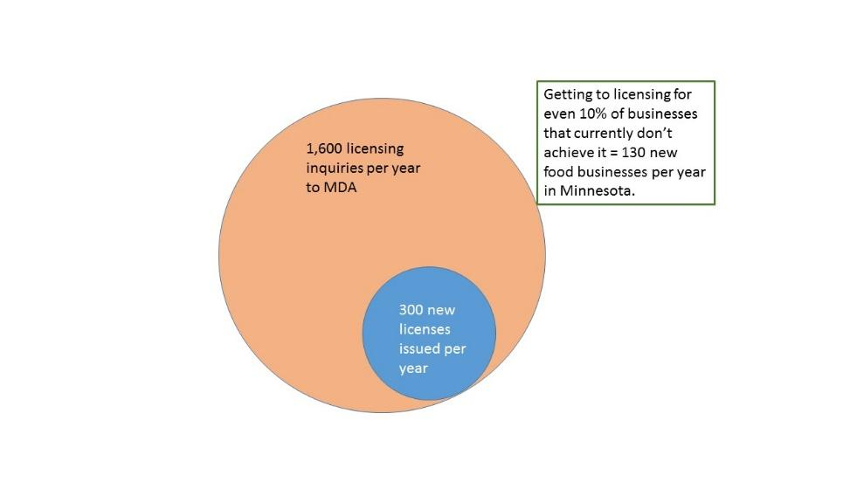
From 2010 to 2016, there was a 150% increase in the number of food business licenses issued; license requests more than doubled between 2010 and 2014. While there is no tracking mechanism for how many food businesses fall victim to regulatory hurdles, anecdotal evidence among farmers’ market managers indicates the number could be considerable.

Currently regulators meet the demand to license complex business models via informal meetings. However, these meetings are not part of an official process, are not mandated and may face elimination as staff and commissioners change.
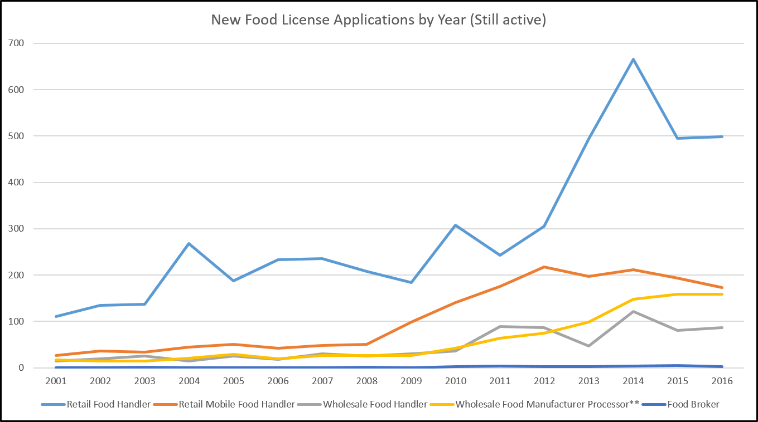

SMOOTHER PROCESS
A new MDA position backed up by a team of experts would clear the path to licensing, providing both regulatory interpretation and timely decision-making. Where different interpretations arise among regulators, this group would push through to a decision and prevent complicated cases from languishing in limbo.

- Coordinator level liaison for licensing housed at MDA (how does this related to existing licensing liaison?)

- SALT: Solution Advisory Licensing Team
A team of regulatory specialists from MDA and MDH to remove regulatory roadblocks and create more optimal functioning of food licensing at the state level. The team of high-level representatives from MDA and MDH would be joined by experienced business entrepreneurs, as well as representatives of economic development agencies and the Department of Employment and Economic Development (DEED). (Proposed number of reps?)

IMPROVED CLIMATE FOR SILICON VALLEY OF FOOD
The SALT Team’s number one priority will be to serve the innovative food entrepreneur and to relieve the burden on inspectors of handling the most complex cases.

The coordinator and team would work closely with MDA and MDH inspection supervisors and have authority to move the license process to conclusion and avoid “limbo” situations.

GOOD FOR AGENCIES
A coordinator liaison position housed at MDA would receive calls from entrepreneurs and inspectors, do troubleshooting, track problem areas and monthly convene a team of highly experienced government and private sector specialists. This would relieve the burden on individual inspectors and support them in handling complex cases.

The Coordinator and SALT team would interpret regulations and facilitate licensing process for those businesses operating in unclear areas of the regulatory system.

IMPROVED REGULATORY PROCESS
The current process can be costly and time-consuming, delaying or stopping many food start-ups. This hurts the state’s business climate and creates additional hostility to regulation. In addition, many food entrepreneurs currently operating under exemptions or exclusions from licensing are a pool of potential licensed operators who can more fully support the costs of regulating the industry.

