PROPOSAL FOR IMPROVING FOOD LICENSING FOR INNOVATIVE ENTREPRENEURS

Economic upheavals and opportunities inspired by the local food movement have led unprecedented numbers of Minnesotans to start food businesses.

2010 to 2016: 74% in number of food business licenses issued.  Mostly:  * retail food handler  * food manufacturer  license types used by  small and mid-size food entrepreneurs  Source: MN Department of Agriculture | 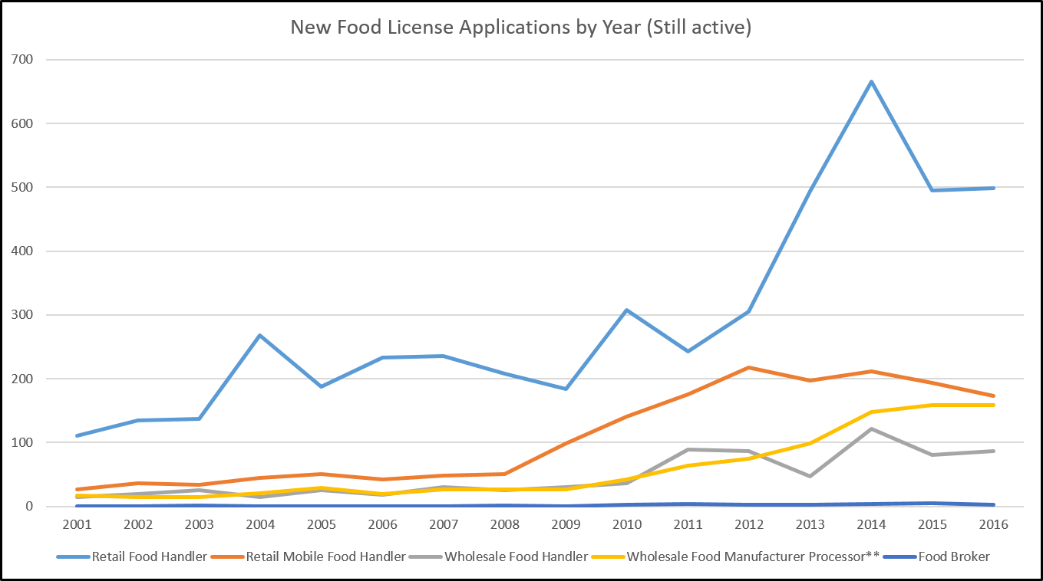

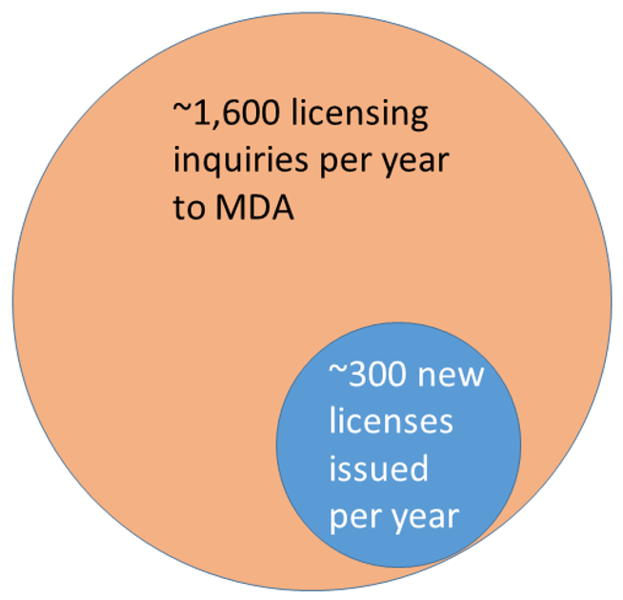
~ 1 new license from every 5 inquiries.

IF just 10% more inquiries get a license, that means
~130 more food businesses per year in MN

Why some would-be food entrepreneurs
give up:

Source: Food Enterprise Experiences Survey, Feb. 2017

Some innovative enterprises become tangled in unclear regulatory language. | Wabasha Farmers’ Market took:  18 months  +  involvement of farm groups  +  meeting with MDA staff  to achieve licensing for innovative local produce distribution enterprise.  Source: Wabasha Farmers’ Market case study, June 2016 | Delays are especially costly to small businesses.  How long until a food entrepreneur could proceed?  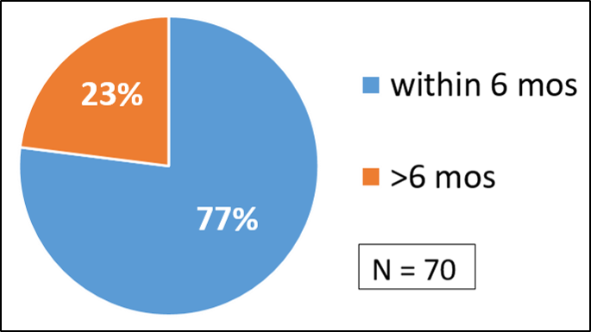  Source: Food Enterprise Experiences Survey, Feb. 2017

SOLUTION: Standardized process to handle models that do not fit current regulatory categories, in a timely fashion.

Informal teams of regulators, local food system experts and members of farmer organizations have come together to help food entrepreneurs with compliance and licensing issues. These teams have been successful.

We propose forming a Solutions Advisory Licensing Team (SALT) to formalize the process to help novel food enterprises become compliant and licensed within a reasonable amount of time
(6 months or less).

  - Regulatory specialists and coordination from MDA: One FTE
  - Regulatory specialists from MDH
  - Volunteer participants:
    - Experienced business entrepreneurs
    - Representatives of economic development agencies/DEED
    - Food system advocates

The Solutions Advisory Licensing Team would:
- Have authority to issue definitive interpretations of statute and rule
- Convey decisions back to MDA and MDH staff trainers and field-level staff for implementation in the field.
Continuous improvement feedback loop

This proposal supported by:
Minnesota Farmers’ Market Association Renewing the Countryside
info@mfma.org // (320) 250-5087 info@rtc.org

