PROPOSAL FOR IMPROVING FOOD LICENSING FOR SMALL BUSINESS

Economic upheavals and the lure of the local food movement have inspired unprecedented numbers of Minnesotans to start food businesses.

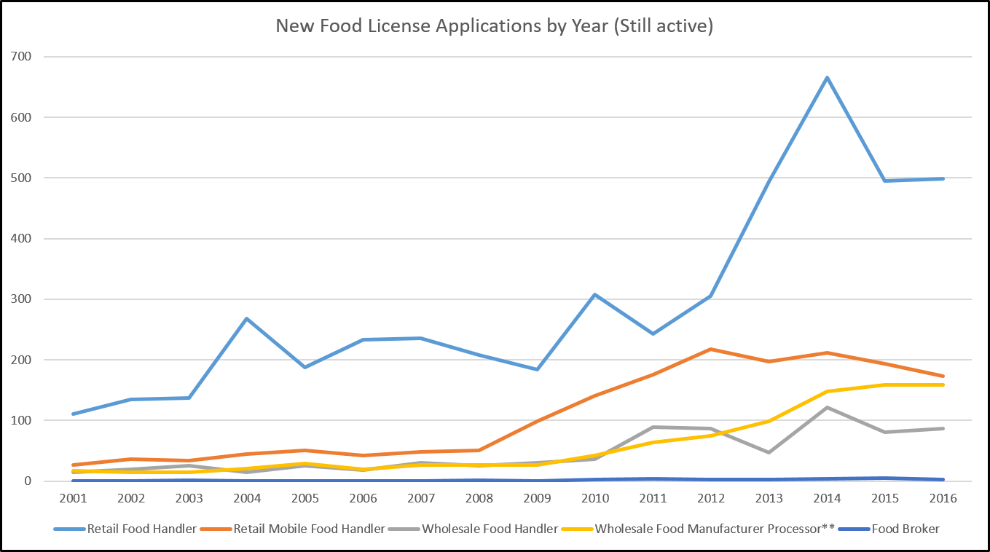
2010 to 2016: 74% in number of food business licenses issued.
Mostly:
* retail food handler
* food manufacturer
license types used by small and mid-size food entrepreneurs.

Way more people are interested in starting food enterprises than the number who succeed.

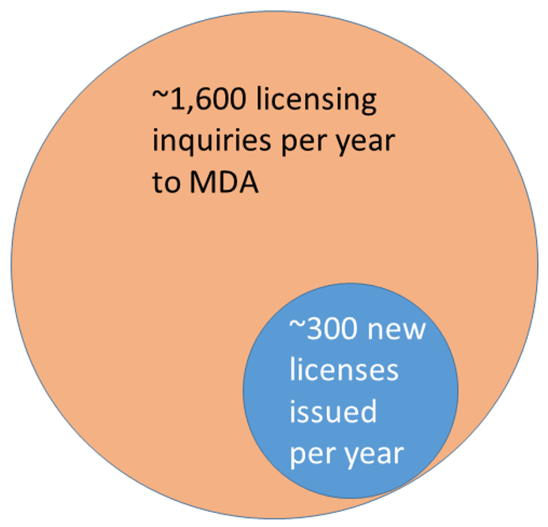
~ 1 new license from every 5 inquiries.

IF just 10% more inquiries get a license, that means
~130 more food businesses per year in MN
Survey by U of MN and farmer organizations found 80% of respondents were able to  proceed with a food enterprise  in <1 year,  while 20% took a year or more. | 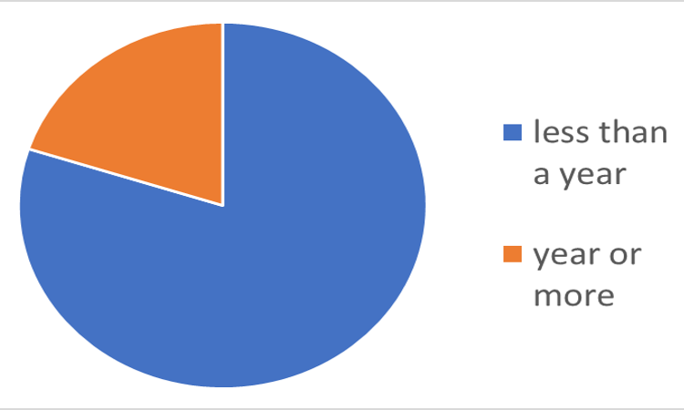

Surveys by MDA found about 80% of food license applicants received satisfactory to very helpful information and a timely response to their requests. About 20% were not satisfied with either response or timeliness. | 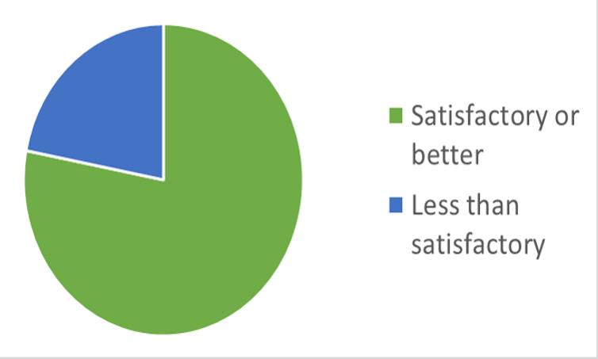

Some innovative enterprises become tangled in unclear regulatory language | Wabasha Farmers’ Market took:  18 months  +  involvement of farm groups  +  meeting with MDA staff  to achieve licensing for innovative local produce distribution enterprise. | Delays are especially costly to small business

SOLUTION: A SMOOTHER, MORE CONSISTENT REGULATORY PROCESS
A new MDA “Food Business Innovation Coordinator” position backed up by a team of experts would clear the path to licensing, providing both consistent regulatory interpretation and timely decision-making.

- One FTE for Food Business Innovation housed at MDA
  - 0.5 FTE = Coordinator
  - 0.5 FTE = MDA regulatory specialists
- SALT: Solution Advisory Licensing Team
  - Regulatory specialists from MDA and MDH
  - Volunteer participants:
    - Experienced business entrepreneurs
    - Representatives of economic development agencies/DEED
    - Food system advocates

The SALT Team will serve the innovative food entrepreneur while protecting food safety.

The coordinator and team would:
- Have authority to issue definitive interpretations of statute and rule
- Convey decisions back to MDA and MDH staff trainers and field-level staff for implementation in the field.

This proposal supported by:
Minnesota Farmers’ Market Association Renewing the Countryside
info@mfma.org // (320) 250-5087 info@rtc.org

