MN SOS – Second Opinion Scrum/Sprint? SOAR?

Introduction
Food entrepreneurs face complex regulations and confusing requirements. New food business models are created to meet the changing and emerging taste of customers. Licensing focuses on food safety. It is sometimes the case that food entrepreneurs are not well-versed in food safety requirements, but may think they are.

When they are ready for inspection and licensing, they are surprised to find that their plans are not accepted and licensing is denied. It is at this point that most entrepreneurs decide to either change their business model or stop pursuing the idea altogether.

The second opinion campaign aims to help those entrepreneurs facing difficulties acquiring a license by encouraging them to ask for a second opinion and by contacting the SOS group.

The SOS group provides access to highly trained MDH/MDA inspectors, food advocates and other stakeholders in order to offer viable suggestions and adjustments to their original model without losing sight of the desired business outcome.

INPUTS:

- Funding: legislature? Private?
- Initial portal outreach/marketing: got food? Think MDA/MDH
- Outreach/marketing: there is a second chance

DESIRED OUTCOMES:

- Faster licensing
- No new business model is too complex to be licensed?
- Training of inspectors that are part of the scrum
- Improving web site and communication at MDH/MDA/DA’s
- Elimination of dead-ends

CURRENT ISSUES:
- Rules are complex, hard to interpret consistently
- There are so many rules, that the only way to find out if you’d done something wrong, is when an inspector points it out.
- No avenue for settling disagreements with inspectors should an issue arise. Mistrust?
- People are using new models, new technology
- Inspectors do not agree on interpretations
- Regulations always behind new business models
- TOO MANY REGS that have nothing to do with food safety
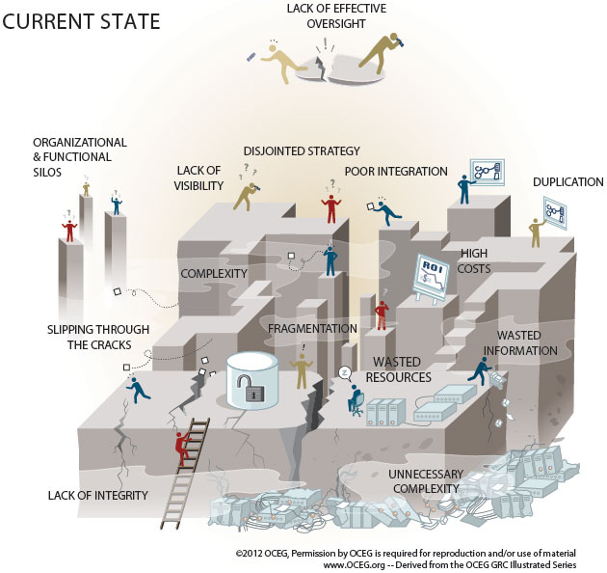

FUTURE:
- Need to understand the connection between food safety and rules
- Need to be given alternatives
- Need advocate
- Remove some regs that have nothing to do with food safety

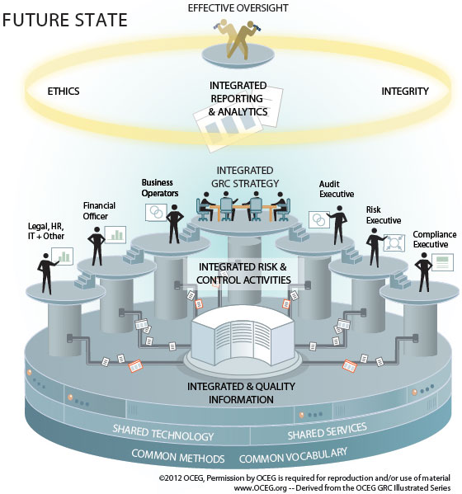

A plan-driven process works well if you are applying it to problems that are well defined, predictable, and unlikely to undergo any significant change. However, most innovative models are anything but predictable, especially at the start/beginning. Furthermore, developing a new business model rarely goes as planned.

Scrum is an agile approach for developing innovative products and services. It is a framework for organizing and managing work. It originally was applied to software development, but now is used to organize the the flow of work or to develop new products. It is simple, people-centric, based on principles of openness, respect, focus, trust, empowerment and collaboration.

Instead of a business entrepreneur spending months building his model, to then find out in a 15 min conversation with an inspector, that it won’t work, scrum allows for the framework of a model to start the conversation. Also, having a cross-functional team (agencies, advocates from private companies/groups, nonprofits, etc.,etc) allows problems to be discussed up front, not later on when it is more difficult and costly to remedy.

Scrum vs waterfall
Effort: 1/10 of WF
Time: 7x faster
Customer satisfaction: excellent vs poor

The question is: do you think licensing innovative models is done in a timely, economical and quality manner? The answer is probably, “No”. But dissatisfaction does not have to be accepted. There is a better way.

Entrepreneurs (E) do not really know their true needs until much later in the design process. So a waterfall approach, devoid of “testing” until the very end, is unlikely to lead to a satisfactory outcome.

Team work: enjoyable, frequent, collaborative, productive.

Steps
- Creating a product backlog: a prioritized list of the features and other capabilities needed to develop the successful model. Definition of success: a license in a timely manner? The development of license-able model in a timely manner?
  - Work on highest priority first
  - When you run out of resources, only the lowest priority items are left undone
  - Amount of work in a product backlog is usually more than can be accomplished in one iteration (one week to one month, max)

Actually, in developing this concept, we are probably using scrum methodology.
- Iterations: short, time-boxed. At end of each iteration, must have a potentially shippable increment of a product or a product itself. If not feasible, then a group of increments from several iterations can be released together.
- Self-organizing functional teams: designs, builds and tests models
- Review: at end of iteration, team and stakeholders review product.
- Feedback: based on FB, team can alter what to do next and how to do it.

Background
In a scrum, the whole team tries to go the distance as a unit. Better in today’s competitive market.

Problem:
Business entrepreneurs focusing on the food sector are increasingly designing innovative business models to succeed in today’s highly competitive market. Licensing a business model that is new and in a timely fashion has proven challenging. On the one hand, E design their models based on customer perceived needs. They are usually ready for licensing at a point far into their plan.

When they are ready for licensing, the following issues arise:
- It is not clear who to contact about inspection and licensing. Is it MDH or MDA or the Secretary of State’s office?
  - Solution: marketing campaign (billboards): got a food business? Call MDA or MDH first, before you get to far into planning
- When they do find the right agency (if they do), they may be faced with barriers to doing business exactly like they had envisioned.
- The inspector fulfills the role more of a regulator than an educator/mentor. This means that if the business model can be adjusted, the inspector is not at liberty to help very much. The E has to come up with the right questions and propose changes in what has become now a guessing game.
- The inspector may deny licensing as the model currently stands; he may not suggest too many adjustments. He does not have the time nor the in-depth knowledge of non-regulatory aspects of the business to offer helpful suggestions.
- The inspector either denies licensing all together, or requests significant changes to the business which the E may not wish to undertake.
- The E may decide to either stop progress toward licensing or changes the type of business he would like to undertake.
- The E has devoted considerable time and resources to get to a point where he either does not get a license or decides to change his business.
- The agencies also have devoted considerable time considering the application for license.
- There is no lessons-learned method in place, so the system keeps operating in this way that is clunky and frustrating for entrepreneurs.

Proposal
- Create a group with the following present
  - MDA or MDH representatives, those with the authority to grant a license
  - The Entrepreneur him/herself
  - Advocates from MFMA, RTC or other non-profit, NGO
  - Other stake holders: insurance, bank, city
  - Compliance
  - Risk
  - Financial
  - Business
- The work of this group
  - PR/Marketing/Ad campaign: seek a second opinion if you got a “No” to licensing. SOS campaign.
  - Meet within 2 weeks of being contacted by E
  - Consider the model presented, the issues the inspector faced and how he resolved them or not.
  - Offer alternatives that fit the business model being presented.
  - Meet for about 2 hours, no more.
  - End the meeting with a list of items the E has to take care of, look into or change.
  - Resolve to meet again in 2 weeks (or longer if agreed upon by the group; this will depend on the nature and the number of changes/adjustments)
  - At second meeting, review updated proposal and set a date for an inspection.
  - Licensing to be issued within 6 weeks of initial a contact.
- Questions to resolve
  - Timelines
  - Duration of meetings and frequency
- Why would this work?
  - Complex problems: need a safe-fail environment for experimentation, with high level of communication and interaction. Must be able to explore, inspect and adapt.
  - Scrum is people-centric framework, based on values of honesty, openness, courage, respect, focus, trust, empowerment and collaboration.
  - Roles: Scrum Master, product owner, and development team.
    - Scrum Master: someone with knowledge of the method
    - Product Owner: the advocate for the E or the E himself?
    - Development Team: MDH, MDA, MFMA, RTC, MISA, E, insurance, bank, city
  - Process
    - Product backlog: prioritized list of features (grooming)
    - Sprint planning: which items in the product backlog to work on first, given the duration of a sprint. Is this a commitment?
    - Sprint: design, build, integrate and test features
    - Sprint review: at end of one sprint, meet again to see if features completed can be part of finished product
    - Sprint retrospective: lessons learned about the process
    - LESSONS LEARNED:
      - Policy change issues: lessons learned?
      - Web site improvement
- Resource
  - Standards
  - Webinars
  - Regional meetings
- Cost
  - Free membership?
  - Fee for service

Outline
- Food entrepreneurs are coming up with more complex models to better compete in today’s market
- Plans move forward until licensing
- Models often do not fit existing rules/regs/statues or previous models
- Licensing is denied or delayed (at best)
- E may need to re-work their models (time and resource consuming); some give up
- Those that re-work models, end up waiting long (some 3.5 YEARS) to resolve issues and acquire license
- Scrum method would speed up the licensing process by meeting with the E sooner
- Cross-functional team charged with meeting with E and other stakeholders, including licensing bodies, to design a working model that can be licensed.
- Time, effort and satisfaction increase
- Cross-functional team: MDA, MDH (if needed), E, advocates, insurance, city/delegated authorities, suppliers?
- Called into meeting when model arrives.
- Meeting to educate both regs and alternatives, etc. Time-boxed. Outcome: plan to be done by next meeting. Setting of next meeting or call when ready
- Final meeting: review status, adjust, schedule inspection
- Retrospective is KEY: lessons learned: improve web site, MDH/MDA/DA training, communication, etc.,etc

