Summary of 2016 Licensing & Information Public Survey
In October of 2016, FFSD surveyed approximately 1150 people who contacted us for assistance with licensing, cottage food, and general inquires. Three hundred and sixty people responded for a response rate of 31.3 %. The results in general were positive with most, but not all, of those surveyed stating that they were satisfied with our response to them. Below are the survey result s:

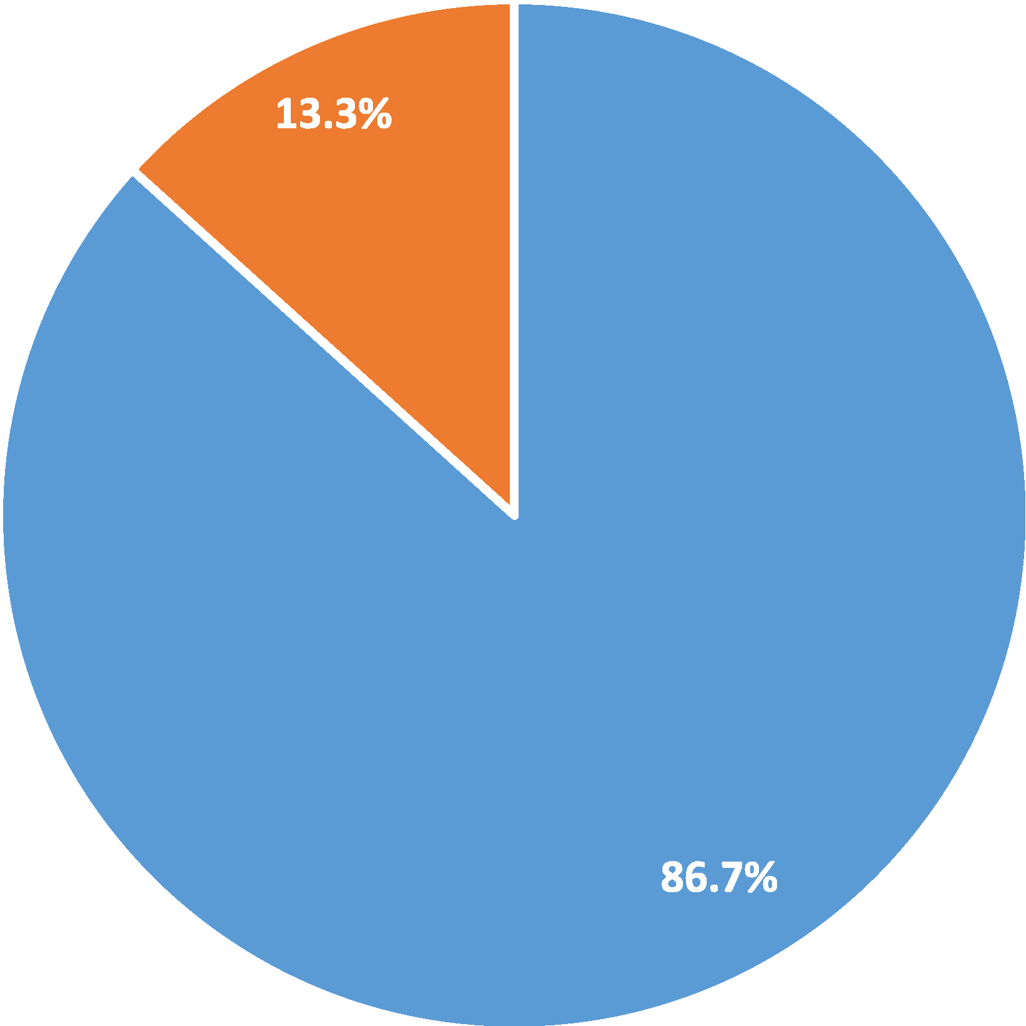
Question one: Were you successful in obtaining the information?

- Yes • No

Question two: How helpful was the information you received to better understand the point you needed clarified?

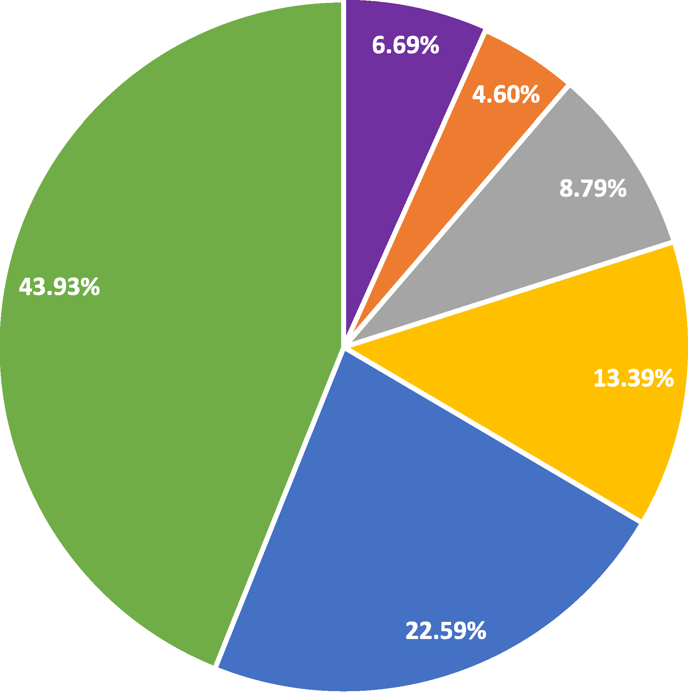

Not helpful at all
Very helpful

Question three: How satisfied were you with the timeliness of the response?
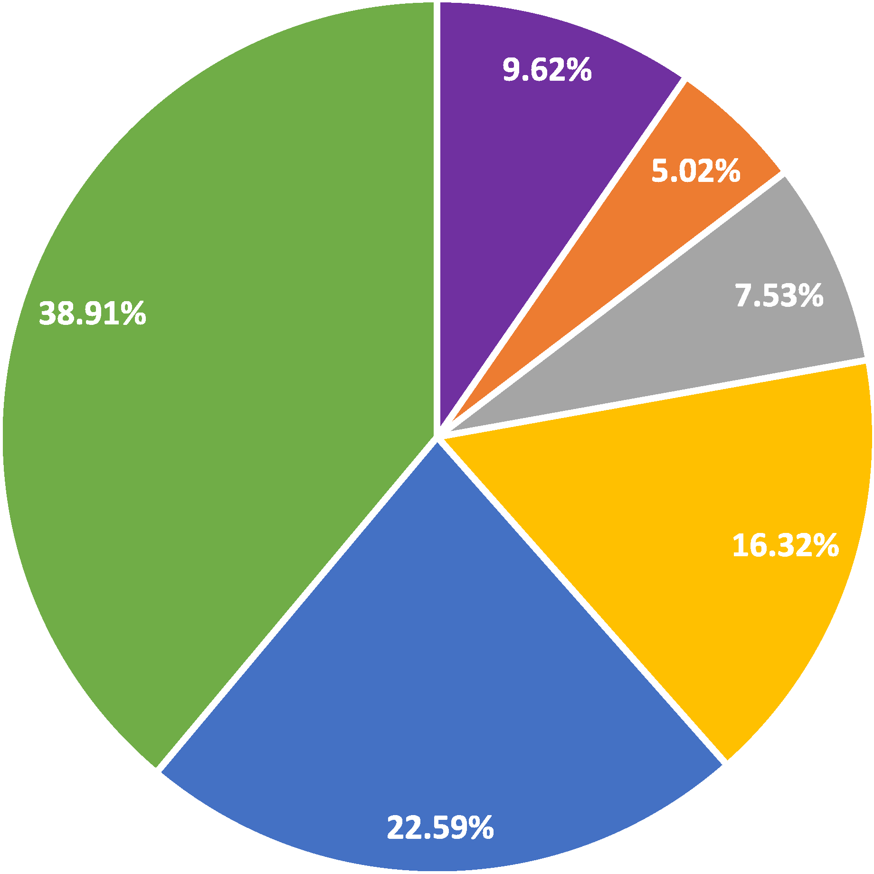

Not at all satisfied
Very satisfied

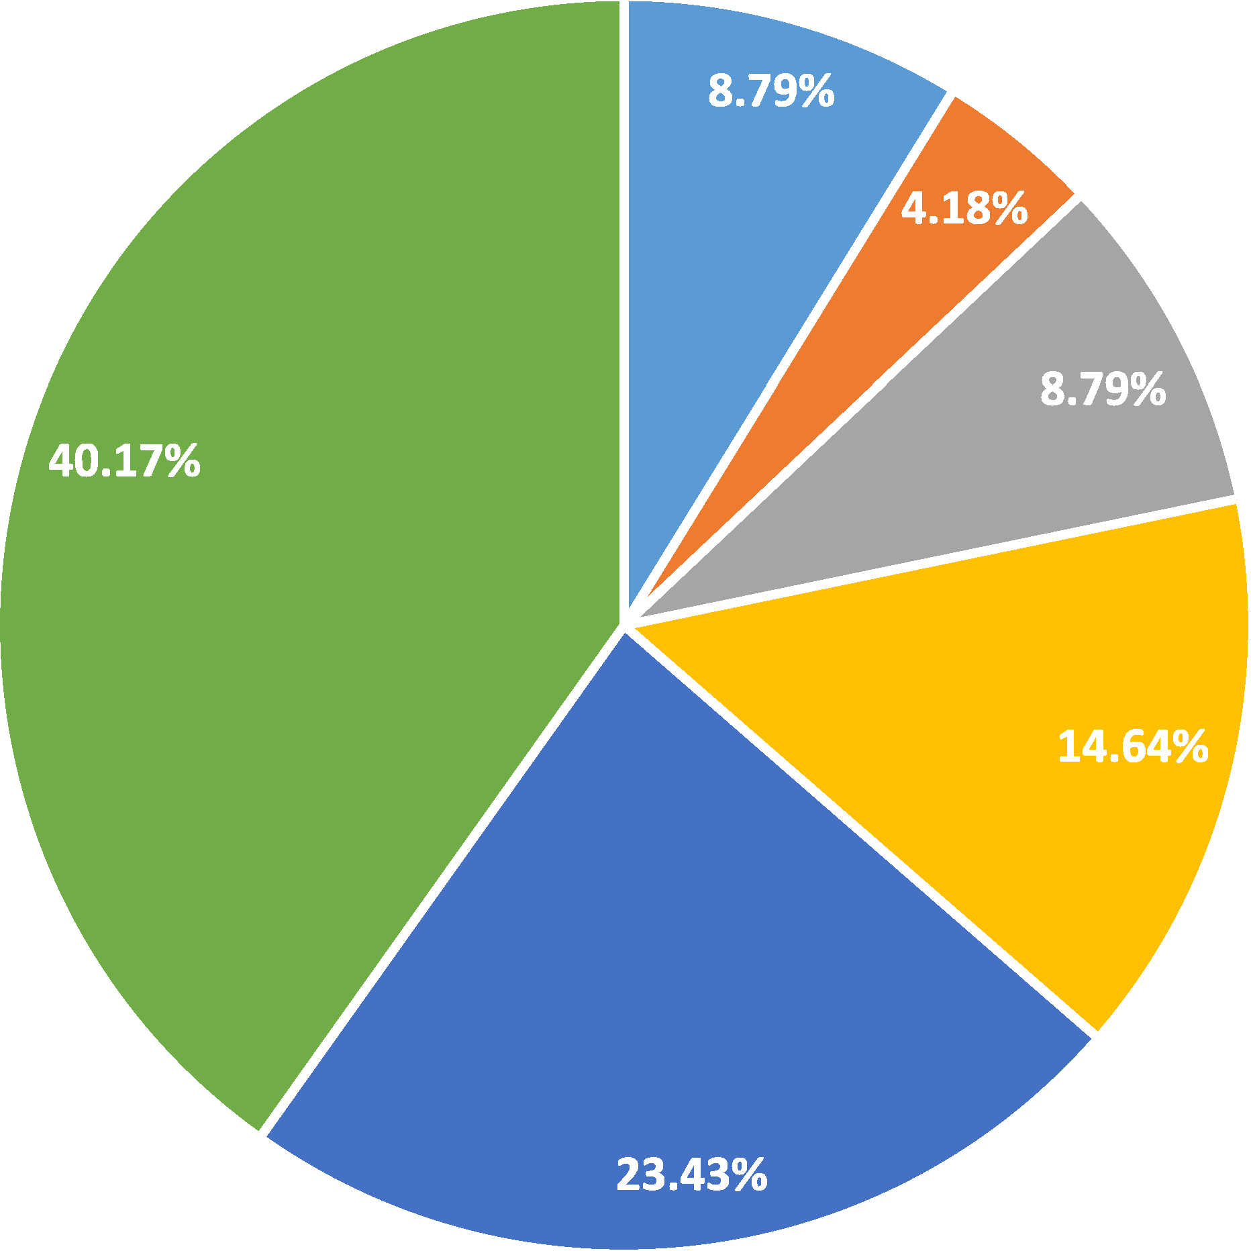
Question five: How satisfied were you with your overall experience in contacting the MN Department of Agriculture?

- Not at all satisfied

•
•
•
•
- Very satisfied

Question four: What is a reasonable time frame to receive information from the MN Dept. of Agriculture?
60%
53.1%

50%

40%

30% 27.2%

20%

11.7%
10% 7.9%

0%
Less than 1 day 1-2 days 3-4 days S+days

Question six: Would you contact the MN Dept. of Agriculture again?
100% 92.9%
90%

80%

70%

60%

50%

40%

30%

20%
10% 7.5%

0%
Yes No

Question seven: How do you prefer to receive information?
Electronicall}' (email/website) 68.42% | 22.37% 9.21%  42.79% 48.65%  34.08% 40.81%
Print or hard coy,_ _ 8.56%
Consult with a live rson 25.11%

Question eight: The MN Dept. of Agriculture is currently working on a new online licensing tool to walk people through what license they need and next steps in obtaining a license.
How likely would you be to use this tool?
60% 56.49%

50%

40%

30%

20%

10%

0%
-3.35%
-1.67%

8.79%

9.62%
20.08%

Not at all likely Very likely

Question nine: Would you be willing to speak with someone concerning yourexperience,goodorbad?

One hundred eleven people responded to this question and about sixty provided contact information. MDA is in the process of contacting them for additional feedback.

Question ten: Is there anything else you would like to tell us?

Approximately ninety people provided comment on the service they received below is a sample of the comments we received. Here are some of the yes responses.

10/19/2016 1:44 PM Too bad selling stuff at market has to have so many requirements

10/18/2016 2:47 PM Great overall experience with the phone question. Loved getting my question answered right away and not a run around on the phone. Thank you!

10/16/2016 7:10 PM I believe our cottage food law is balanced in public safety, while still allowing some home created products. Thank you.

10/14/2016 10:17 PM I don't remember what? I had when I contacted the MN Dept. of Ag so I can't honestly answer these questions.

10/14/2016 4:04 PM I am halfway through the process, and I am still confused.

10/14/2016 11:17 AM I thought that taking 1 mo. to get my registration paper was too long.

10/14/2016 10:13 AM The state require license for cottage food bill, I applied in June and still have not received word from the department, and 5 months is a little long to wait. I went all summer without a legal license.

10/14/2016 2:28 AM Answer you phone

10/13/2016 2:14 PM You are going a great job thanks for caring,

10/13/2016 12:55 PM I did receive my registration but my name was misspelled.

10/13/2016 11:40 AM For many things I prefer talking to a real person, but the cottage law permit that I applied for was simple and very easily done electronically.

10/13/2016 9:43 AM If that new online tool would also have the options of scheduling appointments, then that would be extremely convenient!

10/13/2016 9:32 AM I work forNDSU as a researcher and when I contacted you, I needed an answer to a rules question. So I answered No to #8. And I probably don't have any other questions as I am a plant/fruit researcher. I called around ND before calling MN. There was literally no one to ask here. They are, apparently, just looking into finding out how to deal with the new FSMA rules. Like there have never been rules for food producers before! Thank you MN Dept. of Ag for answering my question and calling me back.

10/13/2016 8:23 AM I currently live in Arkansas and applied for a Health Department license. Because we make fresh made cheesecakes in our concession trailer, I was informed I had to obtain our license from the MN Dept. of Agriculture. Our application was transferred to the Dept. of Agriculture in mid-February. After numerous phone calls and e-mails, I finally was informed in mid-May that I would have to install a Dept. of Agriculture approved vent hood above out electric convection oven. I pointed out that there are no fumes or steam emitted during our baking process. It basically boiled down to the fact that the ordinance was recently updated and now includes convection ovens so we would have to install a vent hood at the cost of approximately $5,000.

10/13/2016 7:58 AM It took me months to get in touch with a Food Safety Inspector to receive my mobile food handler license. I was unable to sell certain products during this time which resulted in lost income. We are a family farm business that relies heavily on the sales we receive during the summer farmers' market season. I was very proactive with making contacts months in advance of needing a license, but it took multiple emails and phone calls over a 6 month period before I finally talked to an inspector who would schedule a meeting. I hold a similar license in a neighboring state and have never had these same issues in regard to getting a response from an

inspector. I am very dissatisfied with how long it took and how many tries it took to receive a response.

10/13/2016 6:55 AM Keep up the good work

10/13/2016 6:45 AM More information needed on licensed kitchen on farm needed

10/13/2016 6:25 AM The few people I have been able to contact are very unsure of what they are talking about. There are apparently many gray areas and they don't know the rules like they should. It's hard to do what you are supposed to do ifno one can tell you what the rules are!

10/12/2016 9:18 PM I had a question about whether or not I could sell lard made from a pig, never did get an answer. Cottage food registration was great, no problem there

10/12/2016 8:19 PM It worked well for me.

10/12/2016 7:43 PM Compared too many departments of the state of Minnesota, your department rates very well. Compared to the department of Revenue - outstanding!

10/12/2016 7:18 PM It was difficult to find the info I wanted. It would be good to have a flow chart to get me to my destination.

10/12/2016 6:43 PM Thank you:)

10/12/2016 6:43 PM How do you renew a cottage license?

10/12/2016 6:38 PM I am currently looking for what the "next" step is in licensing and that has been difficult for us. Additional links or information would be great. Thanks

10/12/2016 6:32 PM Better training on sales tax for those that teach, for example, cottage foods classes.

10/12/2016 6:07 PM Frustration with lack ofresponse to our license request. Our application was submitted on or around July 17th, and even with an email contact to request our licenses a month after submission, we STILL have not received our licenses as of today 10/12. So, our
effort to be in compliance with Cottage Food law and display our license at Farmers Markets was not successful as the Dept. of Ag did not follow up and actually mail us our licenses.

10/12/2016 6:00 PM Stop making more rules!!! 10/12/2016 5:25 PM Keep up the good work.
10/12/2016 5:18 PM Thank you

10/12/2016 5:16 PM It is very gratifying to receive a survey like this. It sounds like you really care.

10/12/2016 5:10 PM The response I got was found later than I needed in my spam folder. That was a surprise to me.

10/12/2016 5:09 PM Please update info online ASAP, as so many ask us as other marketers, and we need to refer to the most recent info.

10/12/2016 5:04 PM Please clarify: is pumpkin bars on the restriction list of potential hazard foods? (Cheesecake, pumpkin pies) Also, if registered under cottage food laws, may I get my food handler's manager certificate/license? Please leave me your name when responding to my questions. Thank you, Julia

10/12/2016 4:59 PM I think some parts of the cottage food law aren't really needed -- when something was canned Gelly, jam) for example. Most customers really don't care.

10/12/2016 4:49 PM Nope - the changes to the pickle law were helpful and practical.

10/12/2016 4:48 PM I realize department personnel may have a lot on their plate(s), but even a short email to say: I received your request and will do my best to provide an answer within 10 days, 2 weeks, whatever, would be nice rather than hearing nothing at all.

10/12/2016 3:57 PM I just want to tell you team doing very good job*****************

10/12/2016 3:39 PM I don't understand how people brake rules and there are never inspections in the markets I do

10/12/2016 3:34 PM The inspectors are great I have worked with two inspectors in two different areas. However, they are overworked or poor with managing their time. In order to schedule a visit with an inspector it can take 3 weeks or more. This seems long and perhaps reducing that time would improve

10/12/2016 3:22 PM My thoughts are that I did not get enough detail of what I needed early enough when starting my business or I would have made other financial arrangements or not started my business.

10/12/2016 3:20 PM Any assistance MDA can provide in guiding small business startups in the regulations is extremely helpful!

10/12/2016 2:49 PM Since 2010 our small historical society in New Ulm has received help from the County then MN Department of Agriculture to continue operation of our 102 year old popcorn wagon. We appreciate the open and friendly communication displayed during this process. Your employees were well trained and helpful as we all work to keep the wagon operating for another generational

10/12/2016 2:32 PM I look forward to doing business in Minnesota, and I have many people interested in purchasing my product.

10/12/2016 2:17 PM My husband is not deceased, so hopefully I would have the time needed to complete the course.

10/12/2016 2:16 PM Not having a clear guideline to determine if an event is considered a community event or part of the farmer's market type is extremely hard to navigate. For example:

My company participated at the MN Grill fest hosted at CHS Field in 2016 and we were not required to have a permit to sample; 3 months later, we participated in the Summer Beer Dabbler hosted at CHS Field and we were required. We did the exact same thing at each event. Further, lack of clarity leaves the event coordinators short on direction.

10/12/2016 2:01 PM Our division recently had a change of personnel & fell behind on registration. My colleague & I contacted the MN DOA and received clear & accurate instructions so we could quickly bring our status up to date.

10/12/2016 1:58 PM That I'm so thankful this law passed. It is a blessing.

10/12/2016 1:44 PM The licensing tool would be great. Please make sure you streamline the new site so it is not so confusing.

10/12/2016 1:41 PM Keep up the good work.

10/12/2016 1:40 PM Please call so I can figure out how to proceed forward with my business questions. Thanks Chad Martin

10/12/2016 1:36 PM Thanks for making this process EASY. That is huge.:-)

In conclusion while most people received timely and useful information MDA need to continue to provide this type of service and improved on its ability to reach our clients in a timely and helpful way. We need to streamline the way we receive requests so as not to delay our response. In some cases however as the comments show we may never be able to satisfy all our clients do to philosophical differences in governance. Improved electronic methods can provide initial information that is helpful and continued staffing and live contact is also warranted. This survey should be conducted at least annually to judge performance on a wide variety of subject matter.

