Food Enterprise Experiences Survey Report
March 6, 2017

Introduction
This survey was conducted by a team working to address barriers in the food enterprise start-up process by developing a clearer, more streamlined process for regulatory compliance and approval. We recognize that barriers often delay or halt the process of innovative food enterprises looking to become established in Minnesota. Survey responses will help our team with planning of an improved process for compliance and approval of food enterprises.
- Minnesota Farmers’ Market Association (MFMA)
- Minnesota Institute of Sustainable Agriculture (MISA)
- Renewing the Countryside (RTC)
- University of Minnesota Regional Sustainable Development Partnerships (RSDP)

The survey was open from afternoon of February 14, 2017 through evening of February 20, 2017. It was advertised to members of the Minnesota Farmers Market Association, the Sustag listserv, the FEAST! Local Food Network, and pushed out through numerous other listservs and Facebook pages.

The outreach and advertising done on this survey primarily targeted Minnesota’s local food and small-to-mid-scale food entrepreneur communities. However, this was not a random sample of people involved in those food communities. Participation in the survey was entirely dependent on an individual seeing a survey link and choosing to participate.

There were 214 responses received.

Question 1: Have you ever been involved with or tried to start a food business, enterprise or activity in Minnesota?
Number of people who responded to the survey: 214
Number answering “Yes” to Question 1: 199
Number answering “No” to Question 1: 15

Pie chart showing answers to Question 1
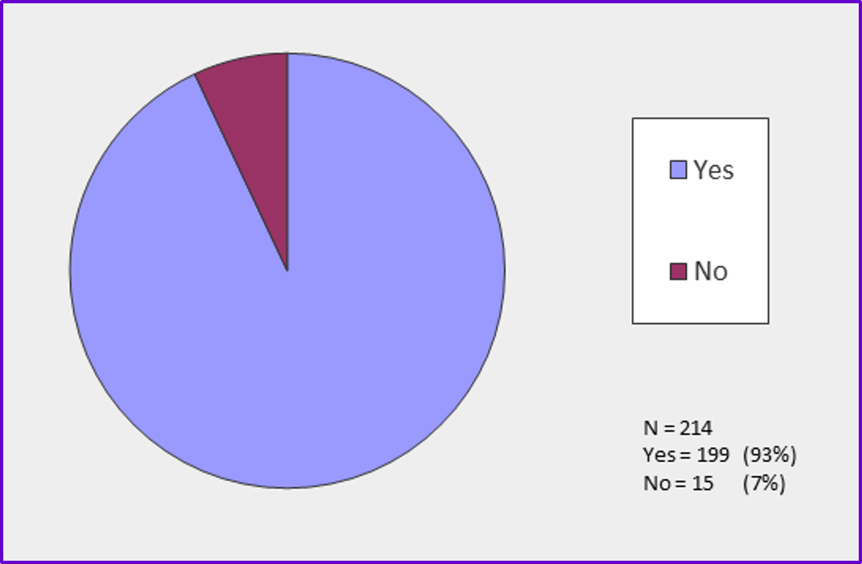

Question 2: In what types of food business, enterprise or activity have you been involved? Check all that apply.
Type of food business, enterprise or activity | # of respondents | % of respondents
 | ------ (N=157) ------
Owned and/or managed a food business | 79 | 50%
Worked as an employee in a food business | 50 | 32%
Marketed my own farm products | 79 | 50%
Marketed my own cottage food products | 73 | 47%
Worked or volunteered in food access or food education programs (Meals on Wheels, Farm to School, food bank/food shelf, cooking classes, etc.) | 44 | 28%
Worked or volunteered with a food-related enterprise or activity of any other kind (fundraiser dinner, food booth at a festival, cook-off competition, etc.) | 39 | 25%
Other (please specify) | 20 | 13%

Chart of responses to Question 2:

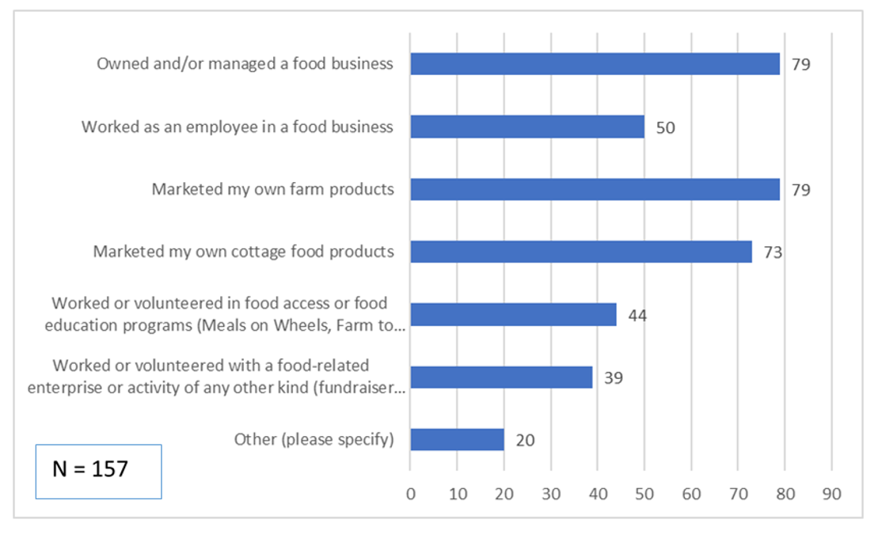

Number of respondents claiming multiple categories of involvement in food activities

The average was 2.4 categories per respondent.
“Worked as an employee in a food business” was the category most correlated with involvement in multiple categories (R = 0.66).

Chart showing number of respondents claiming multiple categories of involvement in food activities

Answers offered to the “Other” food involvement option in Question 2
See appendix, page 13.

Question 3. How did you find information about food regulations and requirements for your business, enterprise or activity? Check all that apply.

Sources of information about food regulations and requirements | # of respondents | % of respondents
 | ------ (N=156) ------
Asked someone I knew who was already involved in a similar type of food activity | 102 | 65%
Looked for information online | 124 | 80%
Contacted an Extension staff person | 47 | 30%
Contacted a non-profit organization | 31 | 20%
Contacted the Minnesota Department of Agriculture or an inspector of that department | 94 | 60%
Contacted the Minnesota Department of Health or an inspector of that department | 68 | 44%
Contacted a local city or county office | 49 | 31%
Other | 24 | 15%

Chart of responses to Question 3
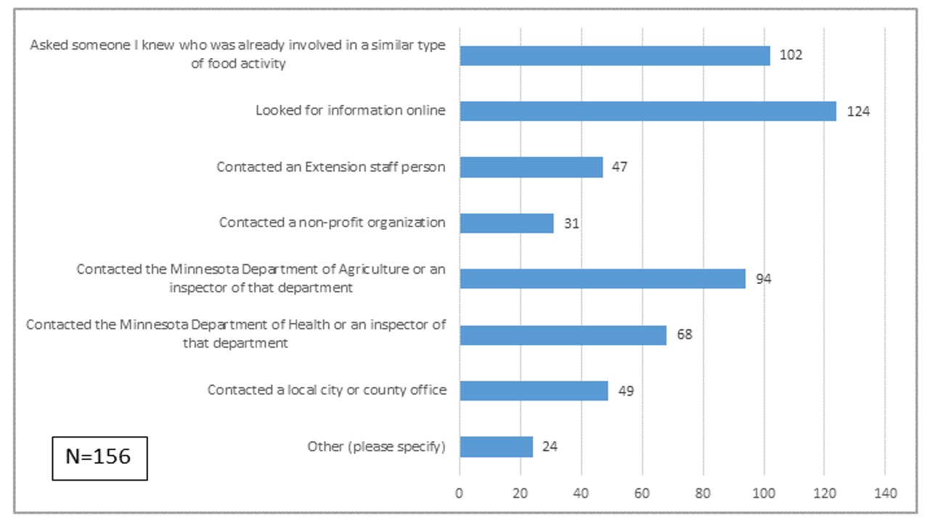

Number of respondents seeking multiple information sources

- The average number of sources per respondent was 3.5
- 85% of respondents sought out more than one source of information
- 47% of respondents sought out more than three sources of information

Chart of number of information sources per respondent

Answers offered to the “Other” information source option in Question 3
See appendix, page 14.

Question 4. Were you able to get enough information to allow you to proceed with your food business, enterprise or activity?

Question 4 answers | # of respondents | % of respondents
 | ----- N = 155 ------
Yes – I was successful | 84 | 54%
No – I gave up | 19 | 12%
I had to seek out more sources of information or help before I could proceed | 57 | 37%
I got conflicting information | 40 | 26%

Chart of responses to Question 4, on a percentage basis
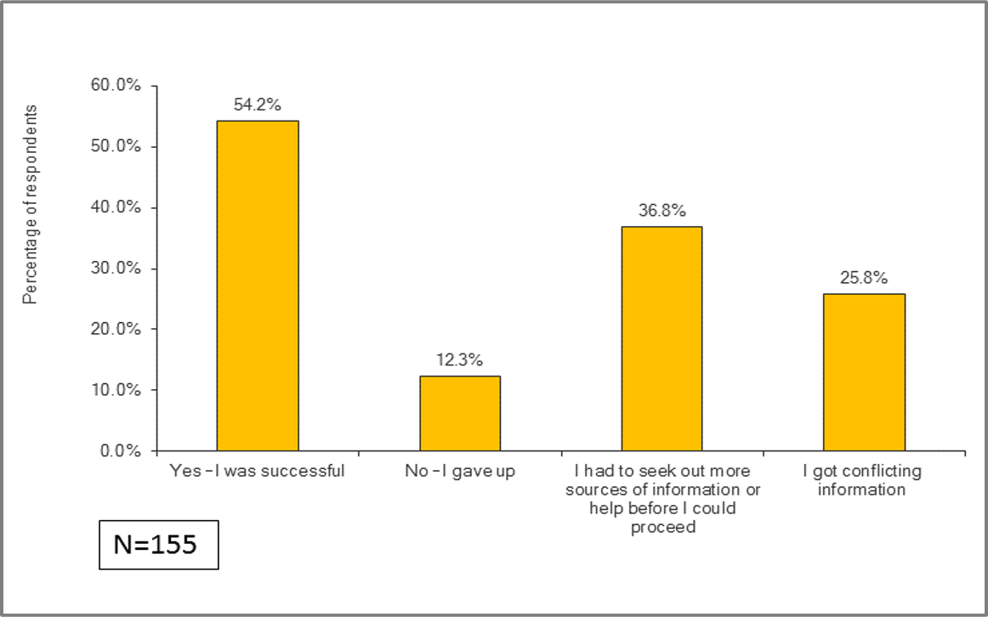

Comments on Question 4
See appendix, page 15.

Question 5: Did you feel like you knew where to go to get information or help for your food business questions?

Out of 156 responses to this question, 85 (55%) said yes and 65 (42%) said no. We did not offer an “undecided” option. Forty-three respondents submitted comments.

Chart of responses to Question 5, on a percentage basis
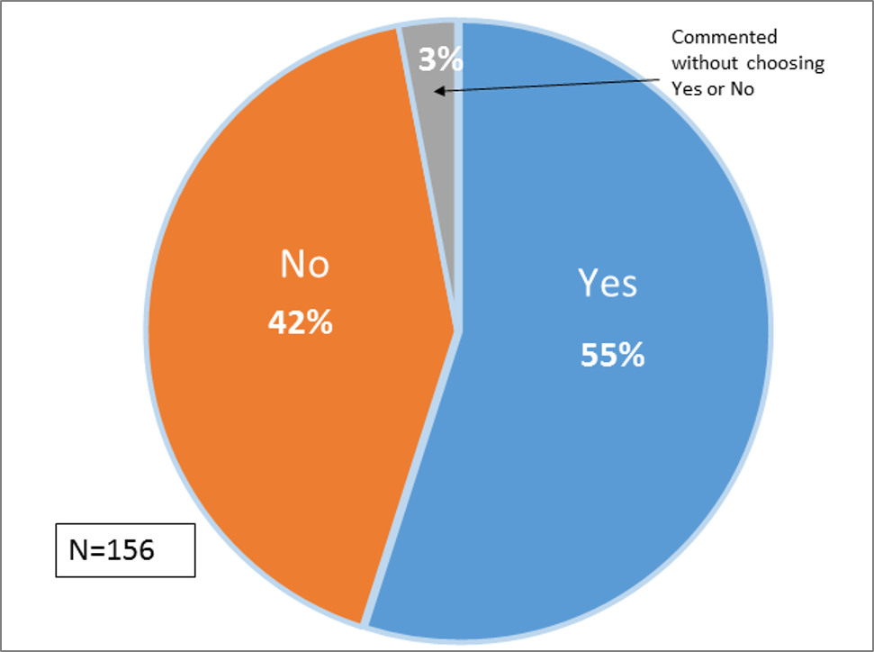

Comments on Question 5
See appendix, page 18.

Question 6. Did you feel like you knew what to do in order to meet requirements for your food business?

Out of 156 responses to this question, 87 (56%) said yes and 64 (41%) said no. We did not offer an “undecided” option. Thirty-nine respondents submitted comments.

Chart of responses to Question 6:
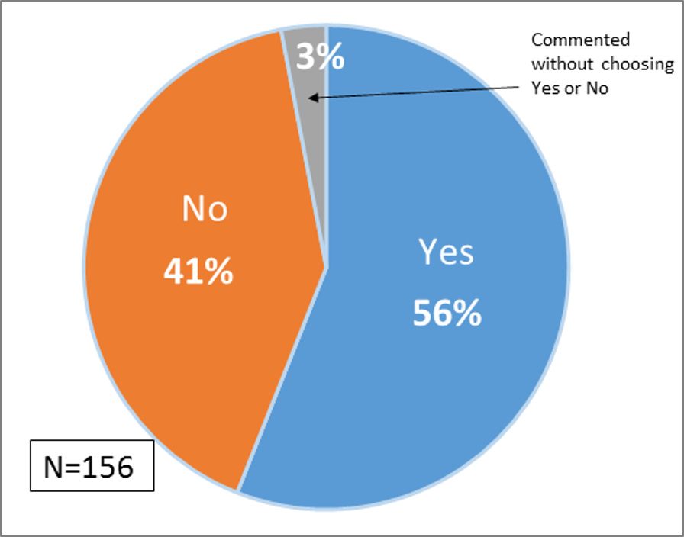

Comments on Question 6
See appendix, page 20.

Question 7: Approximately how long did it take for you to EITHER get the information you needed to proceed, OR to make the decision to stop your efforts for your food business?

Question 7 answers from 14 people who answered “No – I gave up” to Question 3 AND provided a numerical response to Question 7:

Answer | Number of respondents
Haven’t started | 1
Couple of days | 1
1 summer | 1
2 months | 2
3 months | 1
Several months | 1
7 months | 1
1 year | 2
2 years | 2
3 years | 1
Long time | 1

Question 7 answers from 70 people who answered “Yes – I was successful” to Question 4 AND provided a numerical response to Question 7:

Answer | Number of respondents | Cumulative # of respondents | Cumulative % of respondents
A few hours | 2 | 2 | 3% | 77 % of respondents were able to proceed within 6 months
A few days | 10 | 12 | 17%
1 to 2 weeks | 9 | 21 | 30%
About a month | 7 | 28 | 40%
2 months | 10 | 38 | 54%
3 months | 9 | 47 | 67%
A few months | 4 | 51 | 73%
6 months | 3 | 54 | 77%
>6 months, <1 year | 2 | 56 | 80% | 23% of respondents took > 6 months
1 year | 6 | 62 | 89%
2 years | 6 | 68 | 97%
3 years | 1 | 69 | 99%
4 years | 1 | 70 | 100%

Question 8. If you decided to stop pursuing your food business, enterprise or activity, can you tell us why? Check all that apply.
Seventy-four people answered this question, compared to only 19 who chose “No-I gave up” in response to Question 3. Combined with information from Question 2 about people having experiences in multiple categories of food-related activities, this suggests some people may have abandoned one or more attempts at a food enterprise before finally succeeding.
Reasons for stopping pursuit of a food business, enterprise, or activity | # of respondents | % of respondents
 | ------ (N=74) ------
It was too hard / too expensive to pursue the required licenses / permits / certificates. | 37 | 50%
The required equipment was too expensive / not readily available. | 25 | 34%
I could not find an approved kitchen facility to prepare my food products. | 22 | 30%
The process took too long and I lost that opportunity. | 12 | 16%
I changed my plan and pursued something else. | 18 | 24%
Insurance was too hard to find / too expensive. | 14 | 19%
Other | 35 | 47%

Chart of responses to Question 8:
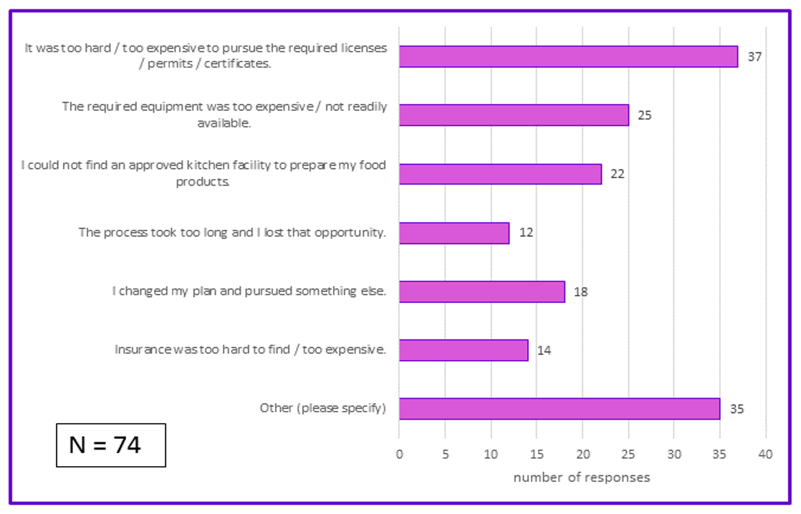
Question 8 allowed multiple responses. On average, people cited 2.2 reasons for stopping pursuit of a food-related activity.

Comments on Question 8
See appendix, page 22.

Question 9. If we can follow-up with you, please provide your name, phone, and email.
More than half (58%) of those who answered questions 2 through 6 provided name and contact information.

APPENDIX: Answers offered to “Other” or Comment options

Caveats:
This survey did not provide context for these comments. We don’t know specifics of respondents’ situations, and therefore cannot determine if individual comments regarding interactions with regulatory agencies or organizations were reasonable or unreasonable.
It has been observed in the past that sometimes people are mistaken about which agency or organization they have interacted with. The survey did not provide sufficient context to know if that was the case for any of these comments.

Question 2. In what types of food business, enterprise or activity have you been involved? “Other” food-related activities:
consulted in product development of local food product
Also still currently working as Food Safety QA in Processed Food
volunteered with two food coops, trying to start up in my community
Marketed my own value-added products that do not comply with Cottage Food law.
Manage a Farmers Market
Volunteer at co-op
Farmers market management
Worked at Food Business Incubator (helping potential food business owners get started...)
Worked to organize a local farmers market
Facilitated wholesale & retail food license between users of our shared use commercial kitchen and inspectors
Own a brewery
I have try to look into starting a food Business but I'm biligual, I find now resources to my understanding
worked with local farmers market, ebt, market bucks, etc
making items for family, friends and friends of family
am currently attempting to navigate the regulations for starting a small-scale, local (food grade) grain milling business
Researched starting my own cottage food products
tried to start a co-op
Farm produce to resturant's
run a Farmers' Market

Question 3. How did you find information about food regulations and requirements for your business, enterprise or activity? “Other” sources of information:
relied on co-packer's information
Midwest Pantry was an excellent resource, needed to contact multiple local cities because regulation between cities (vs. state regulation) was very confusing, contacted a farmers market manager, contacted staff at a food co-op
AURI
State/Federal Programs designed to help starting businesses
current work experience
I am attorney at a non-profit working in food systems
got "informed" of issues by my inspector
organized by the regional franchise coordinator
Information from farmer's market organizer and from RED foods - a for-profit.
didn't seek out information at all
Attended workshops and conferences
Researched studies of best practices for starting food businesses in MN
I don't know where to look for specify regulation.
attended workshops and conferences
Attended a seminar for Farmers Market
it's been a nightmare
contacted AURI
MDA website; MnFarmers Mkt Assn Training; from F Mkt Mgr learned about regulation through the cottage food law.
Attended conference sessions like the Minnesota Organic
Book offered by MN(I think Sec of State?) How to start a business in MN
Visited the MFMA.org website

Question 4. Were you able to get enough information to allow you to proceed with your food business, enterprise or activity? Comments:
I was able to proceed but didn't entirely feel confident that I was "following the rules" despite best efforts due to conflicting information from city to city/ city level vs. state level/ different information from different contacts and different inspectors, etc.
Very arduous process.
Really, all of the answers apply. There can be a lot of misinformation / opinions about food regs. As a start-up food entrepreneur, the task of fitting under the laws that govern can be extremely overwhelming, daunting, and perplexing.
farmers markets successful so far
I received information but not enough information and had some unpleasant suprises with duplicate expensive permitting when I manufactured and sold in Minneapolis.
It was REALLY hard to know what was/wasn't required. Far to many details spread over different agencies (federal, two different state, county and municipalities!) and very unclear about what we specifically needed. Still lots of lack of clarity, especially requirements for multiple licences & permits in Minneapolis taht basicaly duplicate what we already have for the State. This has kept us largely out of Mpls retail events & markets!
I talked with Dept of Ag, local inspector and plan reviewer and got different information from each one as to the building and equipment requirements for the business I was trying to open. In the case of the Dept of Ag rep and the local inspecter, it sounded straight forward and seemed to take into account that I wanted to do a small scale coffee roaster business. The plan reviewer did everything by the book requiring walls around the roaster, special hallway to the rest room in case a member of the public needed to use it, required a 40 gallon commercial water heater even though my hot water needs were very minimal- installed over and above the water heater already installed in the space. The questions and thoroughness seemed above and beyond what was practical and necessary for what I was planning to do. I found I had no recourse except to comply with everything he said- down to the specifications for the jars I was going to use to store tea. The other problem is that this took 4 months to get this approved. I heard nothing for over two months until I contacted them and then I was threatened with having my plan put aside (whatever that means) if I didn't reply right away with the latest new requirement.
Conflicting information on foods that are taxed, I always thought that ALL food products were tax exempt. I was very surprised to find out that foods that are in the seasoning catagory are taxed.I also had a hard time finding affordable commercial kitchen space to use...very few and VERY costly.
We were given incomplete regs by state and failed inspection.
I got enough information but did not proceed with the business
Checked all of the above. Sometimes it's a straightforward process and you can get the answers you think you need. But then other times, it may conflict with something you've heard elsewhere via a different source, or it may be different information than you've previously gotten from the same source. This applies to most everything, some specific examples being: everything cottage foods, mushrooms, wild rice, emerging trendy products (kombucha), mechanical refrigeration for potentially hazardous foods...
Health dept sent me to Ag dept and vice versa
Was very challenging to find correct information to advise entrepreneurs
I've experienced all three of these
In 2014 (when I was starting Artisan MN Sauerkraut different departments had different regulations)
Inspector was a roadblock, discouraging rather than helping new food start-ups understand what might be possible. This was a decade ago, hopefully things are changing. The main inspector and source of much pushback has since retired, but the local inspector is still in place.
Food & Health gave up wrong info, we ended up with a $1200 fine from the EPA.
It took quite a bit of researching and digging and more researching. We were looking to sell our beef (product of the farm) from our farm and at a market.
I was told about upcoming relevant community meetings.
It's been awhile, so I don't have details. But all govt agencies aren't always in alignment with laws and rules.
Conflicting information regarding licensing requirements and fees.
Was often difficult to track down the appropriate staff from MDA or get consistent answers from MDA and other sources.
selling farm raised meat and poultry is an issue. findinig which department to talk to and at which level is a mess.
It say this and that
Each inspector/agent had "their take" on interpertation of rules and regulations, many conflicted.
Too many rules to just sell candy at a market
the information isn't easy to find, those who i contact don't often have the answers, and certainly not straight answers. so difficult!
I didnt get all of the information I needed to prepare for my initial inspection, so I had to submit information after the inspection. It would have been easier to be prepared if i had gotten more information about what I would need from the inspector and AURI prior to the inspection. I spent a lot of time looking for a process authority. It would have been nice if the MDA inspector or AURI could have assisted in finding one -- the list I got was old and many of the university contacts were retired or not writing process letters anymore.
Confusion about who is the appropriate inspector (MDH, MDA), confusing rules about licensure.
got the information i needed but it was cumbersome to follow all the rules and regulations required to make it worth my while.
Don't even know where to begin...we do wholesale and retail. Based on info I found on the MDH website I first needed a food manager license. We were going to share an already licensed kitchen, so called MDA to arrange for an inspection. I got in contact with the person whose name was given to me and after a few email and voicemails we set up an appointment for the inspection. Then I get an email saying that because we do both wholesale and retail we had to have two inspections-one for each side of our business, so cancelled the already arranged inspection and set up a second time for two weeks later when both inspectors could be there. We got through that inspection and were approved for both wholesale and retail food handling. We were taken aback by the seemingly nitpicking things we are required to do which for a small business like ours are onerous and costly in terms of time and money. One example: when giving out samples at an event we have to set up a hand washing station which we already knew, but we we were told that the water we used had to come from our kitchen...really? So if we are at let's say a two day market 50 miles away we have to run back to our kitchen to refill our water container? Have other seemingly crazy examples I could share. And to top it off, I apparently didn't need the food manager license after all.
There is really no good information readily available, even the inspectors really don't know. I had to do a lot of research and it was a ton of conflicting info that you have to wade through to make sure that you get it right
Found a lot of info from MN Farmers Market Assoc.
All very confusing on licences needed, taxes and what you can do or not do.
Too many state departments with differing and unclear rules.
There was discrepancies with the cottage food laws. In 2017 the information has become more clear, but before that it was hard to know what you had or where supposed to do.
It seems no one has all the information, so you have to go back and forth between agencies.
Different inspectors have different interperations of the law
County said I has to work with DOA and DOA said I have to work with local County
Often times we were told two different things, as far as what was allowed and what was not allowed.
Too many people did not go to the actual rules-use word of mouth too much

Question 5. Did you feel like you knew where to go to get information or help for your food business questions? Comments:

I knew several good sources, but there was no "one stop shop" that provided either a good starting point or any final clarity. Also, there is a huge gap in ability to track regulatory information as it changes and is updated. If there were a one stop shop or go-to resource that would certainly help staying up to date with rule changes. I would seek out a resource like that (for ex, online) or be willing to sign up for updates from such a resource (listserv etc.).
Yes all the info is available but its not really in one place, you have to go out and find it.
Sometimes (2)
It did seem like certain information sources were more complete than others, but the official guides were generally the most helpful. There's a lot of "other" information out there, and that cottage food laws vary by state can be a source of confusion.
Answers conflicted, had to pursue with multiple agencies
I found one would lead to another source of info which was gratifying.
I try to always refer to the written code and guidance, then to expert opinion to make my judgements. Once the intent of the code is identified, we can then work to meet it in several ways!
But, I am an attorney. Even with my law degree, the most useful information was from our Department of Ag inspector and then the MDH inspector when we expanded
the course was complicated, but did find what I needed
It was rare when the person asking for a permit knew the actually specifics of what I did or did not need and the website with various applications make it look like we need them all.
It was in the mid 90's, so I didn't have ready access to nearly as much information, especially in Northern MN, where I was located
I didn't try very hard.
because the requirements seemed to be open to interpretation- even though I had the building code and requirements in front of me.
Information online can be cumbersome. Many sites offer links to other sites that get confusing. Its also hard to know which organization is the correct organization to ask for information.
I didn't know until I started searching, and, yes, it's complicated.
The state's website regarding cottage foods is not user friendly.
You can find almost any resource online it seems. Phone numbers, contacts , etc.email
After years in the business. At the beginning I did not know
It was very confusing
Yes sometimes, no other times.
I did and the organization worked to make that information more accessible to others
I knew where to go, but that doesn't mean that those sources are easy to understand.
Yes and no, our F & H contact was new as in fresh out of college with little knowledge and training.
Yes, for some answers, but when it came to the complications of small businesses with multiple market channels (farmers markets, wholesale, retail) the licensing information was not straightforward and required having multiple licenses. This is a significant cost barrier for small and mid size businesses.
who handles what issue, the ag dept or food dept. or whom?
Food safety information not easy to find for a small business on MDA website
The MDA website is tricky to use.
I worked in Big Food before I started my own company.
no, no "clearing" house for information on assistance
I think all business should be label with the exact license or permit that needed.
It was difficult to find the right MDA inspector. When I called MDA I got transferred about 5 times to get to the right person!
I had support from other local small business owners.
It was a lot of hunting & pecking. Would ask someone, they would refer to someone else who would refer back to the original person. Happened more than once. What helped the most was having a sharp, responsive, proactive inspector who worked WITH us, encouraged us, was honest and firm.
I thought I did, but apparently not.
It was almost a secret, I jumped through the hoops and then the person in Minnesota wouldn't help so I had to work with someone in another state
The blend of Health vs. Ag is sometimes confusing. I don't know what I don't know.
Somewhat, would like to know more about other regulations.
There is so much to know, that it would be hard to find out everything from one source, but with enough digging, we found out what we needed to know.
Went from office to office--seems every one said something different
Not entirely-too many places to go look for the info

Question 6: Did you feel like you knew where to go to get information or help for your food business questions?
Yes in that I could proceed, and use my own common sense and due dilligence. No in terms of feeling very clear of meeting all the rules.
Not at first
See my previous comment.
Again - only because of the state representatives who were able to help translate the regualtory requirements
But I knew who to contact to ask the right questions about my concerns.
Pretty much yes, but who knows what unknown rule will rear up and bite me?
for my inspected facilty yes, because I can ask questions of my inspector; but licencing for serving samples at farm markets and other consumer events is VERY unclear. I know food saftey, but seems like every government entity wants another license and can't distinguish between a food truck and someone serving samples of their packaged product!
Farmer's market was clear but made no money. RED - there were a zillion things I didn't know, and they stopped answering my calls.
because I got different information from 3 parties
Sometimes. Rules and regs were very confusing and lots of "grey" areas that needed further explainations
I knew once I got into the process: I didn't know the whole process until I started it, and then learned it as I went along.
In some cases yes, all the new rules that seem to make it more difficult to get going when you are first starting out and are still a very small business with very little money. It is also very tough to become profitable with all the lisences, permits and added costs that keep growing every year.
see above
It's easty to think that you know what to do until someone provides clear information stating otherwise.
I did, but I'm a privileged white female with access to a technology, transportation and speak English
Rules were often unclear. The threat of being shut down and the inspector's comment about "looking the other way" were troubling.
At a basic level, yes, but now that FSMA is coming into play, I feel like I have to reeducate myself.
It took several sources, however.
Yes, but it is unclear as to what is a requirement and what is a suggestion from our inspectors.
It was complicated and expensive and tooka long time, but once we had a contct person we knew where to go for questions
yes, after extensive research
I was afraid to go deeper because i would lose more money
In some ways yes, but the obstacles for small buisiness are overwhelming and financially devistating
Some information but need more step by step easy directions as to what you need and where to get it
getting inspectors to respond is challenging
Never felt fully confident about what we were doing. It was fantastic to have a good inspector, but once she left, we felt like we were at sea again.
I thought I did, but apparently not.
The legalities of taxes, tax exemptions, on food products is confusing
I felt like Minnesota doesn't want you to know what you need. Unless you are very persistent and have a lot of perseverance I'm sure many people give up
The accepted recipes versus blanket acceptance of various produce species is still confusing.
Before 2017, no.
After consulting with the Department of Ag
Seems like there are many different suggestions by MDA
The rules explained by Gov agencies were difficult to meet compared to the actual requirements.
but it took time - learning curve
most of the time
Many of the rules and regs are pretty complicated

Question 8. If you decided to stop pursuing your food business, enterprise or activity, can you tell us why?

local ingredients were too expensive
still in business
I haven't quit yet!
did not stop pursuring still selling
Start-up cost used to be the only obstacle -and is a noble endeavor everyone should experience. However, Obamacare is an unnecessary penalty on this countries citizens only benefiting insurance companies, lobbyists, and politicians.
I stopped for a while but am trying again this year.
unfair competition between small food manufacturing companies and actual growers (which we are). The "local" food manufacturers get access to the same events and the premium price people will pay for "local" but often buy all ingredients and just "assemble" the product in MN...not the same thing as being a grower!
I was too small to make any money. I am working on finding someone else to farm my land. I didn't even try to get insurance. Preparing products was too much work. I stoppec throwing good time and money after no money.
Still workin it
My landlord rescinded the offer of a lease
There were a number of issues including access to eqiupment or local processors. Procurring local ingredients at a price that allowed for a competitive price of the finished marketplace was also going to be an issue.
I am still working hard and not getting too far ahead because of some of the above reasons. I am still hanging in there and I'm not ready to give up yet.
A combination, but much had to do with not making enough money to support myself
it was too expensive to rent a kitchen after regular business hours
The above answers would be examples we've seen with our existing or prospective farmers market vendors.
New job, saw many food entrepreneurs not make it for all the reasons listed above
Not enough shelf space, already other good probiotic krauts in this market. And we had limited startup capital.
Got the feeling inspectors did not want increased workload of small businesses and the learning curve and time that would entail.
I am now participating in education and research to help others but plan to get back into my food business next year
Trying to figure it out yet.
Very difficult to approach a lender for a start up
I didn't quit completely but I did stop trying to sell at a farmer's market because they were openly breaking the cottage food regulations, people weren't buying my products despite my price reductions, and only certain vendors were promoted, including one who would make the same products as I had, just the week after I had made them, and they were advertised as some sort of "great new item(s)".
The retail and distribution systems are driving all the costs to the manufacturers
As food business the state should lay out what is legally to use for certain business.
I envision those checked above as being huge hurdles that I have not yet completed.
It took an enormous amount of energy to continue to pursue the appropriate licensing, inspections. The group who was doing this was mostly volunteer and it just became too much work for volunteers.
the cost of having to have every single recipe tested... cost of insurance...all the expense and can only make 1,800 or 5,000 per year. Add to that, having to sell or hand deliver every item myself makes it nearly impossible. I just want to make and sell delicious goods but I am a rule follower and I don't see how I could make this lucrative without breaking at least one rule so I chose to just give my treats to family and friends and not sell them.
I continued on after multiple licenses.classes.etc but probably aren't totally in compliance yet after years of work.
I have not quite, but marked the above answer, because they are the reason we debate with going forward.
Still have business going
Conflicting information on what was needed.
Ultimately we succeeded, but the above reasons were pretty close to us not actually making it through to the light at the end of the tunnel!
lack of customers at our small market

