Pack Shed And Storage Design
Try to find a few photos of various pack sheds from the outside. Maybe Loon Organic.
A well-designed pack shed is a crucial component of an efficient, and is also important for food safety. The value of high quality produce can be lost quickly if it isn’t cleaned, cooled and moved into cold storage in a quick, safe, and efficient manner.

Minimum Requirements
The need for safe food handling cannot be ignored or minimized. Every produce handler needs to grow, harvest, pack, and ship its produce with good safe food handling practices, and it can be accomplished without a state-of the-art pack shed. Here is a list of minimum pack shed needs:
- A roof of some sort to provide shade and protection from rain and wind and dust.
- Potable water (safe to drink)
- Access to toilet and hand washing are an absolute requirement.
- There must be a way to sanitize equipment and tools.
- Rodents, flies, birds and pets must be kept out.
- Cold storage is necessary unless produce is shipped at storage temperature immediately after cooling, or crops that are not highly sensitive to warm temperatures are grown.
- Pack sheds should not be shared with field tools, machine storage or repair. Only items directly related to packing and used as part of the packing operation should be allowed in the pack shed space.

Some farms decide to operate long term with just the minimum. Sometimes the volume of crop handled does not justify a large expense. In these cases, decisions on what to grow and where to market should be integrated with the level of packing functionality.

Convert or New
Some growers build new pack sheds; others convert existing buildings. Some design one pack and storage building; others use multiple structures and strategies to meet all their needs. For conversion, dairy barns can be a good starting structure; they usually have water, concrete floors and drains. Pole barns can be insulated, concrete floors poured, inside walls installed. Lean-to roofs can be added to buildings. Machine sheds can be converted for dry storage, and room coolers can be added. Greenhouses can be used for curing and some storage; and while less than ideal, some farms use them for packing by covering them with a shade cloth. For small farms and beginners starting out, putting the money and attention into building or converting a pack shed can be challenging. One farm got through its first year by setting up a farmers market awning inside an old outbuilding to prevent roof dust from falling into the work area.

Do a careful cost, risk, and benefits analysis in making facility decisions. Keep food safety as a top priority and be certain that your process and facilities are designed to accomplish a safe and quality product to your customers. Businesses grow and change. While designing your packing infrastructure and systems, think beyond the present needs of the operation and include space in the design to expand in the future. A common farm experience is, “As soon as the pack shed was built, it was already too small.”
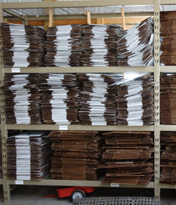Keep boxes shelved close to where they will be needed, in a bird, rodent, bat and vermin free area. Below produce boxes are covered with plastic to keep dust out.
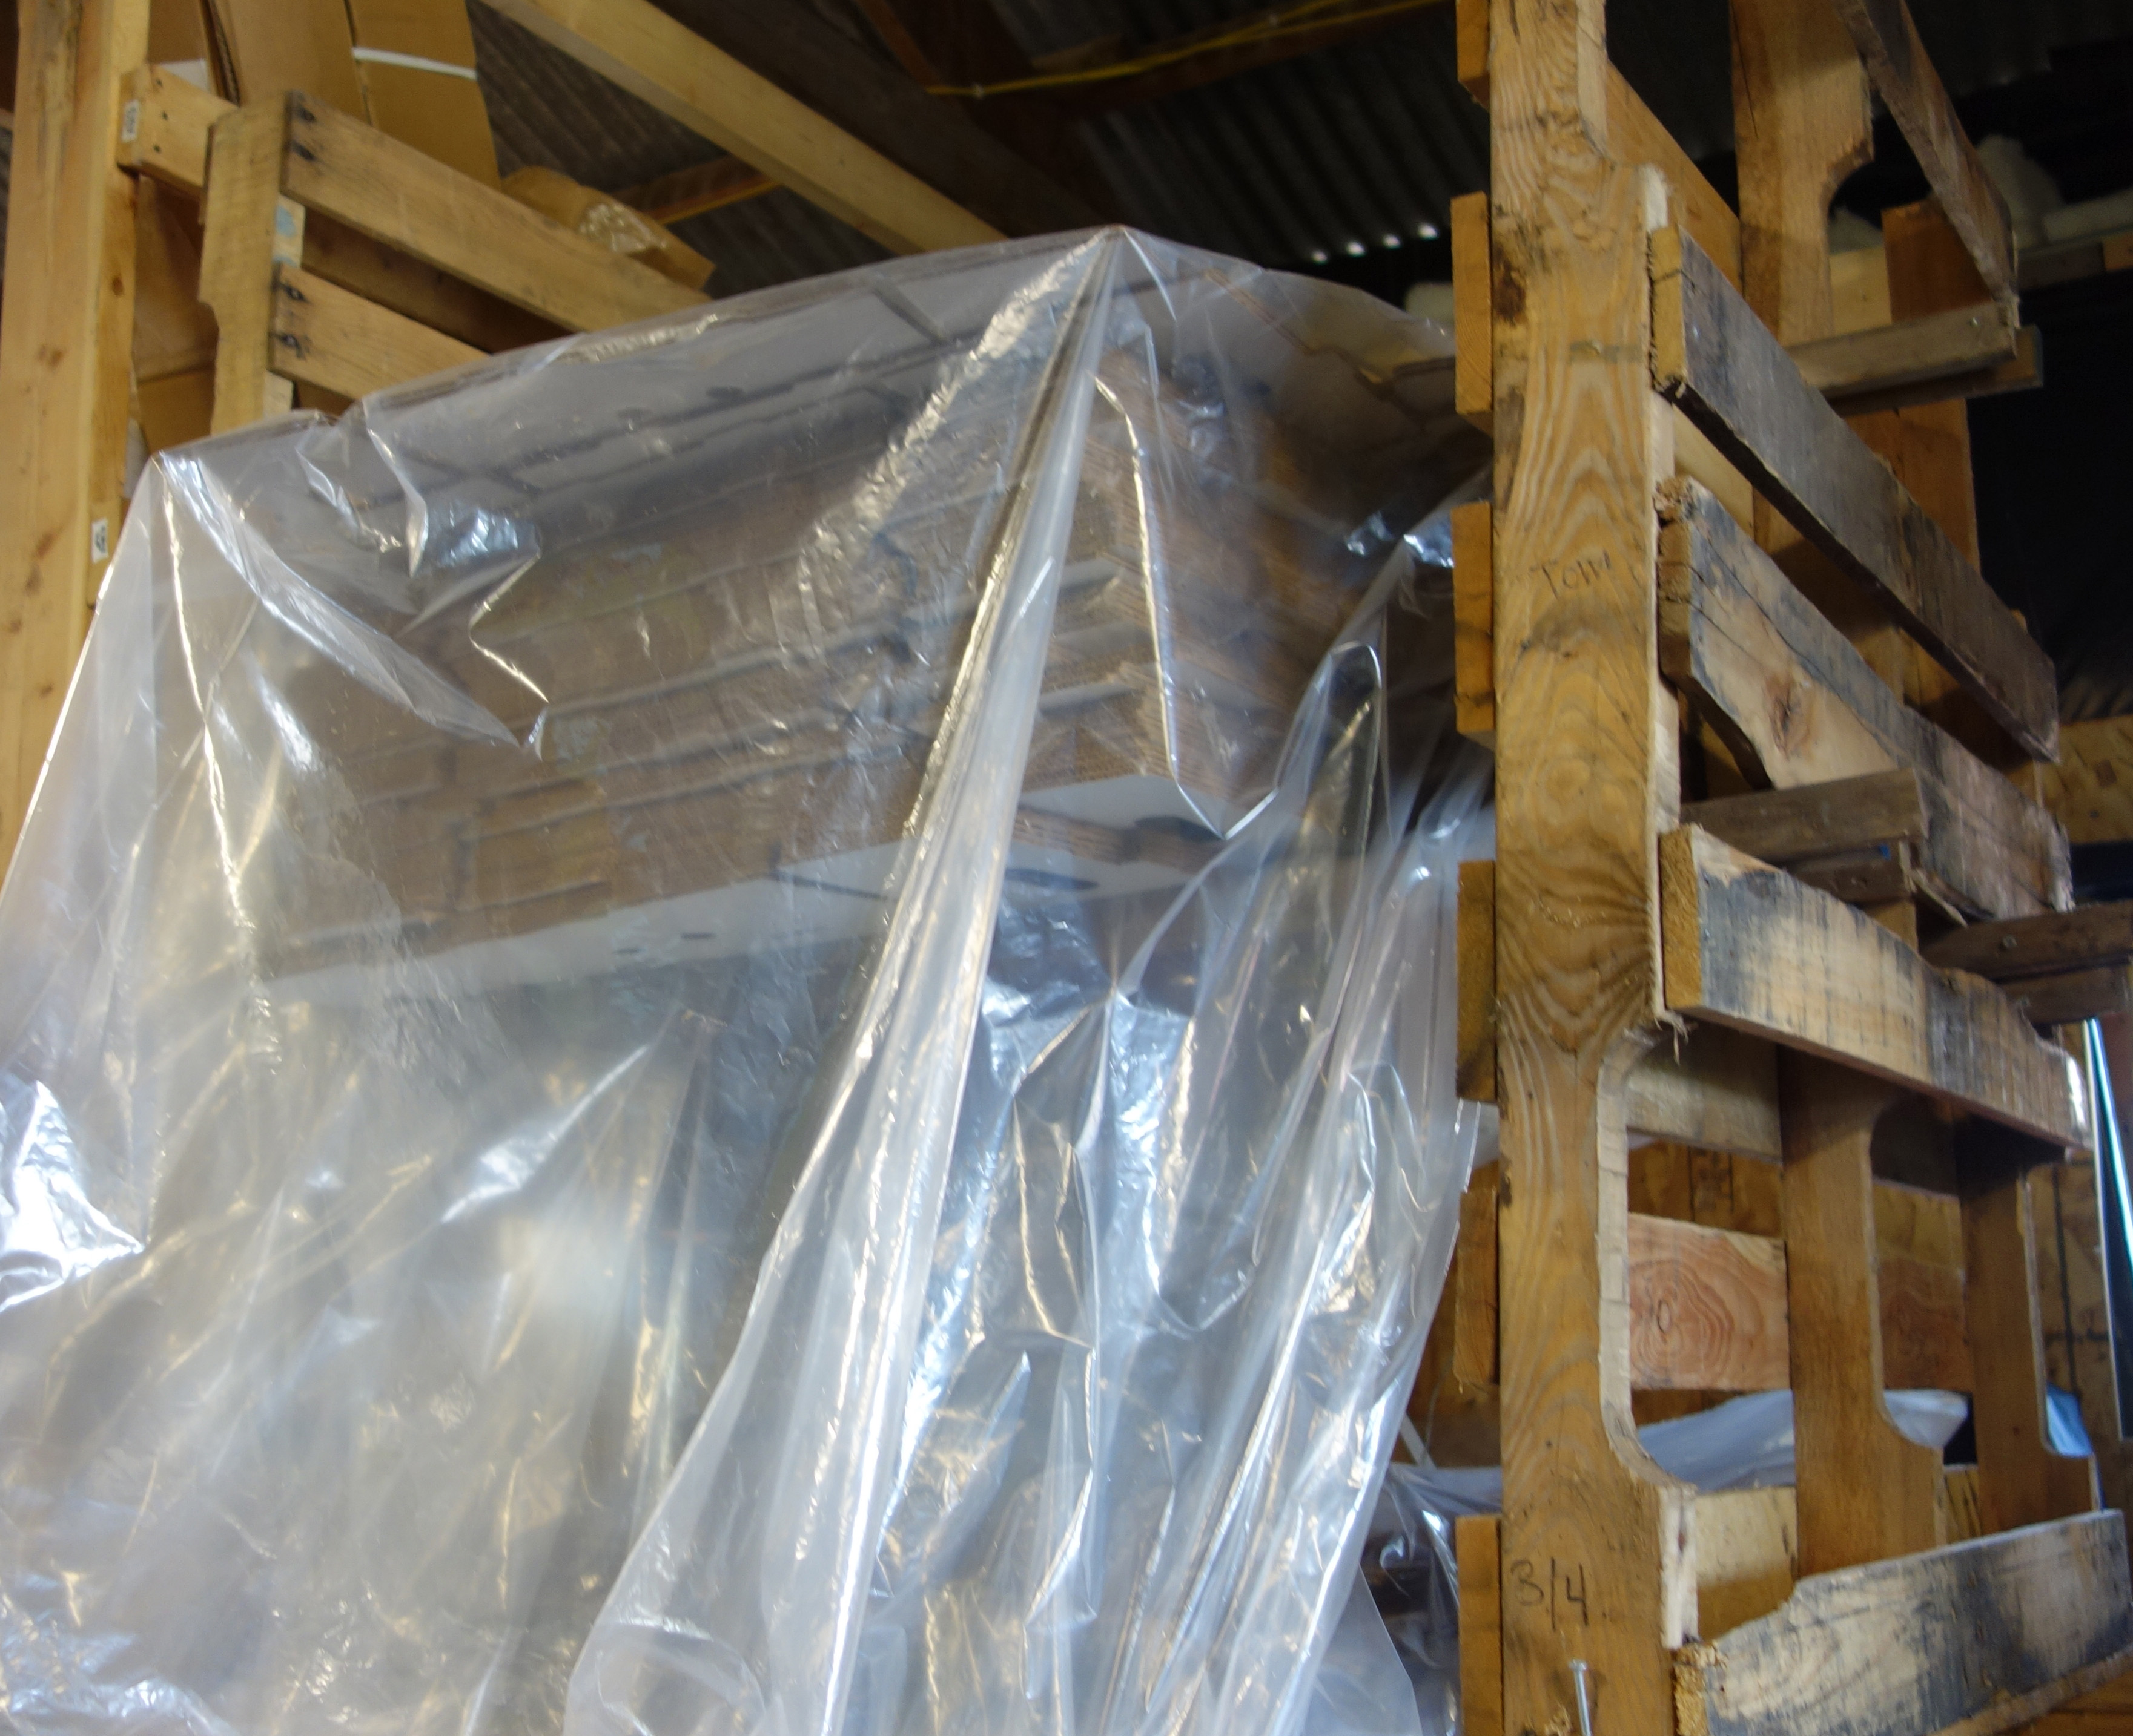

Some farms put up a building large enough to grow into, but stay within their financial parameters by waiting on some of the improvements, such as insulation and year round heat. Another strategy is to rent or buy refrigerated trucks for storage the first few years before installing a room cooler. Others leave space around the pack shed to add on in the future.

Designing Your Pack Shed and Post Harvest System.

Location and Access: Produce needs to be cooled quickly. Close access from fields and multiple entrance points can help the produce enter the pack shed and flow into multiple work areas. Easy loading and unloading for field and delivery vehicles is important and can be accomplished with multiple loading dock heights. Shady locations help keep buildings cool. A pack shed is a high traffic area, with harvest vehicles coming in and out, backing up and parking. Allow space around the building.

Pack Shed Functions and Tools: Here is a list of pack shed functions and tools to consider in your design:
- Wet areas:
  - Workspace with access to water and good drainage for washing tanks, spray-wash stations, mechanical pack lines, drain tables, or salad spinners.
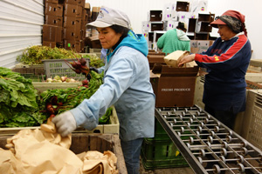
Roller tables can be easily moved where needed to roll boxes and reduce lifting.
  - Work space for cleaning and sanitizing field harvest totes and harvest tools.
  - Storage space close at hand for cleaners and sanitizers and related equipment.
- Cooling: Equipment for cooling such as—hydro-cooling, icing, room cooling, and/or forced-air and sufficient space and access to move produce in and out of cooling systems.
- Curing: Screens, racks or hanging space for garlic, onions, winter squash, or sweet potatoes. Curing is done in fall. This space can be used for other compatible uses during other seasons.
- Produce Storage: While many crops are cooled without a room cooler, most need one for storage. Be sure to identify the storage temperature needs of your crops and how will they be met with room coolers, winter storage, and dry storage.
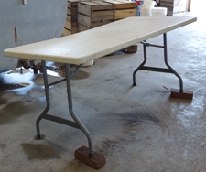Bricks placed under the legs of one side of a worktable convert it to an inexpensive drain table.

.
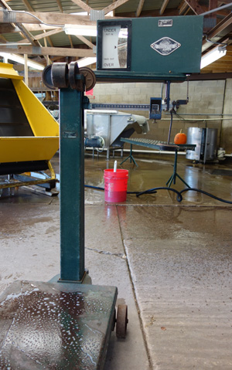
Platform scales are durable and roll easily on concrete floors for weighing heavy boxes.
- Work Tables and Pack Areas: Tables for bagging and banding and bunching.
- Scales: Electronic or platform, portable or stationary. If you sell produce by weight you must have a scale certified for commerce. When purchasing a scale, be sure that it is calibrated and certified as legal for trade, also called trade-legal. Look for the acronyms NTEP (National Type Evaluation Program) or NCWM (National Conference on Weights and Measures.) Many scales available on the market are not trade-legal for commerce. Work with a reputable scale company or go to your state’s department of commerce for specific information.
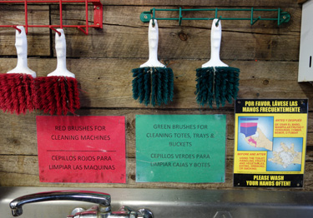
At Harmony Valley farm, designated cleaning tools and supplies are color-coded specific for each task and labeled. Red tools are for cleaning machines, yellow for toilets, and green for tools, tanks, and buckets. Photo Atina Diffley.

- Supply Storage: Pack shed supplies should be kept close to where they will be where needed: Packing boxes, bags, rubber bands, twist ties, field totes.
- Cleaning Tool Storage: Designate brushes and tools for specific tasks: produce cleaning, bathroom buckets, brushes, clothes, floor cleaning equipment, equipment scrubbing.
- Desk Central: Business center needs.
- Information: Wall space for informational signs.

Light: For inspecting produce, bright light that shows every flaw is needed. Increasing natural light is helpful. Translucent skylight roof panels can be used in pole barns. Large doors can be kept open. Use net curtains to keep out birds.
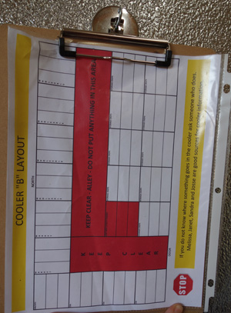
Providing a color-coded cooler chart is part of the food safety plan at Grinnell Heritage farm.

Halogen lights or SP-30 fluorescent lights can be hung directly over sorting and packing areas. Cool white fluorescent light is too soft and makes it hard to see discoloration and spoilage. Make sure to shield bulbs so that if they break, glass shards will not contaminate any produce.

It is important to know that fluorescent bulbs contain toxic mercury. If a bulb is broken, mercury vapor is released. All people and animals should leave the space for several hours until the room is aired, then clean up all glass and any visible powder and seal into two plastic bags. For disposal, contact your state or local environmental regulatory agency. Some jurisdictions permit you to put fluorescent light bulbs in the garbage; others will ask that you take it to a hazardous waste site. Never send a fluorescent light bulb or any other mercury-containing product to an incinerator. To read more http://www.energystar.gov/ia/partners/promotions/change_light/downloads/Fact_Sheet_Mercury.pdf
Water: Wash water must be potable (safe to drink). Sanitizers become inactive when they bind with organic materials and dirt, plan for changing wash tank water regularly to prevent the spread of pathogens from one crop to the next. Two or more tanks may be needed. Plan for water delivery overhead rather than on the ground.

Electricity: Plan for growth; it can be expensive and challenging to add later. Be sure your panel and service can handle the electric load. Most equipment runs on 110-volt, although refrigeration and ice machines may require 220-volt. A 200-amp panel with 220-volt potential can be a good size. Locate the panel in an area that is accessible and away from all water use. Use ground fault circuit interrupters on outlets and keep extension cords and outlets well clear of wet areas. Service electricity for mechanical equipment from overhead; do not run extension cords on the floor.

Walls and Floors: Walls should be easily cleanable, non-chipping, and non porous. Steel paneling, glass board siding, or food-grade plastic wallboard with washable epoxy paint is commonly used. Concrete floors are easy to clean and allow for pallet jacks and carts; a slight slope toward drains makes it easy to wash them down. Wood chips or dirt are rough and unsanitary.
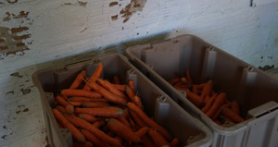
Walls with peeling paint or chipping materials pose food safety issues and should be repaired or covered.

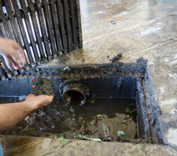
Design floor drains with enough depth that mud can settle to the bottom before water drains out. Clean them weekly. Pathogens can breed in drains and infect produce.
At Grinnell Heritage farm the next step in the drain system is an outside settling basin. Mud has a second chance to settle out before leaving through the drain on the right where it flows out to a drain field. This design allows easy access for cleaning.
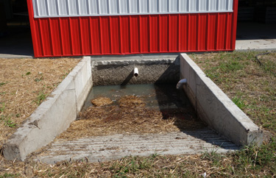
Drains: Attach drain hoses to wash tanks, sinks, and mechanical washers to carry water out of the work area.

Some local jurisdictions require that wash water be put through a septic system. If so, don’t drain it into your home’s septic—there is too much water and soil. When installing floor drains, include enough depth for soil to settle out of the water. Some growers install settlement tanks or basins to collect much of the soil and from there gravity drain the water into drain fields or run it as grey water into a wood lot or other non-produce growing area. A drainage bed deeply filled with gravel can provide an inexpensive way to move and filter water.

Pack shed water can be a carrier of plant pathogens. It is not recommended to use it for watering crops. Do not drain pack shed water into natural wetlands.

Cleanliness and Food Safety: Sanitation is crucial in produce packing sheds. Food-borne illness is serious, real, and a relevant issue for produce handlers of every scale, type, and production method—small or large, organic or non-organic, local or international.
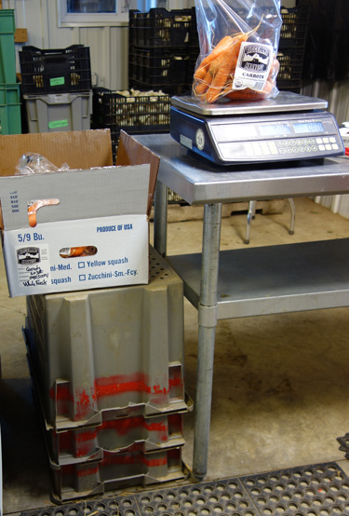Field totes are commonly used in pack sheds for height-adjustable “portable-tables” to set boxes on, or to make legs for roller or drain tables. But floors are dirty, and if the totes were later used in harvest or for clean produce storage, pathogens could be spread to produce. Ridgeland Harvest farm paints red stripes on field totes to designate pack-shed floor use only.

All farm workers must have access to a bathroom with hand washing facilities. Recommended hand-washing times of twenty seconds can seem like a long time in cold water. If hot water is not available, an on-demand electric or propane water heater can be installed relatively inexpensively. An anti-microbial hand dip is recommended.

For wash tanks, work surfaces, and equipment use materials that are easily cleaned and sanitized, such as seamless tubs and smooth counters. Do not use painted wood, or materials that can chip, or splinter. Plan for cleanliness: store designated cleaning tools, and cleaning and sanitizing supplies close at hand. Create a recording system and standard operating plan to ensure the cleaning tasks are done. Template log sheets are available at http://onfarmfoodsafety.org/forms-and-templates/

Birds, rodents, bats, pets, and other vermin need to be kept out of the pack and storage areas. Attach bird netting to undersides of rafters to prevent birds roosting, and hang net curtains in open doorways and walls. Bird scare eyes can be effective to keep birds away from entrances. Have a trapping system for rodents. Plastic sheeting can be used to cover boxes and other supplies to help keep clean.

Functions Separation: It is a good food safety practice to separate un-clean produce and cleaning operations from cleaned produce. Strategies include:
- Establish well-documented, designated storage areas for un-cleaned produce separate from cleaned produce. Produce that is picked clean, such as broccoli, is stored in the clean area.
- Design pack shed cleaning processes in one direction of movement to prevent back-tracking.
- If possible, remove bagging from cleaning and sorting operations, preferably in a separate room.

Ergonomics: Worker comfort and safety should be considered. Workstation heights should be comfortable – adjustable heights are best; step stools or chairs can be provided. According to the Healthy Farmers, Healthy Profits Project at the University of Wisconsin, the most efficient work table height is halfway between the wrist and elbow, measured when the arm is held down at the worker’s side; slightly lower for heavy items. Using legs built of stacked field totes can be a simple way to change work heights for different workers.
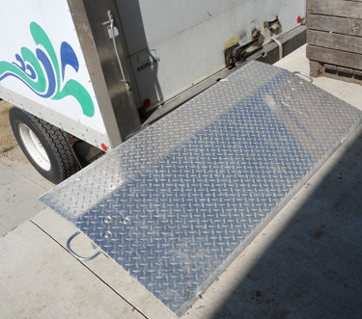A dock plate used to bridge the gap between truck and dock makes for easier loading at Ridgeland Harvest farm.

Work Flow: Design pack areas for efficiency. Look at the workflow from the produce entering the area, and moving through each stage of cleaning, drying, cooling or curing, into storage and then transportation. Are there uncluttered paths for workers to follow? Do the paths intersect with each other, increasing the risk of collisions? Is there enough space to work and move around with carts, or pallets? Are water and electricity available at convenient locations? An example of efficient and inefficient designs is shown below.
KEEP this Illustration presentling in the manual, FIGURE 10: Packing area designs. Use here next to work flow and ergonomics.
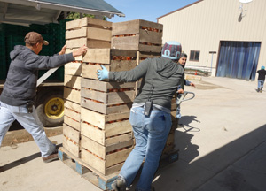
At Harmony Valley farm, a concrete pad between pack and storage facilities allows pallets of produce to be moved by pallet jack.

Product Handling: Design the handling process and facilities to minimize lifting and hand carrying and time spent moving product. Transportation systems should move produce quickly from the field to the pack shed, and with protection from the sun, wind, and dirt. Once in the pack shed, move produce on pallets or carts to minimize lifting and carrying. A standard 2-wheeled handcart will carry four to five bushel boxes and the boxes will need to be lifted again to unload and then set up on a pallet or shelf to keep them off the floor. A pallet jack is easily paid for considering it can move up to forty bushel boxes, or bins holding 1,000 pounds of melons and no further lifting is needed.

REMOVE This Text Panel Hands-Free Washer
For harvest, Diffley’s Gardens of Eagan used multiple aluminum u-haul boxes on pick-up trucks to keep sun, wind and dust off of produce, and to minimize handling. Field crews backed filled trucks up to the pack shed, and then pack shed staff simply rolled a platform scale up to the back of the truck and packed right off the truck into shipping containers, iced the full cartons, and then moved them with a pallet jack into the room cooler. Packing directly out of the truck eliminated the labor of unloading, and allowed for quick cooling and placement into cold storage.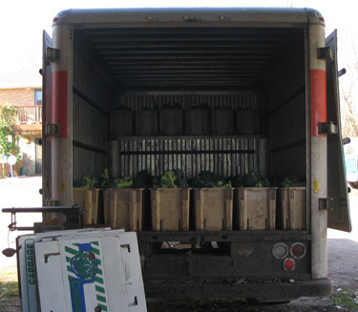
Remove photo from Michael fields of bean washing.
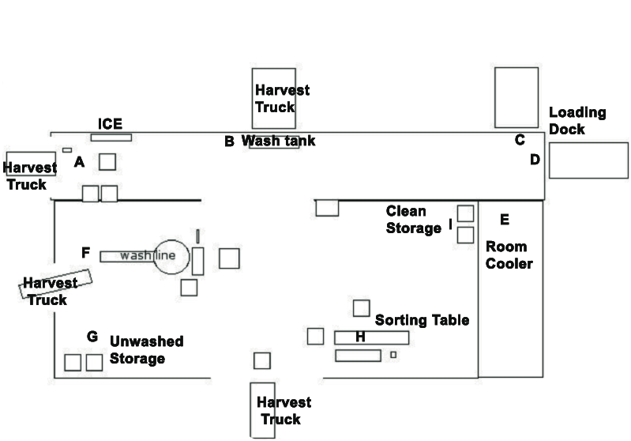
The pack shed at Diffley’s Gardens of Eagan was designed to provide access to multiple workstations. This allowed multiple crops to be packed at the same time and reduced the need to unload trucks. In area A, harvest trucks with crops that need to be iced backed up for packing and icing. Area B had two large washtubs for hydro cleaning and cooling. Trucks backed right up to water tanks and put produce directly into the water. Produce was packed and placed on pallets, and then moved into the room cooler. Area F was set up with a wet brush washer and pack line. Trucks backed up to the washer with peppers, cucumbers, potatoes, melons, and winter squash and the produce was fed directly from the truck into the pack line. Area H was a well-lit sorting table used predominately for tomato packing.

Pack Shed Tour of Ridgeland Harvest Farm
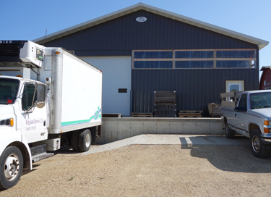
The loading dock has one bay for their standard dock height delivery truck and two bays for the lower pick-ups that haul in produce from the field. 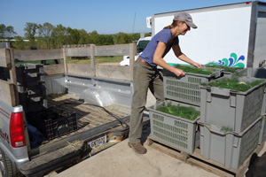
Ridgeland Harvest is a diverse, certified organic farm selling vegetables and meat through farmers markets, a CSA, restaurants, and to local food cooperatives. After eight years of packing in converted outbuildings, Cate and Matt Eddy built a new metal pack shed. Efficient access was an important consideration, so there are five entrances. A floor drain system carries water out to a settling tank, and then gravity feeds into a drain field.
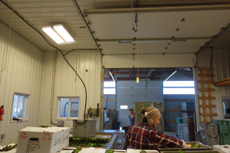
The main cleaning, cooling, pack, and storage area is a well-lit, insulated and heated room, built inside of an unheated, metal building where pack-related supplies and tools are stored.

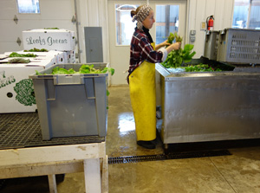
A stainless steel bulk milk tank is used for hydro cooling. PolyMat drain tables are close by to drip-drain washed produce and set packing boxes on.

Pack Shed Tour of Small Family CSA Farm
A diverse vegetable and meat operation primarily selling through their CSA and a farmers market, Jillian, Adam, and Mama Jane use multiple structures, some converted and others new. A converted dairy barn is the main cleaning and packing facility. It was already set up with water, concrete floors, insulation, electricity, a heating unit, and floor drains. Jillian says, “The sheet metal and glass board siding we added were expensive, but easy to clean and well worth the investment.” A greenhouse and metal storage shed are used for curing and storage of winter squash and garlic and onions.
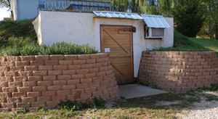
A combination root cellar and Cool-bot room provides room cooling and cold storage.
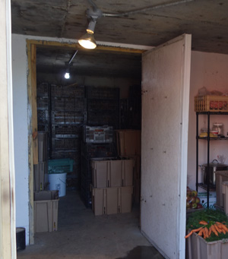
In 2009 they built a new root cellar for storage 80 feet from where they pack. “It feels very in-efficient to walk or drive produce over to the cooler, but to build an energy saving root cellar with an in-ground cooling unit it needed to be built into a hill, and that is where the hill is. We considered building a room cooler in the barn where we pack, but I was dead set on building that root cellar.”
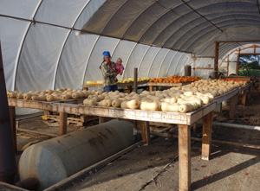
Winter squash is cured and stored in a wood heated greenhouse.

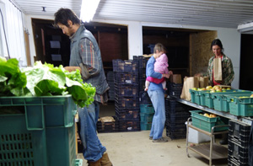
The main wash and pack space is in the lower level of an older dairy barn. A roller table with legs made of stacked field boxes is set up when and where needed. Sheet metal and glass board siding have been installed on the ceiling and walls. Below hydro cooling/cleaning is done in a steel, bulk milk tank.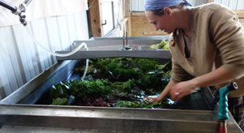

Pack Shed Tour of Grinnell Heritage Farm
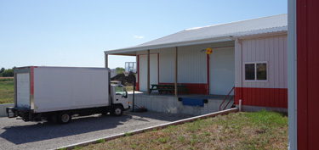
The pack shed at Grinnell Heritage Farm has three loading dock truck bays that service two large overhead doors into the pack shed. A bird scare balloon is used to discourage birds from flying and roosting near the entrance.
A diverse farm selling organic vegetables, fruits, flowers, and herbs, to CSA, farmers markets and wholesalers, Andrew and Melissa Dunham started Grinnell Heritage farm in the fall of 2006 after three years of experience working for other farms. They used existing older buildings and rented refrigerated trucks until they built their new pack shed in 2011. Andy says, “We looked at the numbers and decided we could cover the debt, and we had enough experience that we knew we could grow the produce.” They only insulated behind the coolers with the idea that they’ll insulate and side the rest when they have the cash on hand.
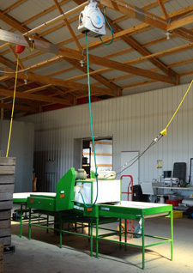
Electric lines and water hoses service equipment from the ceiling rather than the ground to help prevent accidents.
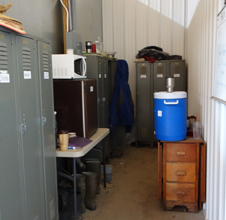A designated separate space for boots, clothes, food, and beverages helps keep the pack area clean, clutter free, and is a good food safety practice.

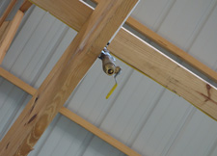
Water hose hook-ups are secure in the ceiling.

Pack Shed Tour of Harmony Valley Farm
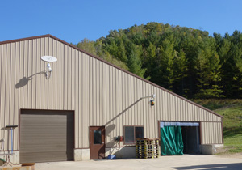In 2005, a new pack shed was built to supplement the original Harmony Valley pack shed. A bird scare balloon keeps birds away from the entrance. A net in the open door keeps birds out.

Richard de Wilde has been growing organic vegetables since 1973, and now ships to wholesalers, sells at farmers market, and supplies CSA shares to over 1500 families. Harmony Valley ships year round from 100 acres of diverse production, requiring a well-designed and efficient packing system and a well-trained and supported crew. Harmony Valley is GAP certified and a leader in good food safety practices.
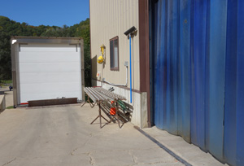
A loading dock on the side of the new pack shed allows trucks to be unloaded with pallet jacks. Plastic door strips keep heat and birds and animals out while allowing people to enter hands-free when hauling loads.
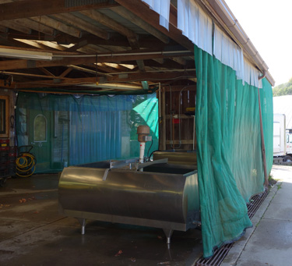
The original pack shed at Harmony Valley uses net curtains, custom ordered from SunWorld, to prevent birds from entering.

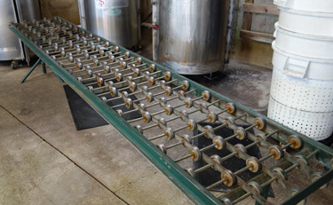
Portable roller tables can be moved and set up where and as needed.

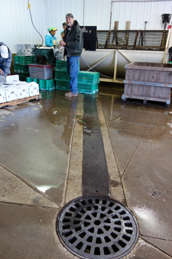
The mechanical brush washer drains into a floor drain and sediment tank.

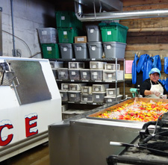
Twist ties for bunching greens and other packing supplies are kept dry and clean in a corner of the pack shed. Ice is close to the washing and cooling tank.
Greenhouse racks used for curing onions are stacked out of the way next to the concrete blocks used for screen “legs.”
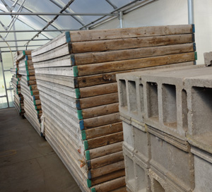

Authors: Atina Diffley, Dennis Fiser, Delia Hollbach, Amanda Korane,

Kitinoja, L., and Kader, A. 2002. Small-Scale Postharvest Handling Practices: A Manual for Horticultural Crops. University of California, Davis. 130.
Meyer, B. et al. 2000. Work Efficiency Tip Sheet: Packing shed layout. University of Madison Wisconsin. http://bse. wisc.edu/hfhp/tipsheets_pdf/shed4web.pdf

