Section 7. Storage and Transportation

Maintaining the cold chain with proper temperatures and humidity levels during storage and transportation are essential for prolonging the shelf life of produce, and to slow the spread of disease and decay.

Temperature and Humidity
Recommended storage temperature and humidity needs vary by crop; specific recommendations are provided in the table below, in quick-read charts in Section 4. Cooling, and in the crop profiles at the back of this manual.

Many crops are stored and transported close to 32°F (0°C) with 90-98% humidity. Storing these crops at warmer temperatures and lower humidity will significantly shorten their shelf life and quality.

Other produce, such as peppers and tomatoes, are “chill-sensitive,” and they need to be stored and transported at warmer temperatures. To prevent chill damage of these crops, it is the temperature of the produce that needs to be considered, not necessarily the air temperature of the refrigeration environment. For the purpose of cooling, chill-sensitive produce can be placed in a room cooler that is colder than its ideal storage temperature, and then moved or otherwise protected from the cold once the produce has reached storage temperature. Chill damage does not occur until the produce is cooled below its ideal storage temperature. It is important to know that chill injury often isn’t easily visible on the produce until days after the damage has been done.

Ideally the temperature of the produce should never vary more than one degree in either direction of the ideal temperature during storage and transportation; however, this level of precision may be difficult to achieve, especially when shipping mixed loads. Make sure the temperature will never fluctuate too low, resulting in chilling-injury or freezing.

Humidity below recommended levels can result in detrimental moisture loss. Generally room coolers have high humidity levels during the summer growing season and do not need additional humidity added. It should be noted that humidity around 100% can increase the growth of molds or other diseases, and high levels of humidity can cause refrigeration coils to freeze-up resulting in downtime to defrost. Keeping refrigeration coils clean can help to minimize freezing-up.
According to organic produce distributor Goodness Greenness, some organic produce needs to be stored at different settings than conventional because they do not use mold or sprout inhibitors. Organic shallots, onions, dry herbs and cranberries should be stored at 32 to 36°F with low humidity. Organic potatoes should be stored at 34 to 36°F with low humidity.

During winter storage many crops will need specific humidity management. Humidity can be increased with mechanical humidifiers or fog spray nozzles. Less costly strategies include: creating micro-climates by covering produce with plastic to hold humidity in and keep air out, or water sprayed on the floor as needed. Spraying water on the floor increases the potential for food safety issues. Floors should be cleaned and sanitized regularly, and care needs to be taken so that water doesn’t splash up on produce.

Recommended Storage Temperature and Relative Humidity Groups
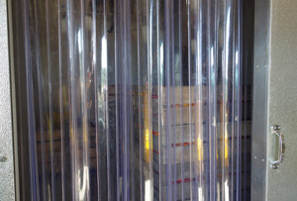
Use plastic door strips to reduce loss of cold air loss, especially when doors are opened frequently. Photo Atina Diffley

32 to 36°F, 65-75% relative humidity.
Moisture will damage these products.
Garlic, Onion (dry)

32 to 36°F, 90-95% relative humidity.
Many products in this group produce ethylene.
Apples, Apricots, Asian pears, Beets topped, Berries (except cranberries), Cherries, Coconuts, Figs, Grapes, Horseradish, Kohlrabi, Leeks, Loquat, Lychee, Mushrooms, Nectarines, Oranges, Parsnips, Peaches, Pears, Persimmons, Plums, Pomegranates, Prunes, Quinces, Radishes, Rutabagas, Turnips

32 to 36°F, 95-100% relative humidity. These products can be top-iced. Many products in this group are sensitive to ethylene.
Amaranth,* Anise,* Artichokes,* Beets,* Broccoli,* Brussels sprouts,* Cabbage,* Carrots,* Cauliflower, Celeriac,* Celery,* Corn sweet,* Daikon,* Endive,* Escarole,* Kohlrabi,* Leafy greens, Leeks,* Onions green,* Parsley,* Parsnips,* Peas,* Radishes,* Rutabagas,* Spinach* Turnips,*
The cold storage needs of Ridgeland Harvest farm are met with two room coolers set for different temperatures and airflow.

32 to 36°F, 95-100% relative humidity.
Many products in this group are sensitive to ethylene.
Asparagus, Bean Sprouts, Belgian endive, Berries (except cranberries), Bok choy, Cauliflower, Cherries, Grapes, Horseradish, Jerusalem artichoke, Kiwifruit, Leafy greens, Lettuce, Lo bok, Mushrooms, Pomegranate, Raddichio, Rhubarb, Salsify, Scorzonera, Snow peas, Water chestnut, Watercress

50°F, 85-90% relative humidity.
Many of these products are ethylene sensitive. These products are sensitive to chilling injury.
Beans, Cucumber, Eggplant, Okra, Olive, Peppers, Potatoes storage, Squash summer

55 to 60°F, 85-90% relative humidity.
Many of these products produce ethylene. These products are sensitive to chilling injury.
Avocados, Bananas, Bitter melon, Breadfruit, Ginger root, Grapefruit, Guava, Jackfruit, Lemons, Limes, Mangoes, Melons, (except cantaloupes), Papayas, Pineapple, Plantain, Potatoes new, Pumpkin, Squash winter, Tomatillos, Tomatoes ripe

65 to 70°F, 85-90% relative humidity.
These products are sensitive to chilling injury.
Jicama, Sweet potatoes, Watermelon, Pears (for ripening),Tomatoes (mature green)

Mixed Produce Storage
The ideal storage infrastructure for mixed produce farms is to have multiple room coolers set to different humidity and temperature levels. For small farms, it may be too expensive to build multiple room coolers. Low cost strategies that protect chill-sensitive produce while meeting the needs of cold requiring crops include:
- Shipping produce soon after harvest and cooling-to-storage-temperature can eliminate the need for ideal storage conditions for multiple produce types. The room cooler could be kept at 35° to meet the needs of the cold-requiring crops. Chill-sensitive crops can be in the cold room also, as long as they are removed before they go below their ideal temperature.
- Multiple temperature zones can be created in one room cooler by hanging sheets of plastic and controlling the amount of airflow between them.
- Chill sensitive crops, such as basil, can be kept in insulated boxes or coolers inside of room coolers to keep the cold out.

ATTENTION: Remove page 249 and 250 – building a porta-cooler -- from the manual. It is out-dated information. It does not have sufficient temperature control or cooling capacity and the more recently developed Coolbot solves this problem with air conditioner built units. (Jim Agrees)
At Small Family CSA, two different temperature/humidity zones are accomplished by a combination root cellar and Cool-Bot room cooler.
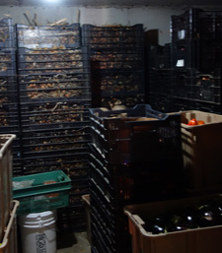The inner room, above, is designed as a root cellar, with outdoor ventilation and higher temperature/lower humidity than the outer room cooler, below.

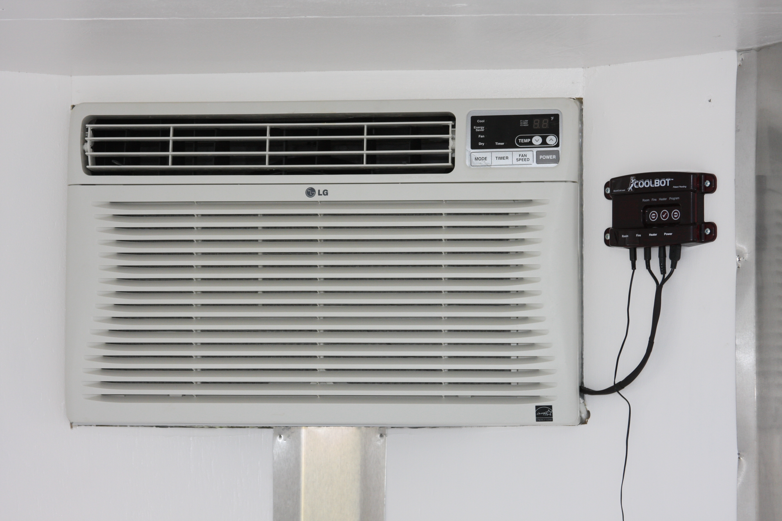An easy to install CoolBot can turn almost any brand of window-type air conditioning unit into a cooling machine that cools down to 35° F. Advantages compared to traditional refrigeration compressors include saving money on installation and repair costs, and reducing electricity use. Disadvantages include CoolBots take longer to cool, recover slower after the door is opened, do not function below 36°F if the door is opened frequently, and require a cold tolerant air conditioner to run in the winter.

Produce Groupings

Besides temperature and humidity groupings, other issues to be considered in mixed produce groups during storage and transportation include the transfer of odors and ethylene production.

Cross Transfer of Odors
A cross-transfer of odors can occur when produce of different types are stored together. This is generally not an issue in the shorter time frame of transportation but can be an issue during storage. Combinations that should be avoided include:
- Apples or pears with celery, cabbage, carrots, potatoes, or onions (apples and pears acquire an unpleasant, earthy taste and odor when stored with potatoes)
- Apples or leeks with figs
- Odors from apples are readily absorbed by meat, eggs, and dairy products
- Citrus with any strongly scented fruit or vegetable.
- Green peppers and avocados will taint pineapples
- Ginger with eggplant
- Truffles can significantly affect the odor of other produce.
- It is recommended that onions, nuts, citrus, truffles, and potatoes each be stored separately.
Quality Test: Hold a box of produce back from the market and see how it holds up in your storage. Does it reach its maximum shelf life? If not, what can you do to improve it.

Ethylene and Its Effects on Fresh Produce
Ethylene is a colorless gas that is naturally produced by plants and functions as a plant growth regulator. In this way, ethylene behaves in the same way as hormones in mammals; it triggers specific events during a plant’s natural course of growth and development, such as ripening. Through this action, it induces changes in certain plant organs, such as textural changes, color changes, and tissue degradation. Some of these changes may be desirable qualities associated with ripening; in other cases, ethylene can cause damage or premature decay.

Examples of Ethylene Damage in Fresh Produce:
• Russet spotting of lettuce (dark-brown spotting on the mid-ribs of lettuce leaves)
• Yellowing or loss of green color (e.g., in cucumber, broccoli, kale, spinach, and acorn squash)
• Increased toughness in turnips and asparagus spears
• Sprouting in potatoes
• Yellowing and dropping of leaves in Brassicas
• Softening, pitting, and development of off-flavor in peppers, summer squash, and watermelons
• Browning and discoloration in eggplant pulp and seed
• Discoloration and off-flavor in sweet potatoes
• Increased ripening and softening of mature green tomatoes
• Development of bitter taste in carrots and parsnips

Ethylene Producers and Ethylene Sensitive
Fruits and vegetables may be classified depending on their response to ethylene. Some crops, such as bananas, apples, and peaches, increase ethylene production as they ripen, and the harvested produce is capable of ripening during the postharvest period, getting sweeter and softer after harvest. Other crops, such as leafy green vegetables, are ethylene sensitive and do not continue to ripen after harvest. They will soften and rot, due to moisture loss, decay, and tissue deterioration, and can be damaged by exposure to ethylene. Fruits and vegetables that are ethylene sensitive should be stored separately from fruits that produce ethylene, or other protective measures should be taken.
Quality Test: Hold a box of produce back from the market and see how it holds up in your storage. Does it reach its maximum shelf life? If not, what can you do to improve it?

- Ethylene producers: Apples, apricots, cantaloupe, coconuts, figs, longon fruit, loquat, lychees, mushrooms, nectarines, oranges, peaches, plums, persimmons, pomegranates, pears, and tomatoes.
- Ethylene Sensitive: Artichokes, beans, broccoli, Brussels sprouts, cauliflower, cabbages, carrots, chard cucumbers, eggplants, endive, herbs, leafy green vegetables, lettuces, mushrooms, okra, peas, peppers, radishes, squashes, sweet potatoes, watermelons, water chestnuts, watercress

Other Ethylene Sources
In addition to being naturally produced by plants, ethylene is produced by a variety of other sources. These include internal combustion engines, cigarette smoke, and natural gas leaks. Even low concentrations of ethylene throughout the postharvest life of a commodity can affect quality, so care must be taken to minimize exposure to both natural sources (i.e. ethylene producing fruits or veggies being stored with ethylene sensitive ones) and to artificial sources (engine exhaust, heaters, etc). All ethylene- producing sources should be considered when optimizing postharvest storage conditions, since inadvertent exposure to ethylene can contribute to loss of quality in certain produce.

In order to reduce ethylene exposure during storage, the following steps can be taken:
- Store and transport at the lowest safe temperature; less ethylene is produced than at warmer temperatures, and produce is less sensitive to ethylene at lower storage temperatures
- When possible, using electric powered equipment in storage areas instead of gas powered
- Remove overripe or rotting fruit from storage loads (these produce higher amounts of ethylene)
- Avoid storing ethylene-sensitive products with products that produce high levels of ethylene
- Increase the ventilation rate of the storage area, assuming that the outside air is ethylene-free
- Use ethylene scrubbers in storage areas to remove ethylene in the air. (There are multiple types of ethylene scrubbers. One uses ozone, and it works well as a cleaner, but in higher ppm-ranges, can be hazardous to personnel. In another, air is drawn through tubes coated in thin layers of titanium dioxide (TiO₂). The insides of the tubes are exposed to ultraviolet light, which creates a simple chemical reaction, converting the ethylene (C₂2H₄) into trace amounts of water (H₂O) and carbon dioxide (CO₂).)

Transportation And The Cold Chain.
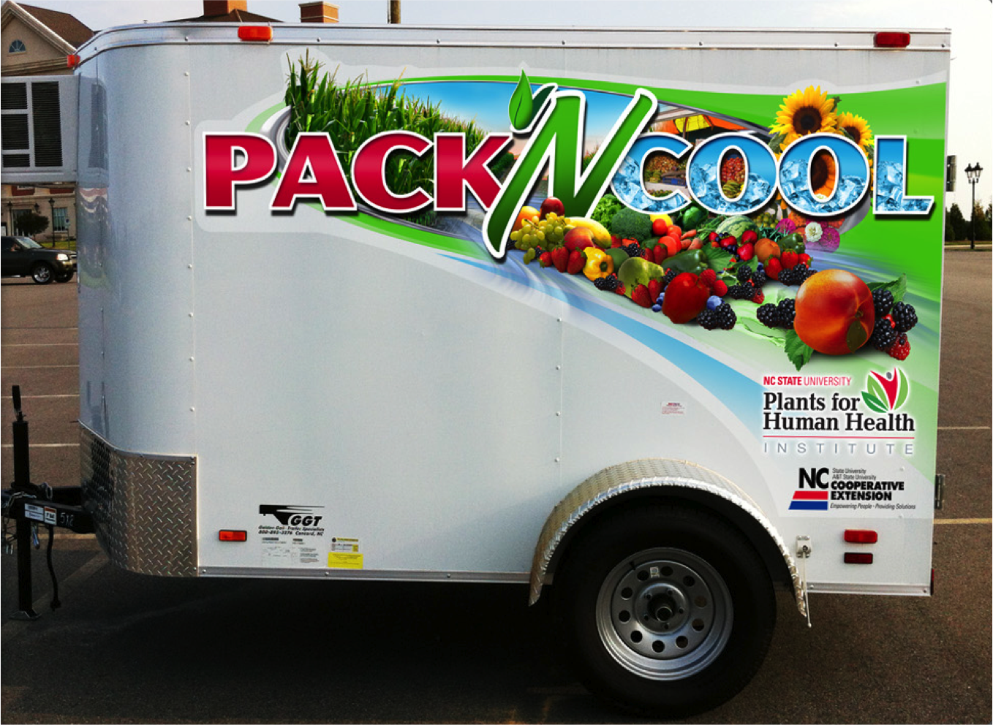
The Pack N’ Cool, mobile refrigerated unit, developed by Dr. Perkins-Veazie at N.C. State University, combines the mobility of a cargo trailer with the refrigeration capabilities of a commercial cooler using Cool-bot technology in a cost-efficient package. Plans with photos are online at
http://ncsu.edu/enterprises/ncfreshproducesafety/refrigeration-units/pack-n-cool/

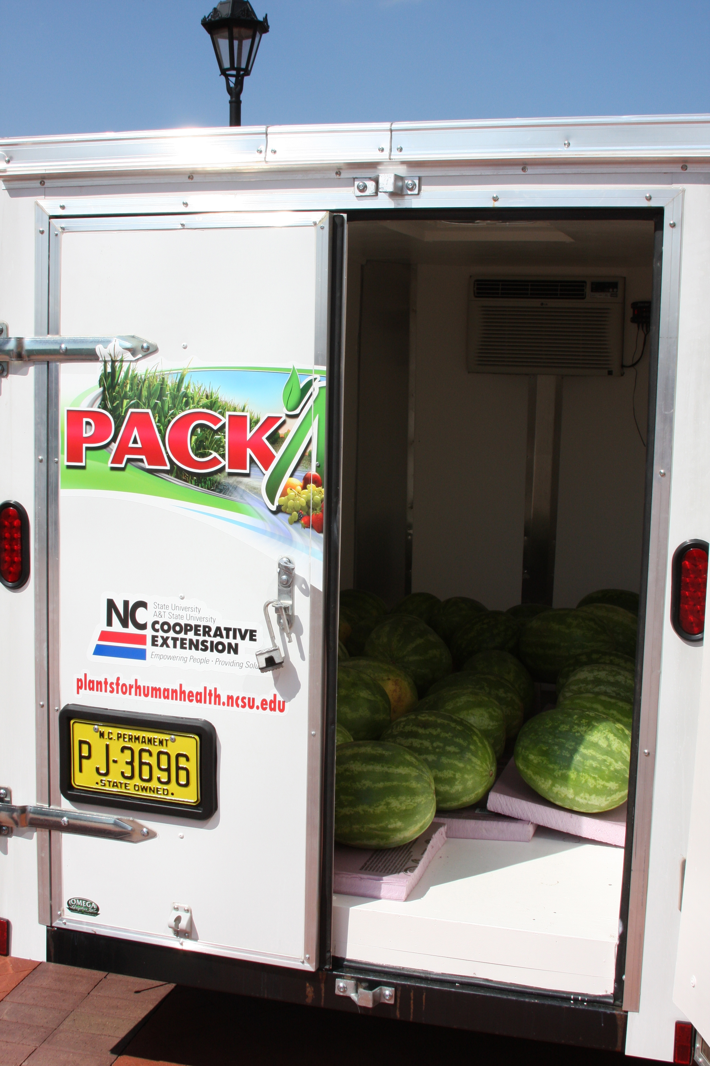

Refrigerated trucks are the most common method of transportation for produce that must remain cold during shipping though humidity is rarely controlled during shipping. When selling to a wholesaler or broker, it is common procedure for the receiver to check the core temperature of produce at the dock before accepting a load.

Ensure Proper Temperature and Protect Produce From Damage During Transit
- Pre-cool produce; most refrigerated trucks do not have the capacity to cool warm produce, only to maintain the temperature of already cooled produce.
- Ice crops that can be iced.
- Wrap chill-sensitive crops in plastic or tarps to keep cold air off.
- Pre-cool vehicle to desired temperature.
- Park in shade whenever possible.
- Record product temperatures during loading.
- Cool air is generally dispersed from the top of the refrigerated box, and less frequently from the bottom. Be certain it is not blocked.
- Leave space for air to flow over the top of produce; use pallets to allow airflow beneath.
- Avoid loading boxes tight against walls; contact with walls can warm the produce, especially in hot weather.
- Allow at least 4 inches of space between the end of the load and the rear doors for return air.
- Secure loads with load bars, or other devices, and use shrink film or netting, or strapping to keep boxes from shifting.
- For palletized loads, stack boxes alternating to avoid shifting in transit.
- Make sure that the boxes are secured to the pallets, and secure the pallets with spacers and bracing.

Shipping Without Refrigeration
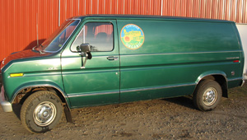
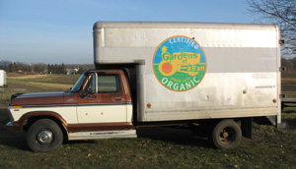
The Diffley’s Gardens of Eagan used a combination of delivery vehicles. For close and small loads, an insulated windowless van, or pick-up truck with an insulated u-haul box, could be packed with cooled produce for the short drive into the Twin Cities. For large loads or multiple stops, a refrigerated 10-pallet truck with a lift gate was used.
Some small growers do not have refrigerated transportation. A few strategies that can help to minimize damage include:
- Use a closed box truck or van that does not have windows.
- Insulate the walls and floor of the delivery vehicle.
- Deliver early in the morning when temperatures are cooler.
- Keep truck in the shade before and after loading.
- Load cooled produce shortly before departure.
- Use ice on crops that can be iced.
- Keep produce a few inches away from the vehicle walls and floor.
- Insulate cold produce in the truck with insulated blankets.
- Grow crops that are not temperature sensitive.
- Hire someone with a refrigerated truck to do your deliveries.

Preloading checklist
Before loading it is good to perform an inspection. A suggested preloading checklist includes:
- Refrigeration unit operating properly?
- Thermostat calibrated?
- Refrigeration air chutes or ducts properly installed and in good repair?
- Door seals in good condition?
- Doors seal tightly when closed?
- Walls free of cracks or holes?
- Floor drains open?
- Inside of the vehicle clean and odor free?
- Load will fit in vehicle?
- Load locks or other devices available to secure load?
- Is the trailer or container pre-cooled or pre-warmed, based on produce temperature needs?

Wholesaler Pick-up and Hiring Freight Companies
Owning, maintaining, and operating delivery vehicles can be a significant expenditure of money and time, and fuel costs can very quickly decrease profit margins.

Some wholesalers are willing to pick up on the farm, especially if the farm is close to their regular route. Even if you have your own trucks and are able to deliver to your wholesaler’s warehouse, taking advantage of their trucks can save you fuel costs and time and may be more economical.

Freight companies can also be hired to haul produce for you. You’ll want to be sure they have refrigeration that will keep your produce the correct temperature. Check that they are licensed and bonded in the event that your produce is damaged and you expect them to cover the cost. You’ll also want to know how long it will take for the produce to arrive at its destination after leaving your farm and if it will be delivered directly off of the truck that picks it up or cross-docked at a warehouse facility. An extra day added to the delivery time can be a reason to make your own deliveries, especially for produce items with a short shelf life. Produce can be hauled with non-food items as long as they will not cause harm or contaminate the produce. Ask what else will be on the truck. Price is of course another important question.

If product is damaged due to temperature issues, the key is to try and determine when the issue occurred. Could it have occurred before loading on the truck? Is there evidence that the product may not have been properly pre-cooled? Or if it was likely in transit, is there any corresponding evidence to show this? How extensive is the issue? Is it just in one product, or from one farm?

One tool is to have a temperature recorder placed on the load at the point of shipping. There are a number of different recording devices available that either manually or electronically document temperatures continually from the time the device is activated (hopefully just when it is put on the truck). The recorder cost is usually in the $23 to $30 dollar range—and usually billed to the receiving customer. Some need software to download the info (which is almost always free). Recorders are used primarily for sensitive products (berries, cherries, etc.), but most trucks that are hauling produce for multiple days have at least one recorder on. This is less an issue for shorter hauls and small loads. But it varies . . . one-pallet berry orders almost always have a temp recorder. Whereas, multi-pallet broccoli orders usually do not.

A recorder can be a useful tool for both parties. If the temperatures on the recorders look good, but the product clearly has issues, then the trucker is not responsible for the damage. And if a grower is concerned about good arrival and wants to insure the cold chain isn't broken, a recorder helps to document what happened to the product after leaving the farm.

If the product comes in too cold (more often the case than warm), or with evidence of recent chilling (like ice crystals present), then the trucking company is considered responsible.

Remove these illustrations (Jim agrees)
Loading for top-air delivery
Figure 11: Examples of loading patterns for shipping
58

Figure 12: Overhead view of loading patterns

Loading for bottom-air delivery

Section 5
Authors: Atina Diffley, Dennis Fiser, Delia Hollbach, Amanda Korane, Erin Silva

Kader, A. 2002. Postharvest Technology of Horticultural Crops. University of California. 88-90.
Recommended Storage Temperature and Relative Humidity Compatibility Groups, Keith L. Smith, Associate Vice President for Ag. Adm. and Director, OSU Extension
Wilson, L. et al. 1999. Postharvest Handling and Cooling of Fresh Fruits, Vegetables, and Flowers for Small Farms: Part IV: Mixed Loads. North Carolina State University
USDA. 2004. The Commercial Storage of Fruits, Vegetables, and Florist and Nursery Stocks. http://www.ba.ars.usda.gov/hb66/
Ashby, H. 2006. Protecting Perishable Foods During Transport by Truck. USDA. 16.
Suslow, T. 2000. Postharvest Handling for Organic Crops. University of California, Davis.
Kitinoja, L. and Gorny, J. 1999. Posthavest Technology for Small-Scale Produce Marketers: Economic Opportunities, Quality and Food Safety. University of California, Davis. 7.5.
Jobling, J. 2000. Postharvest Ethylene: A critical factor in quality management. Sydney Postharvest Laboratory.
Ashby, H. 2006. Protecting Perishable Foods During Transport by Truck. USDA. 27
. Ibid.16.

