Section 4. Cooling
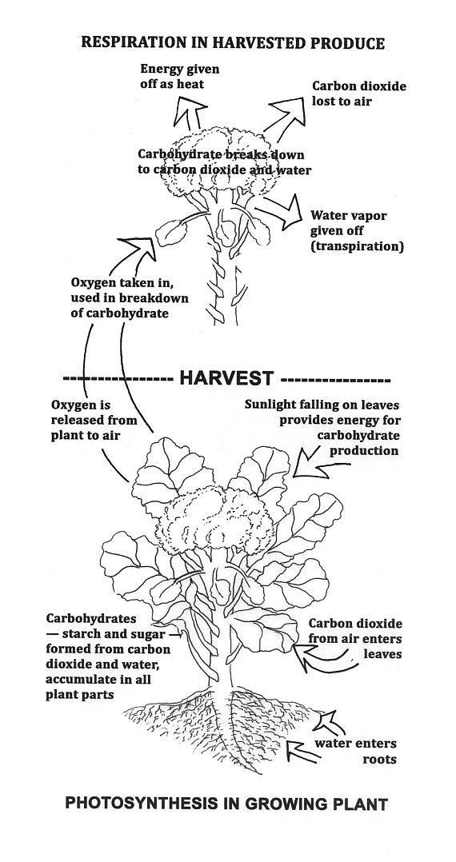
The instant a crop is removed from the ground, or separated from its parent plant it begins to deteriorate.

(lay-out designer: please create a border frame around image and place the words “Illustration by Teresa Diffley” on the left side at a 90° angle.)

Fresh Produce Is Alive .
Fresh produce, both on the plant and after it has been harvested, is alive. After it has been removed from the plant, it continues the metabolic activity that allowed it to grow while on the plant. As such, it is still affected by many of the same factors that affected its growth in the field: heat, water, humidity, and sunlight will continue to impact produce after its been picked.
If you have walked out into a field on a cool autumn morning, you may have noticed a snake moving slowly through the field. Reptiles move slowly when the environment is cold because they require heat from their surroundings to increase their internal temperature and thus their metabolism. Once their internal body temperature has warmed, they can metabolize foods more quickly and produce the energy through the process of respiration.

Similarly, the metabolic rates of plants both in the field and in the postharvest environment are affected by temperature. Like the snake in the field, the rate of metabolic reactions of produce slows in lower temperatures. Over the range of temperatures from 32 – 86° F, every 18° F rise in temperature doubles to triples the rate of all metabolic reactions, including respiration.

As respiration occurs in plants, carbohydrates—the stored sugar and starch in harvested plant parts that contribute to the desirable taste and textures of produce—are broken down to provide energy to drive other metabolic processes. This process requires oxygen and releases heat. Water is also lost through this process, as well as lost through transpiration due to the difference between the water vapor pressure inside the plant versus in the surrounding air.

While fruits and vegetables are still attached to the plant, the carbohydrates and water that are lost during metabolism and transpiration can be replaced through photosynthesis and water uptake by roots. Once harvested, they cannot be replaced – water uptake and photosynthesis stop. Stored food reserves are lost during respiration, which means loss of nutritional value, flavor, salable weight, and a general loss of quality.

Once produce is harvested, post harvest handling practices cannot improve quality; only slow the rate of deterioration.

Respiration and Produce Quality
Different crops and plant parts respire at different rates during the postharvest period; the different rates of respiration directly affect that rate at which carbohydrates and other materials are metabolized. The respiration rate of a product directly impacts postharvest life with respect to transit and shelf life. The higher the respiration rate, the more perishable a crop is.

Respiration rates of commodities can be slowed at lower temperatures; while higher temperatures increase respiration rates. Rapid cooling to the commodity's lowest safe temperature is particularly critical for those fruits and vegetables with inherently higher respiration rates to ensure high quality and proper shelf life. (See the table below for examples. For respiration rates of all crops included in this manual, see the crop profiles).

Classification of Sample Horticultural Commodities According to Respiration Rates.

Class | Commodity
Very Low | Dates, dried fruits and vegetables, nuts
Low | Apple, beet, celery, cranberry, garlic, grapes, honeydew melon, onion, papaya, potato (mature), sweet potato, watermelon
Moderate | Apricot, banana, blueberry, cabbage, cantaloupe, carrot, (topped), celeriac, cherry, cucumber, fig (fresh), gooseberry, lettuce (head), nectarine, olive, peach, pear, pepper, plum, potato (immature), radish (topped), summer squash, tomato
High | Blackberry, carrot (with tops), cauliflower, leeks, lettuce (leaf), lima beans, radish (with tops), raspberry, strawberry
Very High | Artichoke, bean sprouts, broccoli, Brussels sprouts, endive, green onions, kale, okra, snap bean, watercress
Extremely High | Asparagus, mushroom, parsley, peas, spinach, sweet corn

Rate Of Water and Energy Loss
To extend the usable shelf life of produce, the rate of water and energy loss must be slowed as much as possible. Factors that affect the rate of loss include:

- Temperature
For every 18° F increase in temperature the rate of deterioration increases two to three times. Immediately removing field heat is the single most important step you can take in extending shelf life and maintaining a product suitable for buyers. Prompt and thorough cooling to the core of the produce will slow the respiration rate, and the rate of deterioration. This makes a difference of days, weeks, or even months—depending on the crop.

Crops with extremely high respiration rates, such as sweet corn and broccoli, require cooling treatments within one hour of harvest. Even crops with lower respiration levels, such as onions and sweet potatoes, should be cooled within a few hours. A general rule of thumb for moderate and high respirators is that a one-hour delay in cooling reduces a product’s shelf life by one day or more.

This cooling step needs to happen on the farm, and quickly. If produce is shipped with field heat not only will its quality and shelf life be negatively affected, but also grocery stores and wholesalers have storage facilities, not cooling systems. If warm produce is brought into them, the heat and humidity released can warm-up their coolers, affect the humidity, and cause damage to the other products they have stored there.

Lower temperatures can also reduce sensitivity of produce to ethylene, a gaseous plant hormone that can speed respiration and cause earlier than desired ripening.

It is important to recognize and understand the different stages of the cold chain. Produce is in the cooling stage until it reaches its ideal storage temperature, and then it is in the storage stage. Growers who do not own or have access to cooling facilities, refrigerated storage, or refrigerated trucks will have to carefully select which crops they grow for wholesale markets. In these circumstances, the best-suited crops are low respirators such as gourds, some melons, and certain root crops; or chilling sensitive produce such as basil, snap beans, cucumbers, eggplant, muskmelon, pepper, potato, pumpkin, squash, sweet potato, tomato, watermelon, yams that require storage between 45° F and 70°F—check the crop profiles for specifics on each crop. High respiration crops such as broccoli, greens, or sweet corn will not hold quality without a way to quickly remove the field heat and store them cold.

Postharvest Temperature Management
- Harvest during the coolest times of the day; mornings are usually best.
- Keep harvested produce and loaded vehicles in the shade to minimize heating.
- During transport, use covered vehicles, or cover loaded vehicles with tarps to minimize heating and sun injury.
- Thoroughly cool as soon as possible.
- Maintain proper storage and/or transit temperature.
- Ship as soon as possible

- Humidity and Air Movement: Cooling And Water Loss
Fresh fruits and vegetables are full of water; freshness is water, and freshness sells! Water loss is one of the main causes of deterioration that affects the shelf life and marketability of fresh fruits and vegetables.

Effects of water loss: Many fruits and vegetables are negatively affected by losing even a small percentage of their original weight due to water loss. For example, leafy green vegetables quickly wilt, and then shelf life and quality are reduced. Seriously shriveled fruits, vegetables, and flowers are unmarketable and must be discarded.

Factors that affect water loss: Relative humidity in storage, the temperature of the product and its surrounding atmosphere, and air velocity all affect the amount of water lost from fresh fruits, vegetables, and flowers. Water loss from warm products to warm air is particularly serious under windy conditions or during transport in an open vehicle.

The influence of the type of produce on water loss: The rate at which water is lost varies with the type of produce. Leafy green vegetables, especially spinach, lose water quickly because they have a thin waxy skin with many pores. Others, such as potatoes, which have a thick corky skin with few pores, have a much lower rate of water loss.

Water loss and cooling: The faster the surrounding air moves over fresh produce the quicker it cools, and the more water is lost. Air movement through produce is essential to cool and remove the heat of respiration, but the type of produce, and the desired post harvest process—cooling or storage—must be taken into consideration in designing the rate of air movement. During cooling, high rates of airflow are often used to speed the removal of heat. Sensitive crops such as berries must be carefully monitored to prevent dehydration. During storage, airflow is necessary to remove respiration heat but the rate of movement must be kept as low as possible. Well-designed packaging materials and suitable stacking patterns for crates and boxes can contribute to controlled airflow through produce.

Humidity and storage: Maintaining high relative humidity in storage is sometimes difficult because refrigeration removes moisture. For most growers in the United States, humidity in room coolers is not an issue during the growing season, but it can be an issue during winter storage months. Humidification devices can be used in storages; (e.g., spinning disc aspirators and the like). Keeping the floor wet is also helpful but it is messy and may harbor disease organisms on the floor. Frequent sanitizing procedures should be employed, such as cleaning frequently and rinsing with a sanitizer. Produce that can tolerate direct contact with water can be sprinkled to promote high relative humidity. Many farmers cover produce with plastic film or tarps to help maintain high relative humidity.

Maintaining the Cold Chain
Generally Produce Is Cleaned Before Cooling—But Not Always!
Cleaning of most produce happens before cooling. Exceptions are crops that are stored before washing, generally recommended for root crops, onions, and usually winter squash.
At Harmony Valley, parsnips are harvested into plastic lined bins and moved into a room cooler for cooling and storage. The bags will be kept open until the roots are cooled. Then closed to maintain a humid environment. They found the roots stay whiter when the bags are closed.
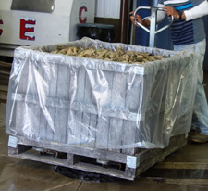
Some crops, such as baby greens, are cleaned and cooled during the same process with a temperature step-down approach for food safety. For more information see the Cleaning Section of this manual.
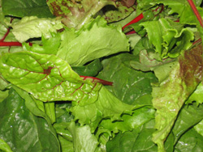

Despite the paramount importance of removing field heat immediately, it is only the first step in a long chain of handling, packing, shipping, and delivery. Lisa Kitinoja and Adel Kader from the University of California-Davis discuss the “cold chain” from field to wholesaler. Farmers should measure and record produce and storage area temperatures at each stage until the wholesaler has picked up or received it.

Harvest
- Protect the product from the sun.
- Transport quickly to the packinghouse.

Cooling
- Minimize delays before cooling.
- Cool the product thoroughly as soon as possible.

Temporary Storage
- Store the product at optimum temperature.
- Practice first-in, first-out rotation.
- Ship to market as soon as possible.

Transport to Market
- Use refrigerated loading area, if possible.
- Cool truck before loading.
- Load pallets toward the center of the truck to minimize heat loss through the walls.
- Put insulating plastic strips inside door if the truck makes multiple stops.
- Avoid delays during transportation.
- Monitor product temperature during transport.

Handling at Destination

- Use a refrigerated unloading area.
- Measure product temperature.
- Move product quickly to the proper storage area.
- Transport to retail markets or foodservice operations in refrigerated trucks.
- Display at proper temperature range.

Shaded areas should be available for harvested produce, cooling facilities, packing and storage areas, and transport vehicles. Trees not only provide shade in the field, but also can drastically reduce ambient temperatures around packinghouses and storehouses. Also, lighting options should be evaluated; incandescent bulbs are in fact better suited for small-scale heating purposes than for lighting a cooled storage room. Look for fluorescent or high-pressure sodium lights, which produce far less heat and require less energy to provide the same amount of light as incandescent bulbs. Higher up-front costs will save money over the medium and long-term. Make sure to shield bulbs so that if they break, glass shards will not contaminate any produce.
COOLING METHODS

Before putting produce into refrigerated storage, it is important to remove field heat as quickly as possible. Several methods are available to do so, depending on the produce item’s characteristics. It is important to use the proper cooling method for each type of produce. The chart at the end of this chapter and the crop profiles in this manual provide specific cooling options for each produce type. In this manual we will discuss these five cooling methods: room cooling, forced-air cooling, hydro cooling, water spray cooling, and icing.

Comparison of 5 common cooling methods

 | Room cooling | Forced-air | Hydro cool | Water spray | Ice
Typical Cooling Time (hours) | 20 to 100 | 1 to 10 | 0.1 to 1.0 | 0.3 to 2.0 | 0.1 to 0.3
Product Moisture Loss (percent) | 0.1 to 2.0 | 0.1 to 2.0 | 0 to 0.5 | No data | No data
Water contact with product | No | No | Yes | Yes | Yes
Potential for decay contamination | Low | Low | High | High | Low

“Prompt cooling to required temperatures inhibits growth of decay-producing microorganisms, restricts enzymatic and respiratory activity, inhibits water loss, and reduces ethylene production by the product.”

Half-Cooling Time
One of the most important concepts to understand the speed of cooling in postharvest handling is half-cooling time. This is the time required for the field temperature to drop halfway to the desired storage temperature. For example, corn harvested with an internal temperature of 95°F should be cooled to 32°F. The half-cooling time would be the time required to reach 63.5°F, which is halfway between 95° F and 32°F. Experts agree that 7/8-cooled (87.5%) is the appropriate time to remove the produce from pre-cooling and placed in cold storage.

Getting to 7/8- cooled generally takes three times longer than the half-cooling time. Knowing the half-cooling time of a cooling process will enable you to calculate how long cooling to 7/8 temperature will take and if your cooling process is quick enough to achieve the desired shelf life.

The illustration below shows the half cooling time in a typical room cooler for large fruit. In this scenario, it would take 12 hours to reach 7/8 cool. A quicker method would be needed for high respiration crops or shelf life will be shortened.

KEEP THE Half-cooling chart in HERE 3 but change the text. Figure 3: Half-cooling time

Room Cooling
At Harmony Valley Farm, unwashed root crops—low respirators—are cooled and stored in a room cooler. Space is left between bins to allow airflow. For food safety, un-washed produce and clean produce are kept in different parts of the cooler.
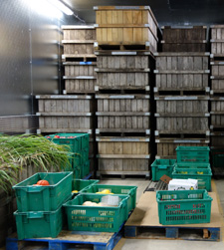
Room cooling is not a true pre-cooling method, but uses the ambient temperature of a refrigerated storage facility to act as the cooling process. The University of Maryland Extension office defines room cooling as a cold room where air movement equals 200-400 feet (60-120 m) per minute or less through the containers.

Cooling times in room coolers are too slow for moderate or high-respiration produce.

Room cooling can be an effective method for cooling less perishable items such as potatoes, gourds, onions, and some citrus fruits; and chill-sensitive crops, such as peppers, eggplant, watermelon, or cucumbers.

To ensure equal cooling, leave space between stacks of boxes for good airflow, about 1 to 2 inches is sufficient to allow cold air to circulate around individual boxes. Produce in vented boxes will cool much faster than produce packed in un-vented containers. If produce is loaded into the room tightly, cooling cannot take place at all, and despite the high cost of running the refrigeration system, the produce temperature will not decrease to recommended levels. Stacks of produce inside the cold room should be narrow, about one pallet width in depth. Fans should be installed to move the cold air throughout the room. You'll want to monitor the temperature of the produce within the packages at various locations in the room to determine that the produce is being cooled as desired. Rearrange the stacks and measure the rate of cooling until you find the right pattern for your cold room.
Cooling Versus Storage
Featherstone Farm uses multiple cold rooms. One has been designed with high airflow and is kept at 33° F for rapid cooling. After produce reaches its ideal storage temperature it is moved to a second cold room with lower airflow to prevent dehydration. Chill-sensitive crops, such as peppers and eggplants, that need to be stored at warmer temperatures, can be cooled in the cooling room, and then moved to a warmer cold room when they reach their ideal storage temperature.
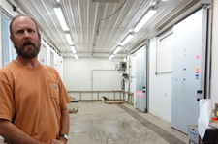

Room cooling systems should be well designed to maximize effectiveness. The cooling system should be large enough to handle the maximum heat load expected, but not so large that the extra capacity is wasted. There should be an air circulation system to mix the cooled air with the room air, but precautions are needed to prevent circulation drying out the produce. Cooling systems should be specially designed to work with high humidity levels, or problems with condensers freezing up can cause frequent shutting down of the system. Working with a refrigeration and cooling specialist to meet your farm’s specific cooling and storage needs is recommended for designing cooling and storage systems.

Forced-Air Cooling
COOL AND SHIP: A LOW-COST, PORTABLE FORCED-AIR COOLING UNIT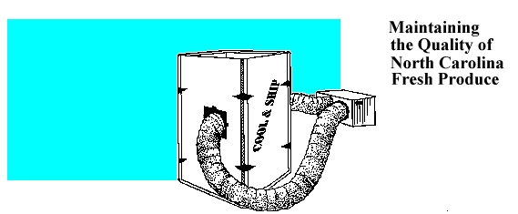
(The North Carolina Agricultural Extension Service provides on-line plans for building and using a forced-air cooling system that also serves as a cold shipping unit. The Cool and Ship system provides rapid cooling for modest amounts of small fruit and is versatile, portable, reusable, and inexpensive. The system uses an air-conditioning system and common building materials. http://www.bae.ncsu.edu/programs/extension/publicat/postharv/ag-414-7/index.html
Forced-air units are ideal for berries, stone fruits, fruit-like vegetables, tubers, and cole crops though most fruit and vegetables can be cooled using forced-air.

Forced-air cooling is similar to room cooling but adds fans to facilitate air movement through stacks of produce. This method is much faster and more consistent than standard room cooling; half-cooling times are often less than one hour. Forced-air units are also generally inexpensive and fairly easy to construct on site.

In a typical forced-air cooling setup, pallets are stacked and lined up in front of a pressure fan and covered with a tarp or other airtight covering. The tarp creates a tunnel and cold air is pulled through the pallets and through the containers.

KEEP THIS IMAGE Figure 4: Forced air systems

An effective and efficient forced-air system requires packaging with vents and a fan system capable of moving enough air to rapidly cool the produce (usually 1-2 cubic feet per minute per pound).

Because moving air also facilitates moisture evaporation, steps may need to be taken to avoid wilting, shriveling, and shrinkage. KEEP THE PRESENT FORMATTING

Humidity control and time in the force-air unit must be carefully managed or dehydration can result.
Plastic Blocks Air Flow
Covering produce with plastic or tarps, or wrapping with shrink film blocks airflow. You may want to do this to reduce dehydration of produce, or to stabilize loads for shipping. Be sure produce is fully cooled before blocking airflow or cooling will be slowed.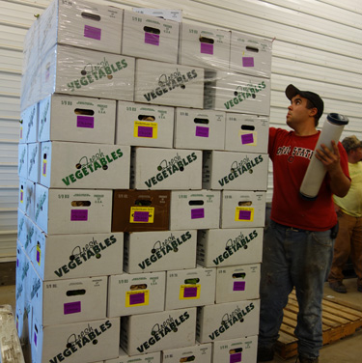
There are a number of approaches to keep the relative humidity of forced air coolers in the 90-100% range required by most produce items:

- Install larger condenser coils and limit the temperature drop across the coils to 5°F or less. This will also help prevent refrigeration coils from freezing.
- Install a humidifying system.
- Do not allow condensation from the coils to drain to the outside.
- Periodically hose down the floors with cold water.
- Monitor relative humidity using a wet- bulb and dry-bulb thermometer.

Do not blow air at the storage containers, but orient the fans so that they pull air over the produce and through the boxes of produce. Blowing air at the produce can “short-circuit” the airflow, with air going immediately back out the fan without reaching the containers. Ideally, there should be a separate room dedicated to forced-air cooling, but you can integrate it into a storage room by hanging a tarp from the ceiling or installing a second wall.

REMOVE THIS CHART Figure 5: Rate of cooling chart

The formula for how much refrigeration is needed at any given moment can be calculated as follows: (Btu/hr) = 2.1 x (A – B) x C x D ÷ E Where:
- A = Temperature of produce, °F (°C)
- B = Temperature of cooling air, °F ( °C)
- C = Weight of produce being cooled, in lb. (kg)
- D = Specific heat of produce, usually about 0.9 Btu/lb./°F (3.77 kJ/kg/°C)
- E = 7/8 cooling time (hr)

For the initial stages of refrigeration, this equation will produce very high refrigeration amounts, often over 20 tons. A general rule of thumb is to design for 2/3 of the amount of refrigeration required at the beginning of pre-cooling.

Hydro Cooling
These spray-washed, green-top, bunched carrots are now ready for hydro cooling at Loon Organic Farm.
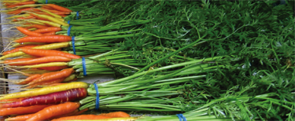
Hydro cooling takes advantage of water’s ability to rapidly transport heat away from an object. While hydro cooling is one of the fastest and most uniform pre cooling methods available, it is not appropriate for all crops, and can quickly distribute and internalize pathogens if the produce is not clean and if the water has not been properly sanitized.
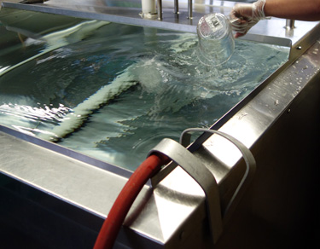
Tsunami is measured and added to fresh and potable water before produce is added for cooling at Harmony Valley Farm. Below, staff checks the concentration with a test strip for a second time after mini-peppers have been added.
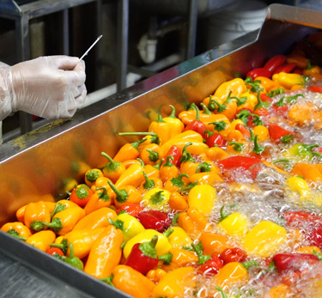

Hydro-cooling is generally best suited for leafy greens, brassica crops except cabbage, asparagus, sweet corn, cucumbers, some fruit-like vegetables, stone fruits, and bunched root crops. Immersion in water should be avoided for crops that cannot tolerate exposure to high levels of water and crops that are very dirty.

The simplest form of hydro cooling, and most commonly used on small farms, is immersing produce in a tank of ground temperature water. To hydro cool produce to a colder temperature, a refrigerated unit could be used or ice can be added to the water, though refrigerated or ice added hydro cooling is a not standard practice on small farms.

Combining Hydro Cooling and Room Cooling
Small growers who do not have an ice machine or refrigerated hydro cooler often combine hydro cooling and room cooling for a two-step cooling process. The first step of hydro cooling in ground-temperature water has a much quicker half-cooling times than room cooling and it can quickly bring produce down out of the highest respiration zones. Without a refrigeration unit on the hydro cooler it will not bring produce down to the ideal 7/8 cooled. The produce is then placed in a room cooler to finish cooling to storage temperature. While this will not accomplish maximum shelf life, it can be a viable, reasonable, and realistic system for a small producer and is significantly better than only room cooling.

Produce Must Be Clean Before Immersion Hydro-Cooling.
Immersing fresh produce in water creates a pressure differential that causes water to be pulled into the produce. The difference between the water temperature and the produce is very important. When the water temperature is colder than the produce the amount of imbibing increases.
If there are pathogens present on the produce surface or in the water they can become internalized. Subsequent washing will not reduce pathogen levels once they are inside the produce. It is crucial to practice food safety procedures when tank washing.
Dirty produce must be cleaned in water that is less than 10° colder than the produce before cooling. See Section 5. Cleaning for more information on this. Highly sensitive crops such as baby greens are often hydro-cooled in a step-down approach. See baby greens in the Cleaning Section for details.

Sanitation During Hydro Cooling (and Washing)
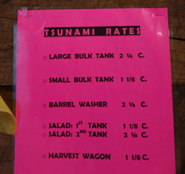
Tsunami sanitizer mix rates are posted on the wall next to the dispenser at Harmony Valley farm.
Hydro cooling creates an opportunity for water-borne pathogens to reproduce readily. Additionally, because postharvest pathogens travel quickly in water and can be internalized, there is the potential for contamination of an entire load of produce.

Several important points should be considered when hydro cooling:
- Produce should always be cleaned before hydro cooling.
- Anti-microbial agents should always be used.
- Water must be potable (safe to drink.)
- Good food safety practices must be used; train yourself and staff to clean hands and equipment.

Peroxyacetic acid (PAA) is an increasingly popular sanitizer for use on produce, particularly for organic producers. PAA can be used to reduce fruit and vegetable surface microbial activity, thus reducing product spoilage by microorganisms and reducing the risk of food-borne illness. Peroxyacetic acid sanitizers are a mixture of the peroxy compound, hydrogen peroxide and acetic acid, with the mode of action of the active ingredient achieved through oxidation. The ingredients decompose into acetic acid, water, and oxygen, thus creating a safe sanitizing product. PAA is particularly appropriate for use in hydro cooling as it has low reactivity with organic matter and soils, thus providing more consistent microbial control. Also, it is effective across the wide pH ranges found in local water sources, allowing for effective microbial control at both acid to slightly alkaline conditions.

PAA is available under several trade names. SaniDate 5.0 (www.biosafesystems.com) and Tsunami® 100 (www.ecolab.com) are two popular brands of PAA. Tsunami® 100 is used for pathogen reduction in fruit and vegetable processing water and is appropriate for the sanitation of produce. It can be used in both batch and continuous operations. Tsunami® 100 reduces 99.9% of the pathogens causing food-borne illness (including Escherichia coli O157:H7, Listeria monocytogenes and Salmonella enterica) as well as providing control of spoilage and decay causing decay or spoilage on the surface of produce. Alternatively, SaniDate 5.0 is a peroxyacetic acid-based sanitizer/disinfectant that can be used directly on produce as well as on pre-cleaned, hard, non-porous, food contact surfaces and equipment. It is effective against fungus, mold, and bacteria such as Staphylococcus aureus, Pseudomonas aeruginosa, Salmonella choleraesuis, Salmonella enteriditis, Salmonella typhimurium, Proteus vulgaris, Streptococcus pyogenes, Enterobacter aerogenes, Lactobacillus maefermentans, Pediococcus damnosus. Listeria monocytogenes, Klebsiella pneumoniae, and Escherichia coli.

When using either of these products, read the label and follow the instructions for proper use. Product concentrations must be maintained at the appropriate concentrations as outlined on the labels; appropriate test kits and equipment are available from the manufacturers for use in monitoring product concentrations.

Chlorine is an accepted disinfectant for hydro-cooling water, but is subject to federal law and must be carefully monitored. Many farmers consider chlorine hazardous because of its toxic fumes and, as a result, more are using peroxyacetic acid. Also some crops do not tolerate exposure to chlorine. Any farmer discharging water, such as from a hydro-cooler, must comply with the Safe Drinking Water Act. Chlorine concentrations at the discharge/effluent point may not exceed the Maximum Residual Disinfectant Limit (MRDL) of 4mg/L for chlorine and 0.8mg/L for chlorine dioxide. Chlorine is allowed in organic production, as long as it remains within these limits. However, individual certification agencies may have more stringent regulations regarding the use of chlorine. Contact your certifier to ensure that you do not accidentally jeopardize your organic status. Chlorine materials may also be used to sanitize food contact surfaces but, again, the residual chlorine levels in the discharge water may not exceed the MRDL.

When using chlorine, measure the pH of the water before and after adding it. Chlorine is most effective in neutral water (pH = 7.0). When water is either acidic (pH < 6.5) or basic (pH > 7.5), much more chlorine is needed to act as a disinfectant. In water with a pH of 8.5, seven times as much chlorine must be added as for water with a pH of 7.0. Common acids such as lemon juice or vinegar will work. On the other hand, making the water too acidic can result in the formation of chlorine gas, which is toxic. Certified organic operations should check the approved materials list to make sure that the particular acid is allowed. See Section 9. Post Harvest Sanitation for more information on sanitizing.

Water Spray Cooling
Produce can also be water-cooled by spraying or moving the produce through running water. Because the produce is not immersed there is less risk of water being imbibed into the produce. Cleaning dirty produce with cold-sprayed water combines cooling with cleaning. After the produce is cleaned, if further cooling is needed, it can be sprayed more, cooled in a cold tank, or placed in a room cooler. Sanitizers can be injected directly into spray cooling water.
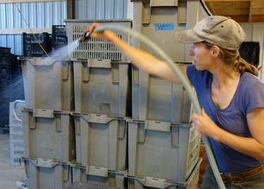
Hydro spray cooling often involves produce being sprayed in a tote or on a conveyor belt, but here Cate, at Rigdeland Harvest Farm, spray cools produce just in from the field as it waits for its turn in the water bath. Photo Atina Diffley
Remove these images from manual
Small to mid-size growers can use a crushed ice machine to manually ice boxes of produce prior to stacking them on pallets. photo: Atina Diffley, Gardens of Eagan Farm—
Figure 6: Liquid icing single cartons of produce.15
Figure 7: Injecting liquid ice into palletized broccoli cartons through the hand openings.17
Figure 8: Automated pallet icing.18

Ice
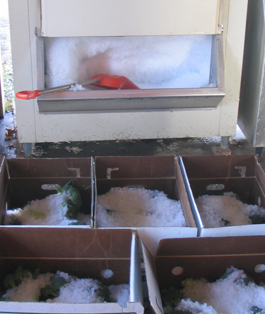
Above, field packed broccoli is brought into the pack shed where it is iced, and then placed in a room cooler at the Diffley’s Gardens of Eagan.
Below, Dehn’s Produce uses ice to keep carrots fresh and crisp for rapid farmers market sales. Photos by Atina Diffley
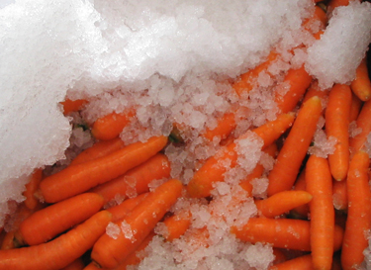
Using ice to cool produce and maintain the cold chain in storage, transportation, and sales is quick, simple, and uniform. While ice machines can seem expensive at first, this is a tool that can pay for itself in quality, shelf life, and farm reputation. If you can’t afford an ice machine right now, purchasing ice when needed can be a viable option.
Icing is limited to produce that can withstand water-ice contact. Some crops should be iced, some can be iced, and some should never be iced. For information on each crop see the charts at the end o this chapter or Section 11. Crop Profiles.
Some Crops Should Never Be Iced
- Berries
- Green Beans
- Cucumbers
- Garlic
- Basil
- Okra
- Onions, dry
- Potatoes
- Peppers
- Summer Squash
- Tomatoes

Package icing is ideal for sweet corn and broccoli, and is frequently used for dark leafy greens such as kale, spinach, and collards, root crops such as radishes and carrots, and green onions.

Bringing a high respiration crop like broccoli down to storage temperature can be accomplished quickly with crushed ice.

Use water-tolerant shipping containers, such as waxed boxes or plastic totes, as ice will melt.

Crushed ice can also be used at farmers markets and roadside stand to maintain cold produce when displayed without refrigeration.

Finally, packing ice, like any water-based cooling system, can spread pathogens. To minimize food safety concerns ensure ice is made from potable water sources only (with sanitizer added if necessary) and that ice making equipment and scoops are cleaned and sanitized regularly to prevent the spread of bacteria.

Figure 9: Night air ventilation.22 REMOVE this illustration in the manual

Cooling and Storage Information Chart 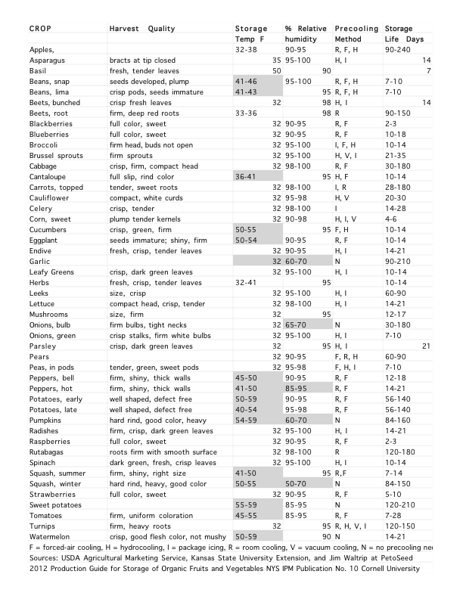
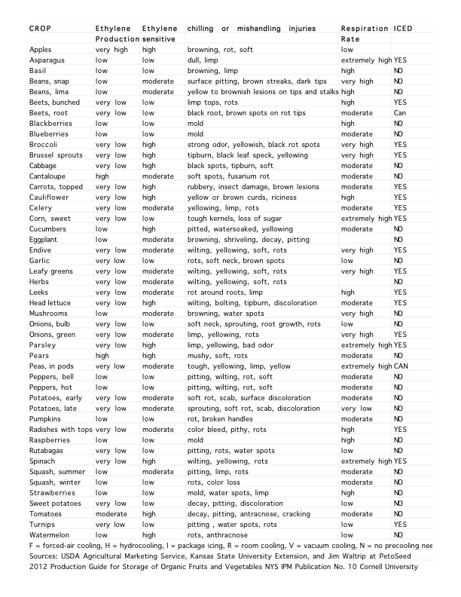

Section 4
Authors: Atina Diffley, Dennis Fiser, Amanda Korane, North Carolina State University, Erin Silva

Small-Scale Postharvest Handling Practices: A Manual for Horticultural Crops (4th Edition) Lisa Kitinoja and Adel A. Kader, November 2003, University of California, Davis Postharvest Technology Research and Information Center
Prevention Of Post-Harvest Food Losses Fruits, Vegetables And Root Crops A Training Manual, Food and Agriculture Organization of the United Nations, Rome, 1989
2012 Production Guide for Storage of Organic Fruits and Vegetables, NYS IPM Publication No. 10, Cornell University
Wilson, L. et al. 1999. Postharvest Handling and Cooling of Fresh Fruits, Vegetables, and Flowers for Small Farms. North Carolina State University. http://www.ces.ncsuedu/depts/hort/hil/hil-800.html
Ontario Ministry of Agriculture, Food and Rural Affairs. 1998. Tunnel Forced-Air Coolers for Fresh Fruits & Vegetables.
Postharvest Handling and Cooling of Fresh Fruits, Vegetables, and Flowers for Small Farms, L. G. Wilson, Extension Postharvest Horticulturist, M. D. Boyette, Extension Biological & Agricultural Engineer, E. A. Estes, Extension Agricultural & Resource Economist, Department of Horticultural Science, North Carolina Cooperative Extension Service, July 1999
Kitinoja, L., and Kader, A. 2002. Small-Scale Postharvest Handling Practices: A Manual for Horticultural Crops. University of California, Davis. 130.
Pre-cooling and Storage Facilities, James F. Thompson Department of Biological & Agricultural Engineering University of California, Davis, CA http://www.ba.ars.usda.gov/hb66/contents.html
Ross, D. 1990. Post Harvest Cooling Basics. University of Maryland. http://www.bre.umd.edu/facts178.pdf
Kushad, M., and Stiles, H. 2003. A Longer Marketing Life for Bramble Fruits. Virginia State University. http://pubs.ext.vt.edu/423/423-701/423-701.html
Kader, A. 2002. Postharvest Technology of Horticultural Crops. University of California. 98.
Ibid.
Small-Scale Postharvest Handling Practices: A Manual for Horticultural Crops (4th Edition) Lisa Kitinoja and Adel A. Kader, November 2003, University of California, Davis Postharvest Technology Research and Information Center, and Kitinoja, L. and Gorny, J. 1999. Posthavest Technology for Small-Scale Produce Marketers: Economic Opportunities, Quality and Food Safety. University of California, Davis. 6.6-6.8.
Ontario Ministry of Agriculture, Food and Rural Affairs. 1998. Tunnel Forced-Air Coolers for Fresh Fruits & Vegetables.
Boyette, M. et al. 2000. Forced-Air Cooling. North Caroline State University.
Ibid.
Boyette, M. et al. 2000. Forced-Air Cooling. North Caroline State University.
USDA Agricultural Marketing Service, Kansas State University Extension, and Jim Waltrip at PetoSeed; Chilling and Freezing Injury, Chien Yi Wang, USDA, ARS
2012 Production Guide for Storage of Organic Fruits and Vegetables NYS IPM Publication No. 10 Cornell University

