Home Page

Profiles in Sustainable Agriculture

About the Profiles in Sustainable Agriculture Project
How to Use the Case Studies

Loon Organics  Pilot Case Study | Clover Valley Farms  Case Study #2 – Sneak Preview!
[insert video clip #1 – videographer is finalizing – will have “poster frame” set to attractive picture] | [insert “overview” clip – videographer is finalizing – will have “poster frame” set to attractive picture]
The Loon Organics case study was prepared as a prototype for a database of case studies that is under development. It features a pair of Minnesota farmers who have been producing and marketing organic vegetables since 2005. The case study illustrates how the keys to long-term farming success include not only hands-on production experience but also measured growth, careful planning, asset management, financial analysis, and strategic marketing. | Preparation of the second case study is underway, featuring another pair of Minnesotans who farm in Duluth. Cindy Hale and Jeff Hall raise pastured poultry and hogs, produce herbs in a passive greenhouse, and use integrated pest management to grow apples in new and restored heritage orchards. As with Loon Organics, their story shows that goal setting, record keeping, financial management, and gradual expansion have set them on the path to success.
Win a free print copy of "Building a Sustainable Business: A Guide to Developing a Business Plan for Farms and Rural Businesses"!
Be one of the first 25 people to read through this online case study and complete a survey!
Click here to take survey

“About” Page

About the Profiles in
Sustainable Agriculture Project

Today’s aspiring farmer is confronted with many sustainable agriculture resources, which generally fall into two categories: inspiring narratives and technical bulletins. The Profiles in Sustainable Agriculture project seeks to integrate these two types of resources into a technical case study format that combines a detailed narrative with embedded technical assistance via links to finance, production, and marketing resources. This “one-stop shop” case study format provides beginning and transitioning farmers with both a motivating story and the contextual understanding needed for integrating the nuts and bolts of sustainable farming into a real-life enterprise.

Recent trends related to local food and the changing demographics of American farms are creating a whole new enthusiastic generation of aspiring farmers. While this enthusiasm can carry beginning farmers through many an exhausting day in the field, a healthy dose of realism is essential to long-term success. Although it may seem logical to focus on learning how to grow crops and worry about the rest later, there is a “three-legged stool” of farming: production, marketing, and financial management. When all three components are addressed from the outset, farming dreams can be realized.
“How To Use the Case Studies” [currently Read This First] Page

Return to Main Page

How to Use the Case Studies

You may have already discovered that “cookie cutter” approaches don’t work well in farming; what works on one farm or for one farmer may not work for another. There is no formula or tool for getting you from A to Z, but these case studies do step you through what beginning farmers need to think about before starting their own enterprise.

It is recommended you read through the case studies once from beginning to end, then use them as reference documents and revisit appropriate sections as needed. Although PDF versions are provided, reading the case studies online is optimal due to the number of external resources to which they are linked. The case studies have also been laid out with as many internal links as possible to help you navigate the information and find resources that are relevant in multiple locations.

Resources are provided as links within the text and in various sidebars called “Educator’s Perspective: Resource Tips” or “Farmer’s Perspective: On the Bookshelf.” Other sidebars called “At A Glance” and “Farmer’s Perspective: Lessons Learned” provide supplemental details and insight.
Loon Welcome Page

Loon Organics

Loon Organics was established in Minnesota in 2005. It is a certified organic vegetable farm that provides product to consumers through Community Supported Agriculture (CSA) subscriptions, a farmers market, and wholesale outlets. | 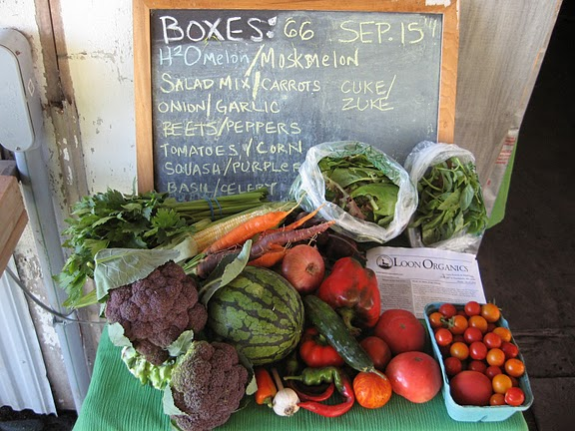
This case study describes how the husband-and-wife team became interested in farming, how they got their training, and how they transitioned from farming on land rented from mentors to buying their own 40-acre farm.

Diverse aspects of their operation are described, including business and production planning, infrastructure and equipment, horticultural practices, and marketing models. The finances section is particularly detailed and valuable due to the financial data made available by Loon Organics. The unique challenges of managing an organic CSA operation are highlighted throughout the case study.

[insert “Farmer’s Perspective: Lessons Learned” box]
Enter Online Case Study
Acknowledgements
PDF version

