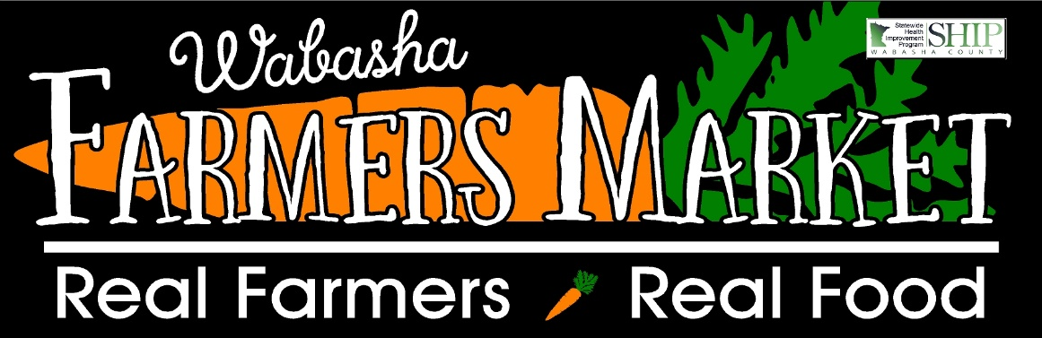

Welcome to Market Share, a bounty of goodness from a group of local farmers!
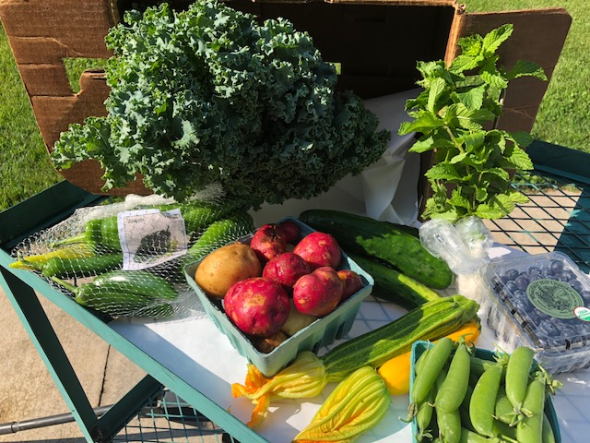
This weeks box includes:
Kale
Mint
5 types of Peppers
Potatoes
Zucchini
Snap Peas
Blueberries
Cucumbers

Did you know?
Wabasha Farmers Market has a weekly newsletter that is sent out to announce what is in season, what to expect at the market and if there are any activities happening during our normal market day? You can sign up simply by clicking on SIGN UP on our Facebook Page. Don’t forget to “DIG US” on Facebook too!
Field Report
The weather sure was hot and humid this past week, you could literally watch the crops grow. This rain and the heat may hinder some field activity, but things are sure looking plush!
We hope that you had a very Happy 4th of July!

Thank you for joining us for a summer of delicious vegetables!!

