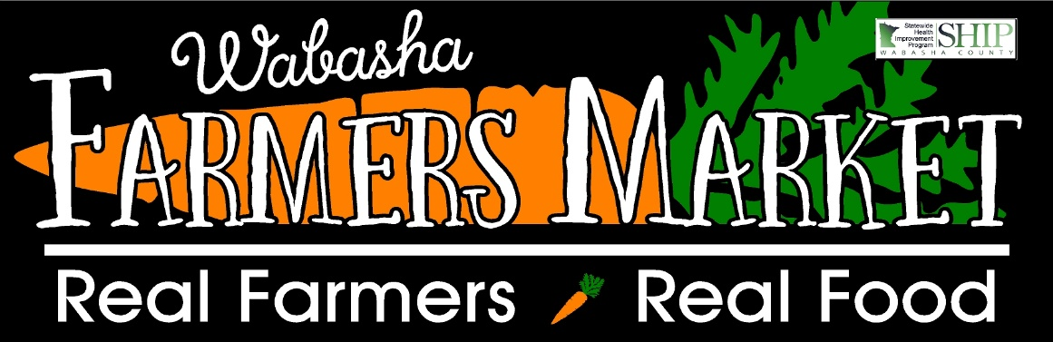

Welcome to Market Share, a bounty of goodness from a group of local farmers!

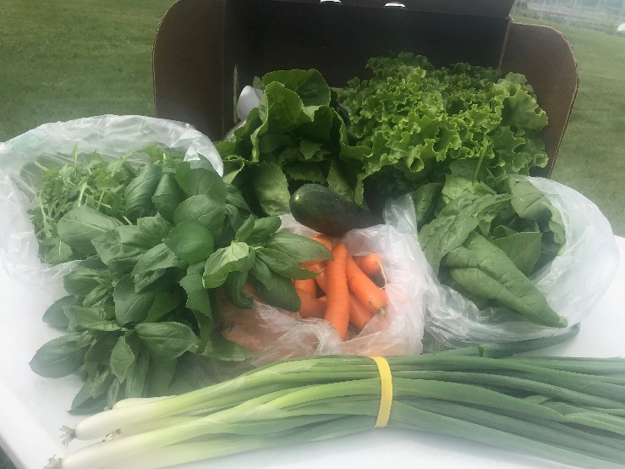
This week’s box includes:
Romaine Lettuce
Basil
Spinach
Arugula
Carrots
Cucumber
Green Curly Lettuce
Spring Onions

Please note that the first boxes are normally filled with lovely greens to enjoy. Many vegetables that you are eager to eat take longer to grow. As the weeks wear on, the boxes will get more abundant and diverse then will slowly decrease as the season comes to an end.
What is Market Share?
Market Share is a CSA model where fresh, locally grown produce will be delivered to drop sites weekly (every Thursday between 2-4 depending on your scheduled time) to be enjoyed all season long. What makes Market Share different is that we aggregate our produce. Aggregate means that we are combining the produce from local farmers to supply the boxes with a larger variety than 1 farmer would be able to do.
Deliveries will be in ½ bushel wax boxes. These boxes will be lined with wax freezer paper on the bottom as we hope to preserve them to reuse. Please remember to bring your box back to the drop site when you pick up your next market share. Consider bringing bag to transfer the produce on site if you would rather not worry about the box weekly.

Fun Fact: Arugula
According to the USDA National Nutrient Database, two cups of arugula weighing about 40 g contains approximately 10 calories.
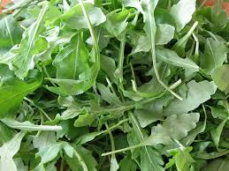
Arugula is a type of cruciferous vegetable.
A certain chemical in arugula may help slow the progression of cancer.
Arugula might also improve muscle oxygenation during exercise.

Arugula also contains:
One g of protein
  - g of fat
Consuming 2 cups of arugula will provide:
- percent of vitamin A
over 50 percent of vitamin K
8 percent of vitamin C, folate, and calcium needs for the day

Arugula ranks among the top 20 foods in regards to Aggregate Nutrient Density Index (ANDI score). The ANDI score measures vitamin, mineral, and phytonutrient content in relation to caloric content.

Feedback
Feedback is strongly encouraged and a very important part of any program. If you have ideas, suggestions, concerns or just want to talk, please reach out to Sara George our market manager and Market Share coordinator. She can be reached at wabashafm@gmail.com by email, home 715-442-2488 and cell 715-651-5046. Please note that I am challenging to reach as when not at the market or making deliveries I am spending time in the field so don’t give up!

Thank you for joining us for a summer of delicious vegetables!!

