PROPOSAL FOR IMPROVING FOOD LICENSING
FOR INNOVATIVE ENTREPRENEURS

A flourishing number of Farmers’ Markets across Minnesota and economic disruptions of the recession have pushed unprecedented numbers of Minnesotans into starting their own food businesses. Many of these businesses are innovative in nature and not reflected fully in statute and rules governing food safety and production in the State of Minnesota.

Entrepreneurs who wish to start innovative food business in MN face unique challenges. Rules and regulations governing compliance and licensing new food business models, although straightforward for standard food businesses, are not easy to find or interpret.

Some innovative food models become tangled in a regulatory web that doesn’t offer clear language, resulting in delays and confusion during the licensing process. These delays are especially costly to small “mom and pop” businesses.
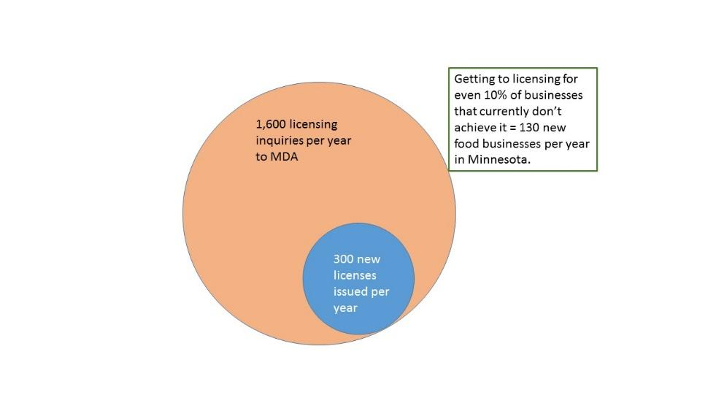
From 2010 to 2016, there was a 74% increase in the number of food business licenses issued; license requests more than doubled between 2010 and 2014. While there is no tracking mechanism for how many potential food businesses fall victim to regulatory hurdles, anecdotal evidence among farmers’ market managers indicates the number could be considerable.

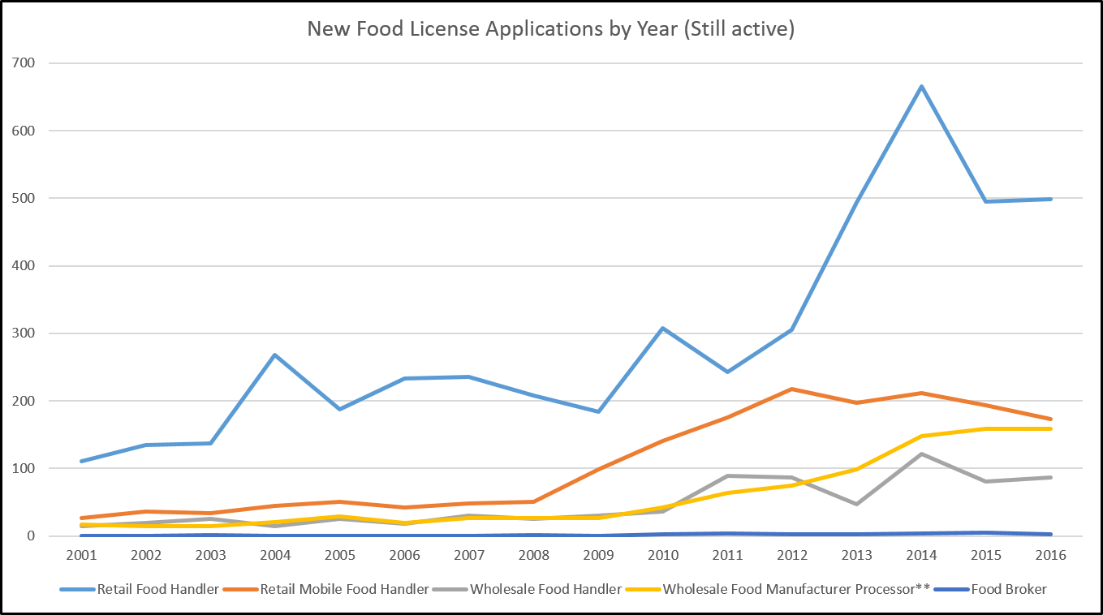

Both entrepreneurs and regulators devote considerable time and money getting to the right information, and licensing these businesses. One reason for the increased time and cost of licensing these new models is the lack of a standardized process to handle models that do not fit current regulatory categories.

Currently regulators meet the demand to license complex business models via informal meetings. However, these meetings are not part of an official process, are not mandated and may face elimination as staff and commissioners change.

Over the last several years, informal teams of regulators, local food systems experts and members of non-profits have volunteered their time to help these food entrepreneurs with compliance and licensing issues.

The Local Food Advisory Committee, where regulators, business owners, farmers, U of MN staff, and members of non-profits meet in a collaborative environment, was created to address complex regulatory issues.

Team Wabasha was formed about a year ago, to help the Wabasha Farmers Market with compliance and licensing issues that had stalled progress for over 18 months. After a two-hour meeting, most licensing and compliance issues were resolved to the satisfaction of both the market and regulators.

These teams have been successful in working out licensing issues, but on an ad hoc basis. Formalizing the structure and process would improve the business climate for innovative entrepreneurs.

SMOOTHER PROCESS
A new MDA position backed up by a team of experts would clear the path to licensing, providing both regulatory interpretation and timely decision-making. Where different interpretations arise among regulators, this group would push through to a decision and prevent complicated cases from languishing in limbo.

We propose forming a Solutions Advisory Licensing Team (SALT) to create a state-wide process to help novel food businesses become compliant and licensed within a reasonable amount of time (less than 6 months).

SALT would be a team of regulatory specialists from MDA and MDH to remove regulatory roadblocks and create more optimal functioning of food licensing at the state level. The team of high-level representatives from MDA and MDH would be joined by experienced business entrepreneurs, representatives of farmer organizations and local food advocates, the Department of Employment and Economic Development (DEED) and other economic development agencies.

In order to scale the process, to standardize it, to reach a state-wide audience and to impact the MN economy in a significant way, we are seeking funding for the following:

A MDA “Food Business Innovation Coordinator” position backed up by a team of experts.

- Coordinator for Food Business Innovation housed at MDA
- SALT: Solution Advisory Licensing Team
  - Regulatory specialists from MDA and MDH
  - Experienced business entrepreneurs
  - Representatives of economic development agencies
  - Farmer and food system advocates

The coordinator and team would:
- Have authority to issue definitive interpretations of statute and rule
- Convey decisions back to MDA and MDH staff trainers and field-level staff for implementation in the field.

IMPROVED CLIMATE FOR SILICON VALLEY OF FOOD
The SALT Team’s number one priority will be to serve the innovative food entrepreneur and to relieve the burden on inspectors of handling the most complex cases.

The coordinator and team would work closely with MDA and MDH inspection supervisors and have authority to move the license process to conclusion and avoid “limbo” situations.

GOOD FOR AGENCIES
A coordinator liaison position housed at MDA would receive calls from entrepreneurs and inspectors, do troubleshooting, track problem areas and monthly convene a team of highly experienced government and private sector specialists. This would relieve the burden on individual inspectors and support them in handling complex cases.

The Coordinator and SALT team would interpret regulations and facilitate licensing process for those businesses operating in unclear areas of the regulatory system.

The coordinator and MDA and MDH regulators would convey regulatory interpretations from SALT to field-level inspectors. Over time this feedback loop would clear up many areas of uncertainty faced by inspectors and lead to an improved climate for food business innovation in Minnesota.

IMPROVED REGULATORY PROCESS
The current process can be costly and time-consuming, delaying or stopping many food start-ups. This hurts the state’s business climate and creates additional hostility to regulation. In addition, many food entrepreneurs currently operating under exemptions or exclusions from licensing are a pool of potential licensed operators who can more fully support the costs of regulating the industry.

