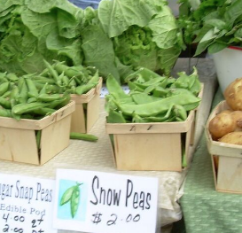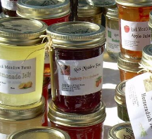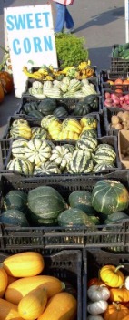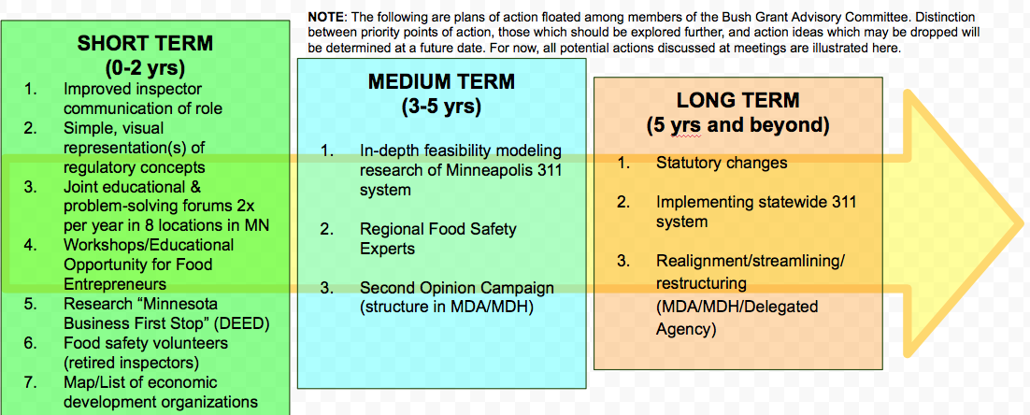

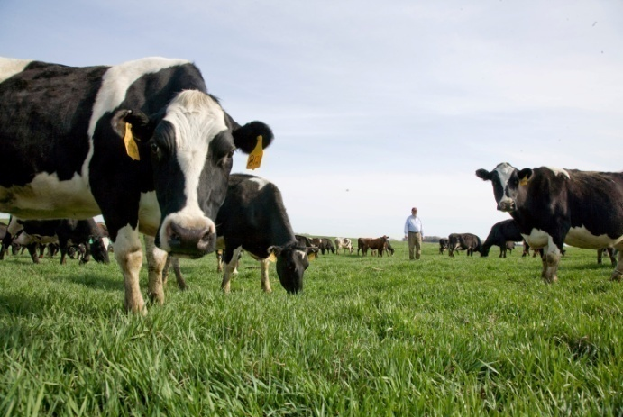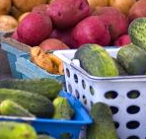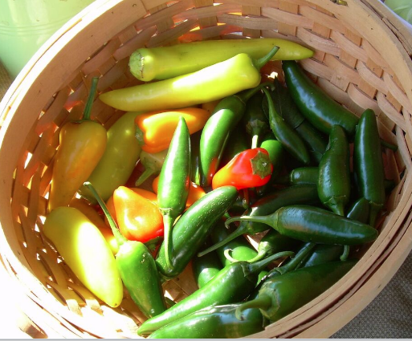

Minnesota promotes food safety and economic development through a user-friendly food business regulatory system that is coordinated, reliable and efficient.

**Entrepreneurs** of small and large food businesses successfully navigate Minnesota’s easy-to-understand, transparent and streamlined system. Operators obtain the appropriate licenses and certifications and produce safe food for consumers.

**Regulators** from agencies across Minnesota (MDH, MDA, and delegated local agencies) freely share knowledge and work a timely manner with entrepreneurs of food businesses and with each other. Regulatory agencies are accountable and consistent and support education, outreach and the production and service of safe food to Minnesotans.

## Vision

All materials generated by project staff and committee members are posted on the webpage listed below. **These materials are open-source, free, and publically available.** Anyone with an interest in regulation of local food systems is welcome to **use and adapt them as needed**.

Please visit:

**https://mnlocalfoodregs.wordpress.com**

Changing the Approach to Regulation of Local Food Systems in Minnesota. June 2015-June 2016. Karen Lanthier and Stephanie Van Dyke. Minnesota Institute for Sustainable Agriculture; funded by Bush Foundation Community Innovation Grant. https://mnlocalfoodregs.wordpress.com/

**Contact Jane Jewett**

Minnesota Institute for Sustainable Agriculture

**jewet006@umn.edu**

Questions?

Bush Foundation Community Innovation Grant

**June 2015 – June 2016**

Changing the Approach to Regulation of Local Food Systems in Minnesota

**https://mnlocalfoodregs.wordpress.com**

### Timeline for Proposed Initiatives

**HOW**:

* **CATCH** the Vision for a better local food system
* **READ** the Issue Brief and Alignment Document to understand the context and advances made by the Bush Grant Advisory Committee
* **USE** the Timeline and Program Logic Models to dig into the specifics of potential next steps.
* **TURN TO** the Case Studies as resources to illustrate issues in the regulation of local food systems.
* **TALK** with people in your networks about what changes could be beneficial for you and your communities.
* **IDENTIFY** actions you could join or champion
* **COMMUNICATE** with MISA and the Local Foods Advisory Committee (LFAC) to get connected with others on these topics
* **ADD** to the Referral Organizations document to identify stakeholders across MN and what expertize they bring to the table
* **MODIFY** any of the other documents here as needed for your work

**WHAT:**

Please use these materials (individually and in teams) to tackle next steps in creating a user-friendly food business regulatory system that is coordinated, reliable, and efficient.

**WHO:**

* Economic development agencies
* Farmers
* Farmers Market vendors & managers
* Food safety advocates
* Food safety regulators
* Food system advocates
* LFAC members
* Local food advocates
* Local food entrepreneurs
* Local-level policy-makers: county commissioners, city councils, mayors
* Nonprofit organizations advocating/working in the local food systems realm
* State & local regulators & other agency staff
* State-level policy-makers: Commissioners of Ag & Health, Governor, Legislators

**WHY:** The Bush Grant Project’s goal is to **promote the growth and success of the local food system and small businesses** while **creating systems change** that will benefit current and future entrepreneurs, farmers, nonprofit organizations, state agencies, and food regulators.

Changing the Approach to the Regulation of Food Systems: **A Call To Action**